Which factors influence consumers’ choice of payment method when purchasing online?

Abstract

While researchers have studied the various payment methods for both online and in-store purchases, the available literature on factors influencing choice of online payment method needs further extention. Specifically, prior research does not indicate whether monetary value of a transaction is a key determinant of the payment method chosen. This study is aimed at contributing to the body of knowledge by developing an understanding of the key factors likely to affect the choice of payment method when customers are shopping online.
The research questions for the study were as follows:
RQ1: What are the factors that influence choice of payment method when consumers shop online?
RQ2: Do perceived usefulness, ease of use, security and risk impact on consumers’ choice of either PayPal or credit card as a payment method?
RQ3: Does the choice of payment method depend on the monetary value of the product being purchased online?
To carry out this research, a quantitative research approach was adopted. The research used a scenario experiment, delivered via an online survey questionnaire as the research instrument. To analyse the information collected through the survey questionnaires, SPSS was used producing descriptive statistics, ANOVAs and logistic regression analysis.
Findings from the analysis indicate that respondents prefer to use a credit card rather than PayPal when shopping online. It was found that the respondents considered credit cards more secure, easier to use and to understand, and flexible. Furthermore, the respondents suggested that they tended to use the more easier to use, secure, and flexible form of payment, credit card, in making expensive purchase (branded items) but they engaged any form of payment when buying cheap items (unbranded items). This study also found that customers tended to choose a payment method which enables them to ensure a temporal separation between payment and purchase. The results indicate agreement with the literature review, that factors such as ease of use, safety and security, comprehensibility and privacy are considered important by online shoppers when deciding the method of payment. These findings indicate that consumers view these factors as determinants of their choice of payment method. If businesses can focus on these factors they would be able to positively encourage consumers to purchase online including the value of their purchase and the choice of their payment method.

Contents
Abstract i
1 Chapter 1 – Introduction 1
1.1 Background and Research Problem 1
1.2 Problem Statement 2
1.2 Research Aim 3
1.3 Research Objectives and Questions 4
1.4 Significance of the Study 4
1.5 Scope of Research 5
1.6 Structure of Research Report 5
2 Chapter 2: Literature Review 7
2.1 Introduction 7
2.2 History and Evolution of Payment Methods 7
2.3 Payment Methods 9
2.4 Technology Acceptance Model 12
2.5 Consumer Behaviour and Payment Methods 13
2.6 Effects on Rational Choice 18
2.7 Factors Affecting Online Payment Methods 19
2.7.1 Perceived Risk 22
2.7.2 Trust 23
2.7.3 Ease of Payments, Time Saving, and Risk 24
2.8 Summary 24
3 Chapter 3: Methodology 26
3.1 Research Method 26
3.2 Justification for the Methodology 26
3.3 Research Questions 27
3.4 Data Collection (Primary and Secondary Data) 28
3.5 Research Instrument (Survey Development) 28
3.6 Population and Sample Size 30
3.7 Sampling Method 30
3.8 Data Collection Process 30
3.8.1 Branded Items vs Unbranded Items 31
3.9 Data Analysis 32
3.9.1 ANOVA and Logistic Regression 32
3.10 Limitations 33
3.11 Ethical Considerations 33
3.12 Summary 33
4 Chapter 4 - Findings 35
4.1 Introduction 35
4.2 Findings 35
4.2.1 Descriptive Statistics 35
4.2.2 Differences between PayPal and Credit Cards 52
4.2.3 Descriptive Statistics 55
4.2.4 Differences between PayPal and credit cards for the Gucci Scenario (ANOVA) 57
4.2.5 Descriptive statistics for the unbranded coat scenario 59
4.2.6 Differences between PayPal and credit cards for the unbranded scenario (ANOVA) 62
4.2.7 Comparison between branded and unbranded scenarios 63
4.2.8 Demographic differences in choice of payment method 64
4.2.9 Factors which most strongly predict choice of payment method 65
5 Chapter 5 - Discussion 69
5.1 Online shopping occurrence 69
5.2 Shopping scenarios 70
5.3 Determinants for payment method choice 70
5.4 Chapter Summary 74
6 Chapter 6 - Conclusion and Recommendations 75
6.1 Limitations of the Research 75
6.2 Addressing the Research Objectives 75
6.3 Answers to the Research Questions 77
6.4 Recommendations 78
6.5 Recommendations for Management/Businesses 78
6.6 Recommendations for Future Researchers 78
6.7 Benefits to Managers / Bankers / Marketers 79
6.8 Benefits for Future Researchers 79
References 80
Appendices 86
Appendix A. Ethical Approval and Information Sheet 86
Appendix B. Participant Information Sheet 87
Appendix C. Survey 90

List of Figures
Figure 4.1Recency of online purchases 35
Figure 4.2 Preferred payment method 36
Figure 4.3 Demographic Indicators - Gender 36
Figure 4.4 Demographic indicators - Age group 37
Figure 4.5 Demographic indicators - Civil status 37
Figure 4.6 Demographic indicator - Level of education 38
Figure 4.7 Demographic indicators - Employment status 39
Figure 4.8 Demograhpic indicator - Annual income 40
Figure 4.9 Ease of learning to use PayPal 40
Figure 4.10 PayPal tractability 41
Figure 4.11 Interactions with PayPal are clear and comprehensible 42
Figure 4.12 Flexibility of PayPal 42
Figure 4.13 Ease of learning PayPal 43
Figure 4.14 PayPal's perceived ease of use 44
Figure 4.15 PayPal cannot be trusted online 44
Figure 4.16 PayPal may not keep personal information private 45
Figure 4.17 PayPal may not be secure 46
Figure 4.18 Credit cards - ease of operation 46
Figure 4.19 Credit card tractability 47
Figure 4.20 Interactions with credit cards are clear and understandable 47
Figure 4.21 Credit card flexibility 48
Figure 4.22 Ease of becoming skillful at using credit cards 48
Figure 4.23 Credit card ease of use 49
Figure 4.24 Level of trust in credit cards 50
Figure 4.25 Privacy of personal information with credit cards 50
Figure 4.26 Security of credit card number during online shopping 51

List of Tables

Table ‎4.1 Comparison of PayPal and credit cards on the 9 rating scale items 1
Table ‎4.2Descriptive statistics for Gucci coat scenario 1
Table ‎4.3 ANOVA analysis of Gucci scenario 1
Table ‎4.4 Descriptive statistics for the unbranded coat scenario 1
Table ‎4.5 ANOVA analyses of unbranded coat scenario 1
Table ‎4.6 Comparison of branded and unbranded scenarios on the 9 rating scale statements 1
Table ‎4.7 Analysis of payment choice by demographic indicator 1
Table ‎4.8 Preferences for payment method 1
Table ‎4.9 Results of the logistic regression (1) 1
Table ‎4.10 Results of the logistic regression (2) 1
Table ‎5.1 Answers to Questions 3 and 4 1
Table ‎5.2Mean and Significance of Difference 1

Chapter 1 – Introduction

Background and Research Problem
With the ever-evolving modes of payments, there have been considerable changes and improvements in the way consumers pay for their shopping through online channels. Most businesses these days have adopted contemporary ways of selling their products which comprise of conventional and online platforms for presenting, marketing and selling (Fumiko & Klee, 2003). Not very long ago, paying through paper cheques used to be the norm and the reliability and convenience of this payment mode never created the need for an evolution in the payment methods. However, with the emergence of Internet and eventually online shopping, paper money or paper cheques became outdated for doing any business online. It is pertinent to mention here that these changes not only brought convenience and wide variety of options for consumers and businesses, they also presented challenges in the form of reliability, ease of use, privacy, security and many other issues (Agyapong, 2017; Baubonienė & Gulevičiūtė, 2015). Questions like “What if my payment does not go through?” or “What if someone steals my information?” or “What if I do something wrong and do not understand how to make payments online?” are some common examples of challenges consumers face when using online payment methods. It is understandable that these online payment methods are still evolving and are being made safer, securer and easy to understand and use, but a common consumer still has some reservations which force him or her to opt for conventional payment modes or if not that then opt for one out of many online payment options. The big question here is what makes consumers think that a particular method of online payment would suit their needs; ease of use, safety and security, or something else?
Researchers in the past have studied different modes of online payments, however, the existing literature on the subject is insufficient in understanding whether monetary value of an online transaction affects the factors determining choice of online payment method? The researcher has identified a research literature gap which establishes the need to explore what factors play a decisive role in determining the preferred mode of payment by online shoppers; and is there any moderating role for monetary value of the transaction in this relationship?

1.2 Problem Statement
While prior research studies investigated the growing importance of online payment in ecommerce markets, the majority of these studies placed particular focus on the demand-side of purchase behaviour and they did not broadly consider the number or variety of factors that are likely to affect the choice, availability, accessibility, and preference for methods of payment consumers may choose. It is important to note the availability of numerous online payment methods have tranformed the marketplace and impacted on the growth of ecommerce platforms. However, it is important to appreciate that different online payment methods are accessible for different kinds of ecommerce, and online shoppers make decisions relative to the type of online payment and visa versa.

Studies report on the impact of the availability of various online banking and payment services. These online services simplify banking and payment transactions for consumers, by ensuring availability of banking services anytime and anywhere. However, a reasonably low number of online users (only 29 percent) engage in online buying activities. A special feature of online banking is the ability to create new technical infrastructures to connect different modern and traditional modes of payments. However, online payment models are new and undergoing significant change as technology improves, as new entrants join the market, and as new needs emerge. Further, there is a dearth of research into the needs that may drive payment methods during online purchases, and how online payment methods relate to different types of brands. Global brands invest much time and resources to comprehend and meet the needs and expectations of consumers , and the increase in online brand awareness and purchases highlight marketers’ need to understand the factors that influence the way brand marketers, consumers, and merchants adopt online payment methods. The issues of flexibility, data management, the security of systems, risk of losing money, privacy and confidentiality, and function of the system are seen as important factors that influence transactions through online modes of payment. However, existing studies do not reveal the way these factors affect consumers’ choice in online payment methods, upon learning about the available options. Thus, this research study focuses on the way different factors influence consumer’s choice of mode of payment when buying branded and unbranded items online.

Research Aim
Based on the overview and research problem presented in the previous section, this study aims at understanding which factors influence the method of payment choice when consumers purchase online. In other words, the study aims at exploring the factors which have a significant influence on chosing payment options by customers who are shopping online. For the purposes of this study, the researcher has taken into consideration two different scenarios, which are purchasing a higher-priced branded item online and purchasing a lower-priced unbranded item online (See Chapter 3 for details). The idea behind taking into account two different scenarios is to understand whether consumers who are shopping online have different perceptions and choice of payment options when it comes to buying an expensive (branded) or inexpensive (unbranded) item. The monetary value of the transaction will be explored as a moderating variable.

Research Objectives and Questions
Keeping in view the research aim of this study, the researcher has put forward the following research objectives:
- To review the literature pertaining to the subject of online payment choices and consumers’ behaviour;
- To understand what factors influence the method of payment choice when consumers shop online; and
- To determine if consumers’choice of payment method depends on whether they are purchasing a higher-priced branded or a lower-priced unbranded item online.
These research objectives have been presented as research questions for this study as under:
RQ1: What are the factors that influence choice of payment method when consumers shop online?
RQ2: Do perceived usefulness, ease of use, security and risk impact on consumers’ choice of either PayPal or credit card as a payment method?
RQ3: Does the choice of payment method depend on the monetary value of the product being purchased online?

Significance of the Study
The significance of this research work is evident from the fact that it aims at understanding how online shoppers perceive using different payment methods, such as using PayPal and/or credit card for making payments for purchases made online. Since the researcher has presented two different scenariors to the respondents of this study (See Chapter 3), purchasing higher-priced branded item or a lower-priced unbranded item, the findings present an understanding how the choice of payment method is influenced by the monetary value of the transaction.

Scope of Research
The scope of the present study is limited in various ways; for instance, the researcher has only aimed at considering two of the many online payment options, which are PayPal and credit cards. The researcher has not taken into consideration other frequently used payment options and therefore the conclusions obtained from this study can only applicable with respect to payments made through credit cards and PayPal. In addition, the researcher has narrowed down the scope of this research by presenting only two options to the respondents who participated in this study by way of filling out survey questionnaire. The respondents are only given two scenarios, which are purchasing an expensive (branded) item and purchasing an inexpensive (unbranded) item.

Structure of Research Report
Chapter 1 includes a background to the research problem and presents the aim and objectives of the research work. The chapter also includes significance and scope of this research work. In the literature review section of the report, the researcher has reviewed the literature pertaining to the subject of this study and includes a critical review of similar research works conducted in the past. This review allows the researcher to present a conceptual framework for the study. In the third chapter of the report, the researcher has presented the research methodology and approach adopted for the present study. The chapter also entails data collection and analysis techniques being used in this study. In the fourth chapter the researcher has put forward the findings obtained from analysis of primary information obtained through surveying a sample of respondents. Findings presented are also interpreted to understand their meaning. In the fifth chapter the researcher has discussed the findings in light of the literature reviewed and research questions presented in the first chapter. The discussion included in this chapter provides the basis for concluding the present study. Chapter 6 is the final chapter of this research report. The researcher has presented conclusions based on the findings and discussion from chapters 4 and 5. The chapter also puts forward how conclusions reached in this study would help future researchers, managers of banks and PayPal and consumers at large. The chapter also entails recommendations for managers and future researchers based on the conclusion and limitations associated with this study.

Chapter 2: Literature Review

Introduction
This chapter covers a structured literature review of the various theories and prior studies related to the impact of payment choices on consumer behaviour. For this purpose, key terms and phrases such as “online payment”,” consumer behaviour”, “spending behaviour of customers”, “outcomes of different payment methods”, and “impact of payment methods on purchase behaviour” were used to retrieve documents from reputable databases including Google Scholar, EBSCO host and ProQuest. The selection of these sources was based on the primary criterion that the sources were published in the last five years, due to the fast-changing nature of online and digital payments.

History and Evolution of Payment Methods
In today’s marketplace consumers have a wide range of options for making payments before, during or after purchasing services and goods. Payments methods include a wide range, from the simplest way of paying by cash and cheque, to paying by debit or credit cards, paying via online bank, electronic fund transfers and paying via mobile applications. Classical economic (Grüschow, Kemper, & Brettel, 2016) theory (Runnemark, Hedman, & Xiao, 2015) asserts that consumers choose to pay the predetermined price or negotiated amount of money for the given product or service, by rationally assessing the value of product/service versus the value of money. However, in some purchase events, increased payments or decreased payments can be demanded by suppliers, depending on the medium of payment the customer chooses, despite no change in the economic value of the given product or service (Drahos, 2017).
In ancient times, the simplest methods such as the barter system were used. In the barter system, there was no universalized value of the particular products, or there were no regulatory authorities to set the prices of the product, and the payment of the particular goods or service was decided based on the negotiation skills of the person (Saka, 2017). In this method, there was no certain price of commodity, but things value depended on the negotiation of persons involved in barter trade.
In order to understand the collective behaviour of the people using different methods, we can refer back to the history and we can observe how the behaviour of people differed with using different payment methods. This is useful in establishing a base for this research as they very aim of this paper is: “Do consumers spend more money when using different payment methods?” Evidence from prior literature and history has come to a positive assertion on this issue. After barter trade, monetary instruments changed to coins and precious metals and these lasted for a certain long time in the history of the financial system. In the industrial and modern era, which started in the 1800s, the monetary system and central banking system were established, and currency notes and coins for a certain amount of money were made through the mint press. In the 1900s, the central banking system was established, and the fiat money was developed, and the payments through cash and cheques became the norm. In the 1950s, the concept of plastic money emerged, and that changed the behaviour of the consumers in spending and with the passage of time, new and different ways of payments were observed (Brunnermeier & Schnabel, 2015).
The estimated probability that an individual will have a credit card has changed from 0.63 in 1983 to 0.78 in 2001 (Bertola et al., 2016), and by the year 2016, this probability has matured at 0.8. It indicates that the use of the credit card has been on the rise with the passage of time, with almost 80% of the people in developing countries using credit cards as payment method. In addition, online purchasing has recently reached a user base of 1.66 billion people, with online sales amounting to 2.3 trillion dollars in 2017. This trend is projected to reach 4.48 trillion USD in online sales by 2021 (Statista, 2018).

The use of different card-based methods and online payment methods are on the rise with the passage of time. The main providers of credit and debit cards are currently VISA, Master Card and American Express - the most prominent global credit and debit card brands and they are accepted all over the world. These electron fund access cards’ usability is almost universally accepted when making purchases and transacting (Colangelo & Maggiolino, 2017).

Payment Methods
The different modes of payments affect the buying behaviour of customers (Ferrao & Ansari, 2015), and payment methods also has an impact the profitability of the firm. Further, substantial innovation in the payment technology is occurring on an ongoing basis ( Avni, 2015) and these significant changes coincide with changes in consumers’ paying habits. According to Grüschow, Kemper, and Brettel (2016), consumers are in search of payment methods that are convenient and will be of the lowest cost to them personally (Grüschow et al., 2016).
If a certain product or good has a certain price, payments can be made through check, and this will include the transaction costs such as annual charges, the cost of the check book and monthly subscription charges of receiving notifications and the annual account statements. Whereas in the credit card, a certain amount of fee is charged to customers and they have to disburse the amount owed to a certain date, if the date is missed, the customer is charged with interest and in case of missed payments; penalties are charged to the payments (Montjoye et al., 2015).
Payment method | Benefits | Disadvantages | Researcher
Cash | Economic principle of value of money remains valid; less spending | Security, bulkiness | Bagnall et al., 2014
Debit Card | Customer can spend only the amount deposited by consumer | Spending more than economic value | Chen et al., 2017
Credit card | Customer can purchase more than money, allows time for payment disbursement | Impulsive buying, unnecessary buying, lack of budget control | Hernandez et al., 2017
Mobile payments | Instant banking transactions, user friendly, timely | Cyber security issues | Liébana-Cabanillas, Sánchez-Fernández, & Muñoz-Leiva, 2014

In the literature, credit card pricing has been discussed on determinants of interest rates. However, these determinants also include credit card penalty fees such as late fees and over-limit fees, issues of penalty on credit card payments has become a publicly debated issue, the legislative authorities have put regulation into place on such transactions and fees as they were abusive. In contrast, banks consider these are to compensate the bank for the risk of providing credit to credit card users (Carbo-Valverde et al., 2014).
Online payments are just equivalent to those that were made through paying by check because they are similar. For online payments, consumers pay following various steps and these create temporal separation between consumer and the payment being made. These separations are caused in online banking through tasks such as asking for the transaction PIN, Transaction PIN and further validations (Kooti et al., 2016).
The very nature of a credit card is compelling to the consumer, because it allows the facility to consumer to purchase goods and services that are not restricted by a budget or intentions of the particular consumer, and the consumer can pay this amount via credit card although he or she may not have that amount of money directly available in their bank (savings, cheque or access) account. The monthly payments usually exceed the amount of money that is present in the account of the consumer, and the dues are carried forward to the next month, and the consumer becomes bound to pay (Gabler, 2016).
Whether the payment method is perceived as expensive or cheap depends on the cognitive perception about the payment methods, as well as rational assessment by users/consumers. The topic is narrowly researched in the present time, and thus has much needed future research implications. Scholars from the fields of economics and psychology are looking forward to understanding how payment contexts affect the buying behaviour (Runnemark et al., 2015). This contextual impact also challenges economic theory related to consumers’ evaluation of products and services is independent of how money is represented, which means that the choice of payment instrument affects spending. This study supports the research question of this study, as it partly answers the question as to whether consumers pay more using the certain methods. It is clear form past literature, that payment instruments affect consumer/buyer spending (Runnemark et al., 2015).
There are behavioural and psychological reasons behind this that have identified in various researches. In the USA, almost 80% of the payments are non-cash payments, which means that people are adopting new technologies and they are using different methods of payments that involves online payment, card payment, mobile payment methods, and even cryptocurrencies (Huang, 2017). The psychological reasons less stress and more convenience when using non-cash methods as human prefer convenience.
From an emotional point of view, the card payments are more inert (Thomas, Desai, & Seenivasan, 2011) as compared to cash payments (Soman, 2003). The very role of money is emotional rather than instrumental (Ball, 2017) statement. Further, it has been found that the pleasure of saving regulates the behaviour of spending and this is based on the emotional association with notes and coins as physical representation of monetary value, and emotions intensify the transactional information using senses such as sight and touch that is translated into immediate experience of a consumer (Khan, Belk, & Craig-Lees, 2015). Further, card-based payment modes decouple the positive emotional association as one does not see the inflow and outflow of money. The positive emotions such as relaxation, confidence, security, and assurance should be aroused because of mental pain of parting with money (Khan, Belk, & Craig-Lees, 2015). Further card usage dulls the acuteness of emotional sensitivity.

Technology Acceptance Model
The technology acceptance model (TAM) is a framework which defines how the use of innovative technology increases According to TAM, technology acceptance is influenced by two important factors; ease of use and usefulness. Usefulness is perceived by the consumer on the basis it will enhance personal efficiency and effectiveness, whereas the ease of use means to what extent the person will be free from effort (Trutsch, 2017).
Perceived usefulness and ease of use help users make the decision to use a technology. Multiple studies sought to find the link between innovative payment methods and perceived usefulness and ease of use (Liebana-Cabanillas et al., 2014). It has been found by Liebana-Cabanillas et al. (2014) that enhanced facility of making payment, reduced transaction costs and better record keeping are the important determinants of the perceived usefulness. The technology acceptance model is at the root of adopting different payment methods by the consumers in the contemporary time.
It has been observed by Marangunić and Granić (2015) that technology is ever-changing and new technology comes, for example, there was a time when the barter system was used, which was replaced with the invention of coins and precious metals, then the fiat money was developed and in the present time, with the fiat money the plastic money is also being used (Marangunić & Granić, 2015).
The consumers and organizations also adapt themselves to the changing technology, and these changing technologies have different impacts on different users. Various technologies also cause changes in attitudes and behaviours. A very good example of this is the use of debit card and credit cards, where it has been found by Ferrao and Ansari (2015) that when consumers use these cards, they spend more money on purchases.
These trends affect overall spending patterns, and different payments methods have different attributes associated with the different payment instruments (Bisht et al., 2015). Some instruments are likely to be responsible for excessive and impulsive buying, and this trend has steadily increased as the available modes of payment have changed from traditional ways of cash and savings payments to various modern means of payments (including credit cards).

Consumer Behaviour and Payment Methods
The study of consumer behaviour is at the centre of determining consumer spending patterns and understanding the phenomena of how buying behaviour differs when consumers use different payment methods. Therefore, to understand consumers’ behaviour it is necessary to establish the factors likely to affect consumers’ buying patterns. Understanding consumer behaviour involves understanding the set of decisions (what, why, whether, how, when how much, where and how often) individuals or groups of consumers makes over time about the acquisition, use or disposition of services, goods, ideas, and another offering; because the psychological core exerts considerable influence on consumer behaviour (Hoyer et al., 2016). Consumer behaviour is also affected by the cultural norms and ideas of a particular group, since consumers belong to many groups and share common cultural beliefs and values and these include household and social class, individual values, personality and lifestyle (Hoyer et al., 2016).
Many studies note that the people are willing to pay more with the credit card and it is based on two reasons: there is a temporal separation between payment and consumption and second is the representation of money itself (Cheng & Chen, 2016). Therefore, it poses a question that whether for the identical products, the customer will pay more or less using a debit/credit card and cash and other methods. The question raised in this research has been answered that the spending behaviour does differ with different types of payment methods and the very example of this is the credit card. It has been noted that customers can pay more for the given products, when using different modes of payments (Avni, 2015).
Consumer behaviour includes certain patterns through which consumers move as they go through various steps and stages while purchasing products/goods/services. It is necessary to firstly study consumers’ behaviour to investigate the variation in behaviour, based on different modes of payments. For example, consumer behaviour in the developing countries as compared to the developed countries could possibly be different. In the developing countries, there is a tendency to use cash as a mode of payment, whereas people belonging to the upper class and upper middle-class use debit cards. The use of the credit card in the developing countries is very low as compared to the developed countries. Therefore, their spending behaviour will differ (Slade, Dwivedi, Piercy, & Williams, 2015).

Furthermore, to establish whether the spending behaviour differs using different payment methods needs to incorporate the consideration that a study on the behaviour of consumers in the developed country and the upper-class may not apply to the people in developing countries that belong to the middle or lower middle class (Slade, Dwivedi, Piercy, & Williams, 2015). It again asserts case-specific considerations, which are bound in terms of time, space, and location and the people from different locations and categories can exhibit different behaviours because of differing contexts. However, the overall implications of the credit card use and the debit card use that leads to higher spending and the payment amount differ with the different spending tools is universal (Trung, 2015).
The consumer behaviour is refers to all of the activities of individuals, groups or organizations, for purchasing, using and assessing services and products that include the mental, emotional and behavioural response that precedes and determine these activities (Trung, 2015). Exceeding the credit limit by credit card users in the case of overspending is not realized first time by them when they first exceed the credit limit. However, because of the penalties imposed, the retraining behaviour is reinforced in the mind of the consumer for the next time, and the person takes care of the excessive buying (Bertola et al., 2016).
Regarding the usability of the plastic cards or plastic money, it is reported that credit cards replaced debit cards as the most preferred payment methods for the first time in 2016 in USA (TSYS, 2016). Whereas in the UK, people are using more debit card as compared to credit card (The UK Cards Association, 2017). The tight bonding between the payment and consumption means that when a person makes the purchase, the money is immediately paid, and this occurs in the case of cash paid. The physical representation of the cash has mental connotations associated with the pain of paying the cash (Bagnall et al., 2014).
The problem of paying cash is associated with the costs that a person bears, and this is the reason that the spending by a person in case of cash payments can be less as compared to the debit card and the credit card. There is a tight bonding between the consumption and the payment, and this is one of the likely sources that could affect the spending behaviours. It is understood in the debit card that the spending cannot increase by the amount that has been deposited by the customer (Chen et al., 2017). On the other hand, in the case of a credit card, this amount can be exceeded.
Credit cards are one of the most studied payment methods. In credit cards, the card primes the consumer to think about the payments whereas the cash activates the mind in terms of cost considerations. In the debit card, the customer can use only the amount that has been loaded or disbursed into the account associated with the credit card and the amount that can be spent by a debit card user is limited to the amount deposited (Doyle et al., 2017).
Usually, the employed class uses the credit card more in the developed countries because these people receive their remuneration on a monthly basis (Cruijsen et al., 2017). These people incur their monthly expenses that can exceed their salary of the month. However, this is facilitated by the credit card and when they are in need of more money that they do not have, they can borrow the money from the credit card provider and pay certain fee for the amount exceeding the amount that they have deposited and sometimes they have to pay the penalties (Nadarajan, 2017).
The penalties that are imposed on credit cards are not present in the case of debit cards, because of their very nature (debit is money available in the holders’ account) there is no credit involved in debit cards. From a demographic point of view, the salaried class is much more likely to engage in the consumption of credit card payment methods, because the amount of money they spend and the amount of money they receive in the form of remuneration is periodic in nature, therefore, their budget constraint is limited to the number of remunerations they receive (Durkin et al., 2015). These salaried class persons can often come to a situation where the expenses they budget exceed the amount of the salary they are receiving (have earned up to that point). However, a credit card provides them the facility to purchase the things that are out of (over and above) their budget constraints and budget limitations for a specific peridod of time (Hernandez et al., 2017).
Cash and cheques have been the most common modes of payments in the early and the second half of 1900s (Runnemark et al., 2015). With the emergence of the internet in the 1990s, e-commerce came to rise, and internet banks and internet payments emerged. With this changing trend, it was a prediction that the cash would sooner or later die. However, cash payments are used for untraceability and anonymity. The online payment methods came with the emergence of online payment methods. In the past, the payment on e-commerce was made through the plastic cards, however the online banks have also established that facilitates the risk-free online payments for example PayPal. PayPal is much safer and it is also very useful in preventing fraudulent online activities and has provided an ideal solution for the people who are engaged in e-commerce.
Mobile payments have also been termed as a next-generation payment method, and it is probable that it can replace the conventional methods. Another important method that is gaining popularity is the mobile commerce, and these are the payments that are made through the mobile, and it is getting increasing attention in the present time (Chen, 2008). The total mobile subscriptions in the world have reached almost six billion, and mobile payments are also being used for online purchases, whereas other methods such as prepaid cards, PayPal and mobile payments are also highly common (Liébana-Cabanillas, Sánchez-Fernández, & Muñoz-Leiva, 2014).

Mobile payments provide additional convenience to consumers. When compared to the online payments, in the mobile payments, the consumer does not have to log in to the banking portal using a PC, but this can be done by using a mobile application. Making payments through mobile are much safer as compared to the online banking. However, in case of lost or stolen mobile, this mode of payment can be very risky (Kooti et al., 2016). These modes of payments have different implications on the spending behaviour of consumers. Consumers are increasingly moving towards the online payment methods. Consumers usually spend more time buying expensive things from mobile applications just like they buy from the physical stores. However, the impulsive behaviour can also be found among the online purchasers. Notwithstanding, they do spend a significant time in evaluating and making a purchase decision (Kooti et al., 2016).

Effects on Rational Choice
Credit card spending has been associated with higher spending levels than cash, and this trend can be seen in spending on luxuries and unhealthy food. Credit cards are also associated with impulse buying; buying in an unplanned and hedonistically complex way which is linked with plastic money payment methods. Impulse buying has increased with the emergence of e-commerce, and it is estimated that almost 40% of online consumer expenditure is attributable to impulse buying (Chan, Cheung & Lee, 2017).
Impulse buying is carried out in an environment which is free from constraints. Impulse buying is characterized as an immediate and sudden purchase. Impulse buying is the process in which the customer purchases a thing that he or she has not budgeted for, but has in mind that he or she has a credit facility, and is lead to think that he or she can afford more and pay later (Hernandez et al., 2017).
On the one hand, in terms of cash, consumers usually go shopping with a limited amount of cash, which is called a budgetary constraint, and it is the limit up to which purchasing products or services can be made (Hernandez et al., 2017). Therefore, the budgetary constraint of cash limits the spending behaviour of customers. I In contrast, budget constraints do not seem to be present in the case of credit card payments.
With credit cards, customers have the choice to spend more than their current budget, although money spent will need to be paid back in the future. This lack of budgetary constraint affects the state of mind of consumers (Trutsch, 2017). The budget constraint is an important economic term that has been useful in the modeling of consumption behaviour and classical economics; it explains the spending behaviour of customers with respect to the budget line or the budget constraint which means that with the given amount of income, a person can obtain a certain mix of different products and services and cannot exceed that limit (Hernandez et al., 2017). Therefore, up to now rationalizing consumer spending patterns is directly attributable to budget constraints. However, the emergence of plastic money, particularly credit cards, has diluted the concept of budget constraint, with an extended budget constraint being present in the case of credit cards, which is the credit limit of a credit card, rather than the actual income of a person.

Factors Affecting Online Payment Methods
The 21st century has witnessed the emergence of various disruptive innovation-based changes and the most important is the fourth industrial revolution, which is the advent of the internet and social media (Peters & Panayi, 2016). The advent of these technological revolutions has required new ways of trading between different parties and new payment methods (Peters & Panayi, 2016).
Rapid development has been made in e-payments, which include payment processes without any paper instrument, such as debit card, credit card, electronic funds transfer(Laudon & Traver, 2016), e-banking, online banking, mobile banking (Tella, 2014), e-wallet, e-cash, e-check, online storage value, digital accumulating balance and wireless payments (Junadi, 2015).
The proportion of total cash flow for each payment form is about 12%, and 97% of enterprises accept payment via funds transfer, 16% payment cards, and 4% e-wallet Although 45% of the population use the internet, revenue from e-payments has only reached 5% of total revenues because of the various risks customers perceive (Laudon & Traver, 2016).
Traditional monetary methods had certain security risks, not being able to keep money secure from theft was one such, and this was one of the reasons that banks came into being, and this system prevailed into the 20th century. Cheques used to represent cash were one of the most convenient methods of carrying and paying money safely without the risks involved in carrying cash (Peters & Panayi, 2016).
Shopping from online stores is becoming more and more popular in developed/ developing countries. However, in developing countries, people are not used to buying products without physically touching and testing them(Abu-Shamaa, 2015). Socio-cultural factors such as these and technology-related factors as well effect the acceptance of online shopping. There are also other factors that affect the uptake of online shopping; barriers in logistics and delivery, limited options for payment, a lack of technology infrastructure and a lack of trust in the internet; particularly in developing countries.
The main model behind the adoption of the new online payment methods is the Technology Acceptance Model (TAM) proposed by Fred Davis (1985 this is not on your reference list), which defines the various drivers and motivations behind adopting different systems and technologies, emphasizing usefulness and ease of use (Abu-Shamaa, 2015).
The most significant factor in the acceptance of a new technology, according to Abu-Shamaa (2015) is trust. Due to the lack of trust, most of the consumers (are you talking about consumers in developing countries here?) avoid paying with credit/debit cards and prefer the cash on delivery method for payment. Security and trust issues affected people in the 1990s in developed countries in the same way that is now affecting the behaviour of consumers in developing countries (Abu-Shamaa, 2015).
The study by SivaKumar and Gunasekaran (2017) shows that four factors affect purchasing behaviour these being; perceived benefits, the risk associated with payment methods, the consumer’s tendency towards innovativeness, and the consumer’s intention and attitude. These have also been the main factors in choosing traditional online payment methods, which is credit card payment over the internet.
While using e-cash and e-wallet through smart mobile devices are common practice these days, the acceptance of mobile payment depends on the provision of mobile networks of consumers and retailers (Tatjana, Jan, & Niklas, 2016). Payment through mobile was identified as the most popular way to pay in the 2000s among American consumers, and later became more popular in Europe, the US and some regions in Asia as well (Taylor, 2016). While mobile payment options seem like an increasingly popular choice, research in this field is in its infancy (Groß, 2015).
A vast amount of literature is looking into the benefits of mobile payments, but the risks related to it are not being researched (Raina, 2014). Mobile payment is an important payment media that has the potential to attract customers, and therefore merchants, mobile phone manufacturers, software developers, bank decision makers, government agencies, should look at their marketing strategy in relation to it (Tan & Ooi, 2014).
One of the most important factors that supports the significance of mobile phone based payments is the increasing penetration of smartphones (Shaikh & Karjaluoto, 2015). German company PayBox first introduced mobile banking in the 1990s in collaboration with Deutsche Bank making it available in European countries such as Spain, Austria, Germany, and the UK, whereas, in developing countries, Kenya was the first country to adopt a mobile banking system called M-Pesa in 2007 (Shaikh & Karjaluoto, 2015).
The Nigerian's MTN was an attempt to reduce poverty and provide supplementary income and microfinance to people so that they may escape poverty, making this passive adoption rather than active adoption (Shaikh & Karjaluoto, 2015).
The meta-analysis of literature on mobile payments from 2005 to 2014 shows that there are fifty-five relevant publications, 13% of which were conference publications on mobile payment (Shaikh & Karjaluoto, 2015).
Interestingly, consumers are also making their payments via smartphones, even when they are in a physical store, which means that consumers do not only consider mobile phone based methods for online purchases, but they also consider these methods in brick-and-mortar settings. This disengages the concept of ease of use in the TAM for online purchases (Abu-Shamaa, 2015) as customers are also making online payments when purchasing products in a traditional setting such as a store. It implies that there is more perceived value in online payments for online shopping, but these methods can be used for traditional shopping as well.
Two of the most important reasons for the development of these payment technologies were the necessity for ease and security (Peters & Panayi, 2016). However the same security risks are now being posed to the new technologies by various fraudulent techniques (Ozcan & Santos, 2014).

Perceived Risk
One of the major perceived risks includes the risk of going to an unsafe website entering one’s credit card details and having the card used fraudulently. It is one of the major risks as internet consumers find it difficult to select the reliable websites which are very few. Online security is one of the major factors, since there were still few websites lacking authentication that will secure the e-payment system (Swick, 2018). Users’ negative experiences are likely to lead to changes in their behaviour due to the impact of perceptions of future risk – known as “perceived risk” (Featherman & Pavlou, 2016, PAGE).

The perceived risk related to online payments methods includes a combination of uncertainty and the seriousness of the outcome involved (Bauer, 2015). The perceived risk can be divided into two dimensions, the risk associated with online financial transactions and the perceived risk with a product or service obtained through online shopping (Park, Lee, & Ahn, 2014). The payment method is a source of anxiety and can impact consumer purchasing behavior; in addition, it is difficult for customers to figure out whether a website is credible (Park et al., 2014).
Customers might be using a dishonest website or the website itself is honest but the security and authentication systems are weak, leading to the customer’s personal information being subject to misuse (Park et al., 2014). An example of this is hacking of debit card, and credit card numbers online, which can be accessed in the case of a breach in a website with a weak security system.
There is also uncertainty about the products and services bought online as no physical experience is available and consumers cannot assess the quality and features of the product or services in person, or they lack a way of assessing the reliability of the products or services (Park et al., 2014).

Trust
Trust is an important factor affecting the choice of payment method, and it is a critical challenge to e-payment systems as it is a subjective belief that a party will fulfil its obligations according to the expectations of the stakeholders (Lu, Yang, Chau, & Cao, 2014). Trust is built from reputation, and it is a defining feature of major economic and social interactions where uncertainty is present.
Trust is the most important element in the adoption of e-payments and when comparing e-payment and traditional payment methods, more consumers use e-payments methods as its convenience and the perceived level of trust increases, as risks are reduced (Yaokumah, Kumah, & Okai, 2017).

Ease of Payments, Time Saving, and Risk
Another important factor that affects the decision to use an online payment method is the ease of making payments. Making an electronic payment is much easier when compared to cash because a person does not need to carry bulky cash at all times and issuing cheques that need ID verification. Instead, a debit card or credit card can be used. Electronic payments also save time for both consumers and companies (Hamid & Cheng, 2014). Some payments made electronically are almost immediately transferred to the account of the company or individual, whereas cheques, still extensively used in businesses transactions and purchases, have clearing times of up to two days.

Summary
Upon reviewing the existing literature on the subject, online payment methods have evolved over time and is becoming increasingly more popular (Grüschow, Kemper, & Brettel, 2016; Runnemark, Hedman, & Xiao, 2015). There are some major factors which consumers consider when choosing their preferred method of online payment (Liébana-Cabanillas, Sánchez-Fernández, & Muñoz-Leiva, 2014; Thomas, Desai, & Seenivasan, 2011; Soman, 2003; Khan, Belk, & Craig-Lees, 2015). The technology acceptance model (TAM) has been developed to understand consumer behavior and this model, applies well to this research problem, due to the technology involved in online payments (Avni, 2015; Ferrao & Ansari, 2015). TAM states that if a consumer believes that a certain technology is easy to use he or she will accept using it and adopt it as accepted or preferred method/product (Marangunić & Granić, 2015). Numerous studies have been carried out which have focused on understanding how people chose their payment method while shopping online; and significant attention has been paid to the consumers’ behaviour and cognitive patterns in order to understand what factors determine the choice of a particular payment method. This review of past studies tells us that perceived risk, trust, ease of use, time-saving, and security are the major determinants affecting the choice of an online payment method (Slade, Dwivedi, Piercy, & Williams, 2015).

Chapter 3: Methodology

Research method refers to the systematic framework used to conduct research. Researcher have identified a number of research methods, such as qualitative, quantitative and mixed-methods research, and these can involve experiments, surveys, interviews, observation, and case study (Verma, 2012). This chapter presents an overview of the research methodology used in this study covering the collection of data, the research method, research questions, survey development, data collection, data analysis, and ethical considerations.

Research Method
Qualitative research methods are used to explore a topic in detail with a focus on events, experiences, and situations. On the other hand, quantitative research methods are based on the categorization of features, calculation and development of statistical models with the aim of testing the hypotheses and generating inferences (McCusker & Gunaydin, 2015). The mixed method methodology, logically, combines qualitative and quantitative methods. This method overcomes the weaknesses of both methods and optimizes their advantages (Walliman, 2017). For this study, a quantitative research method was used and the reasons for this choice are outlined below in Section 3.2. A quantitative method was used to form inferences based on quantitative data and logical answers to the questions with the help of statistical tools (Bernard, 2017). The research questions to be answered by this method are identified below.

Justification for the Methodology
For this study, as indicated above, a quantitative research method was used. This study aims to identify the factors that influence consumers to adopt one of two online payment options (PayPal or Credit Card). This is a relationship between a dependent and an independent variable. So, as per the study conducted by Musa, Khan, and AlShare (2015), a quantitative method was seen as appropriate for this reason. The authors used a quantitative research method developing a survey questionnaire in order to collect data. According to Howell (2012), this is a positivist approach, which uses quantifiable data for statistical evaluation. The role of the researcher in a quantitative method is to collect data and make objective interpretations. The main reason for choosing this method was to work with a larger sample size, infer conclusions which can be generalized to a wider population. The results will be reliable as they are based on statistical evidence. This is a practicable method when there is a need to make systematic and standardized comparisons. However, the method’s limitations include a lack of exploration of the topic in detail, and no inclusion of events and experiences, i.e., there is no subjective perspective from the individual research participant (Bless, Higson-Smith & Kagee, 2006).

Research Questions
This study attempts to understand the factors that affect choice of method of payment by consumers. Research Question 1: What are the factors that influence choice of payment method when consumers shop online? Researchers have different opinions about the adoption of mobile and online payment systems. For example, according to Daştan and Gürler (2016), perceived trust and mobility have a positive impact on consumer choice in regard to mobile and online payment systems such as PayPal and credit cards. However, perceived usefulness and ease of use do not incline consumers to make payments using online or mobile payment systems. On the other hand, Lai (2016) found that factors such as, design, security, perceived usefulness and ease of use inclined consumers to use credit cards or other e-payments methods. Therefore, the study specifically examined the role of perceived usefulness, ease of use, security and risk. Research Question 2; Do perceived usefulness, ease of use, security and risk impact on consumers’ choice of either PayPal or credit card as a payment method? The research also examined the role of monetary value of the transaction. Research Question 3; Does the choice of payment method depend on the expensiveness of the product being purchased online?

Data Collection (Primary and Secondary Data)
There are two main methods of data collection, primary data and secondary data collection. Primary data are data which are raw and that are collected from various sources (Lee, Lee & Lee, 2000). Examples of primary data collection include personal investigation via experiment/survey, through investigators and via questionnaires, telephone interviews, and internet. A survey is an accurate and reliable method of data collection. It is highly practical for smaller sample sizes or field experiments (Gratton & Jones, 2010). The questionnaire method also has benefits, for example, it is less expensive and time-consuming as the questionnaire can be sent via email or mail to obtain the data (Lee et al. 2000). For this study, the questionnaire method was used to collect first-hand data from a sample of consumers.
Secondary data are data which is readily available research that researchers have already analyzed and inferred for results (Bernard, 2017). The secondary data in this study were collected through books, journals, reports, and websites.

Research Instrument (Survey Development)
The survey questionnaire for this research was developed using the online tool, Qualtrics (www.qualtrics.com). The software enables researchers to develop the questionnaire with the help of a self-explanatory wizard interface (Guttmacher, Kelly & Ruiz-Janecko, 2010). The questionnaire included close-ended questions related to factors, such as ease of use, perceived usefulness, security and the risks of using online payment methods.
The choice of these survey questions was informed by the research methodologies employed in previous studies conducted by Davis (1989), Bertea (2010), and Forsythe et al. (2006). Firstly, Davis (1989) sought to study the user acceptance of computers based on their perceived usefulness and their perceived ease of use. In the current study, the researcher employed a similar approach seeking to determine the user acceptance of various online payment methods by asking them if the choice of a method was informed by the perceived ease of use or the perceived usefulness. Arguably, these two variables, as suggested by Davis (1989) can help determine why consumers prefer a specific online payment method over another.
Similarly, Bertea (2010) performed a meta-analysis of various studies that explored perceived risk in e-commerce. Importantly, Bertea (2010) identified trust, privacy, security, and cost of online companies as important factors that consumers consider before choosing an online company to transact with. Therefore, in the current survey, the researcher included question items containing these factors because of their significance in informing the consumer’s decision (Arango, Huynh & Sabetti, 2015).
Forsythe et al. (2006) also had a similar approach in their bid to develop a scale to measure the perceived risks and benefits of online shopping. In their study, the authors claim that financial risk is one of the most significant factors that consumers consider before they transact online. Xu & Riedl (2011) agree that the security of the credit card, the privacy of sensitive personal details, and the trustworthiness of the company specifically define the financial risk that consumers consider before transacting with an online company. Therefore, the researcher found it important to include these variables in the survey to help understand the choice of online payment methods by consumers when they shop online.
The structure of the survey questionnaire was based on the 5-point Likert scale. This scale was used because it is an ordinal psychometric evaluation of behaviors. The respondents of the questionnaire are asked to reply according to their level of agreements or disagreement. The key advantages of this scale include comprehensibility, quantifiable response and that the results can be analyzed mathematically (Madu, 2003).

Population and Sample Size
The population for the study included all New Zealanders who participate in online shopping. The sample of the study was n=228 New Zealanders (See Section 3.7 for sampling method), but after careful assessment the sample came to n=202 participants. The selected participants were between the ages of 22 and 65 years, included both male and female participants, all of whom have made online purchases (using PayPal and/or Credit Cards).

Sampling Method
The sample of 228 New Zealanders (n=202 after cleaning and deletion), was drawn from an online panel. Panel recruitment of respondents is usually based on simple random sampling or stratified sampling. Random sampling is the process of selecting participants randomly to reduce bias and error and to offer an equal chance to every participant to take part in the study (De Leeuw, Hox & Dillman, 2012).

Data Collection Process
The recruitment of the participants for the main survey was conducted through the CINT Panel. Those selected were invited to take part and given a period of one week to decide whether they wanted to participate or not. The invitation also included a participant information sheet (see Appendix B) and a means of assuring respondents about their privacy and the security of their data.
Following recruitment, the participants were asked to follow an online link, which entailed visual stimuli. The participants were provided with brief details about the study in which they had agreed to participate. They were informed about the significance of the topic, given an introductory overview of the study, and other important information.
The next step was to fill out the questionnaire and they were requested to do this based on their own opinion and behaviors. The survey questionnaire (see Appendix C) included ten closed-ended questions, from which Question 1 and 2 were about the choice of paying for a branded (expensive) coat via credit card or PayPal or an unbranded coat using PayPal or credit card. Questions 3 and Question 4 were 5-point Likert scale items about the perceived usefulness, ease of use, risk, and security the method Questions 5 to 10 were about the demographics of the participants.
    - Branded Items vs Unbranded Items
The survey questionnaire presented respondents with one of two scenarios for either a higher-priced branded coat or a lower-priced unbranded coat (Table 3.1) in order to discover whether there is a difference in respondents’ choice of payment methods when it comes to paying for items which are of higher or lower monetary value. In the literature researchers have discussed the idea that customers tend to choose their online payment method by considering the monetary value of the transaction. In this research the branded/unbranded questions were used to determine which factors influence the choice of payment method when consumers are buying an expensive or an inexpensive item online. As noted earlier, researchers in the past have noted that when higher amounts of money are being paid for online transactions, customers tend to choose a payment option which is perceived as more secure and safe to use.

Table 3.1 Branded/unbranded shopping scenarios
Scenarios
You have been shopping online for some time to find a suitable coat for yourself. You have just identified two coats that you consider suitable for your needs. They are perfect for you in style, size and price. Although you also like an unbranded coat, selling at $1,155 at another online store, you prefer the branded Gucci coat at $2,700 in the company’s online store. You decide to select the branded Gucci coat at $2,700. After selecting the Gucci coat and selecting your preferred colour, you need to pay. Among the many payment options provided by the Gucci online store, are the two payment methods you consider: PayPal and Credit Card (Visa or Master Card). | You have been shopping online for some time to find a suitable coat for yourself. You have just identified two coats that you consider suitable for your needs. They are perfect for you in style, size and price. Although you like a branded Gucci coat, selling at $2,700 in the company’s online store, you prefer an unbranded coat at $1,155 at another online store. You decide to select the unbranded coat at $1,155. After selecting the unbranded coat and selecting your preferred colour, you need to pay. Among the many payment options provided by the unbranded online store, are the two payment methods you consider: PayPal and Credit Card (Visa or Master Card).

Data Analysis
Upon the completion and receipt of the questionnaire data, the data from the participants of the study were organized and sorted in order to perform data analysis. The data were analyzed with the help of SPSS software, which provides advanced level statistical analysis (Antonius, 2012). The data were entered into the software and descriptive statistical tools were used to perform the analysis. The descriptive statistics included frequency distribution, charts, mean, median, and standard deviation.
    - ANOVA and Logistic Regression
ANOVA analysis, which is analysis of variance, has also been carried out in this study in order to understand whether there is a significant difference in the mean values of the responses given with respect to branded and unbranded items. This was undertaken to distinguish any differences in customers’ views when the monetary value of the item being purchased online is higher or lower.
Logistic regression analysis was carried out between the variables being tested in this study to determine which of the independent variables had the greatest impact on the dependent variable.

Limitations
The study has some limitations in terms of methodology. For example, this study only used a quantitative research method, i.e., subjective opinions are not included in the study. The sample was small due to time and budget constraints. Further, the sample included only New Zealand online or retail store shoppers from the CINT panel. The results cannot be generalized to other populations.

Ethical Considerations
Ethical considerations were part of the study as the respondents needed to be assured that their privacy and the confidentiality of their data were guaranteed. Respondents were free to leave the study at any time and to decline to answer any question they were not comfortable answering. Ethical approval to proceed with the research was obtained from the AUT Ethics Committee (see Appendix A).

Summary
This research used a quantitative research method to collect primary data via a survey questionnaire. The sample of the study was 228 New Zealanders who shop online or through stores and pay via PayPal and/or credit card. The final sample was n=202 participants after deletion of incomplete responses. The sampling method was random sampling. The survey questionnaire included 57point Likert scale questions and close-ended questions. The collected data were analyzed using SPSS software, descriptive statistics, ANOVA and logistic regression.

Chapter 4 - Findings

Introduction
This chapter presents the results of the analyses of the primary data collected through the survey. As mentioned in the previous chapter, the researcher obtained primary data using Qualtrics surveys involving a sample of 228 individuals (n=202 after cleaning and deletion). The responses obtained are discussed further in this chapter, guided by the structured literature review. The validity of the hypotheses resulting from the literature review was tested using the primary data collected for this study via CINT.

Findings
The findings presented in this section include descriptive statistics and ANOVA (Analysis of Variance).

Descriptive Statistics
This section presents diagrammatic illustrations of the descriptive findings obtained from the analysis.

In Figure 4.1 below, we can see the majority (95%) of the respondents had purchased something online during the previous six months, leaving only 5% not having made such a purchase.
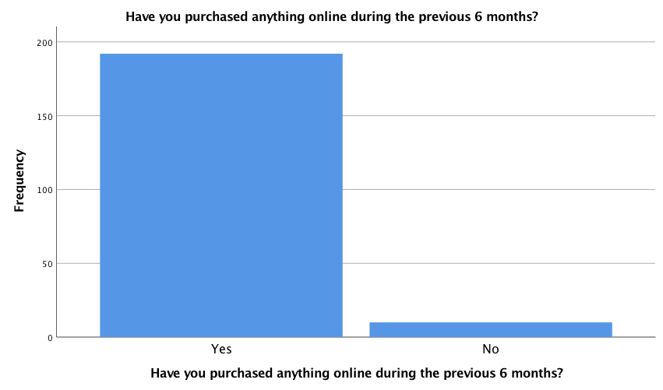
Figure ‎4.1 Recency of online purchases

Figure 4.2 shows that a small majority (56.9%) of the respondents preferred to pay for online purchases using their credit card, while 43.1 % of respondents preferred paying with PayPal.
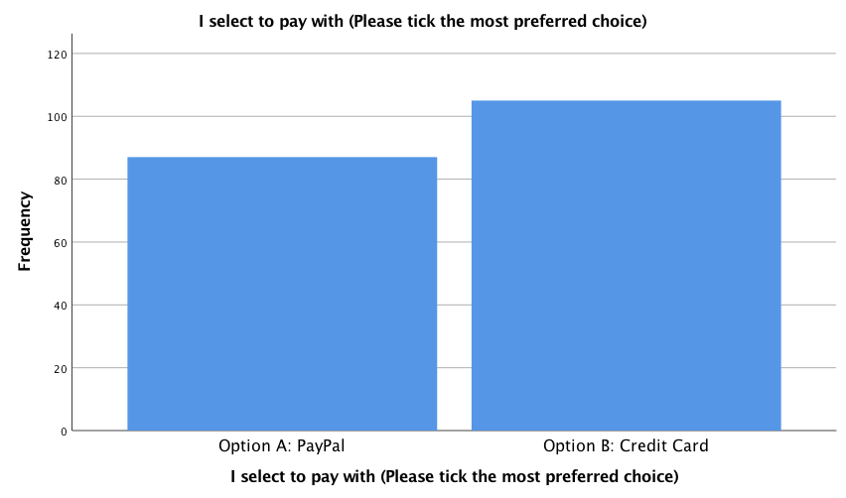
Figure ‎4.2 Preferred payment method
As for demographics, a majority of the respondents were female (Figure 4.3). 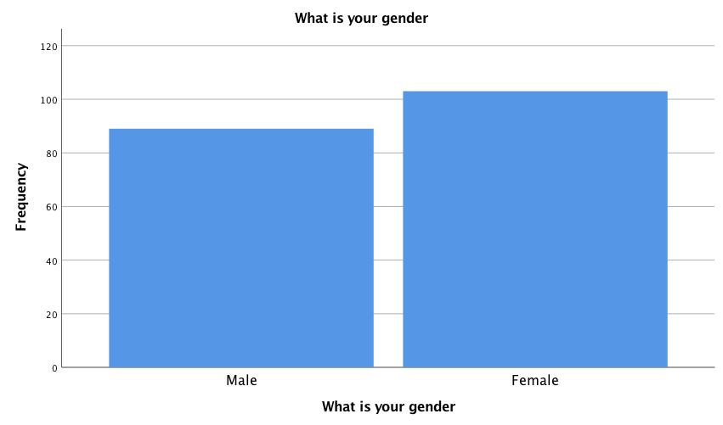
Figure ‎4.3 Demographic Indicators - Gender
Figure 4.4 shows that most respondents were below 55 years of age. The highest number of the respondents was of those aged between 36 and 55 years.
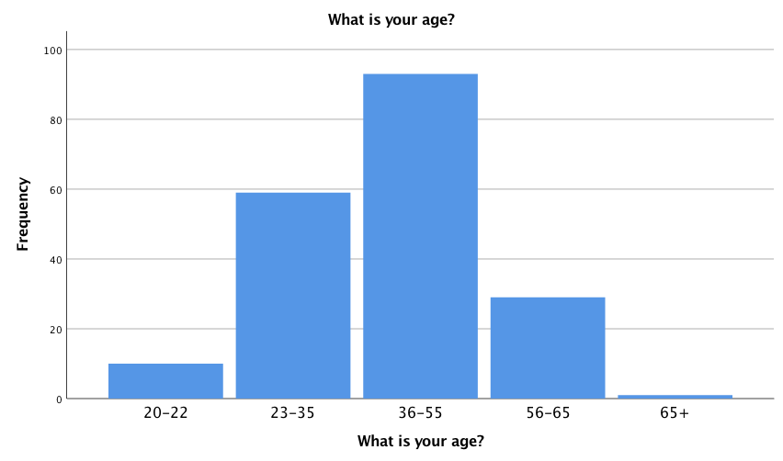
Figure ‎4.4 Demographic indicators - Age group

Most of the respondents (44.8%) were single (Figure 4.5). The number of married respondents is slightly lower than that of the single respondents.
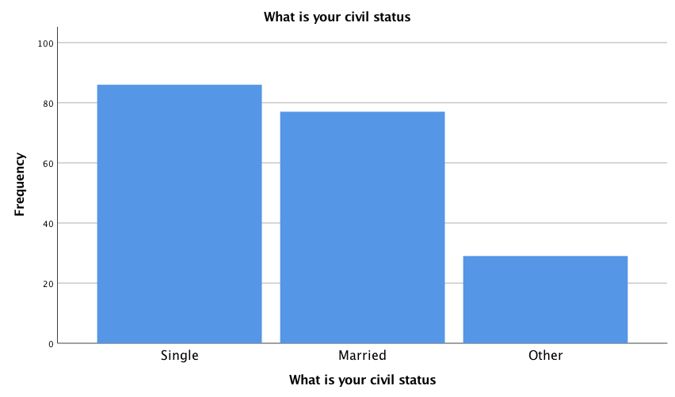
Figure ‎4.5 Demographic indicators - Civil status

The highest level of education for the majority of respondents is an undergraduate qualification (Figure 4.6). Only 0.5 % of these respondents had a PhD as highest qualification.
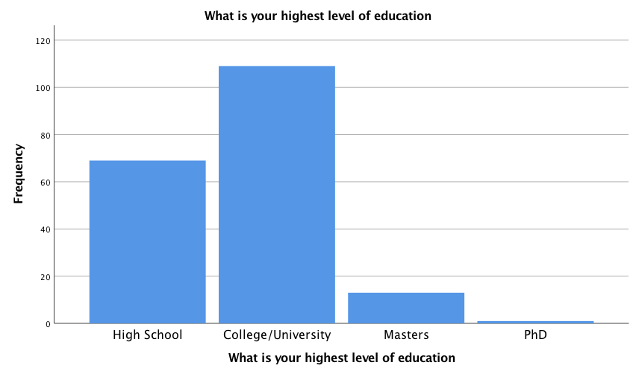
Figure ‎4.6 Demographic indicator - Level of education
Of the 202 respondents, the majority (113) was employed (Figure 5.7). Only 11.9% of the respondents were self-employed, and 27.2 % were not in paid employment.
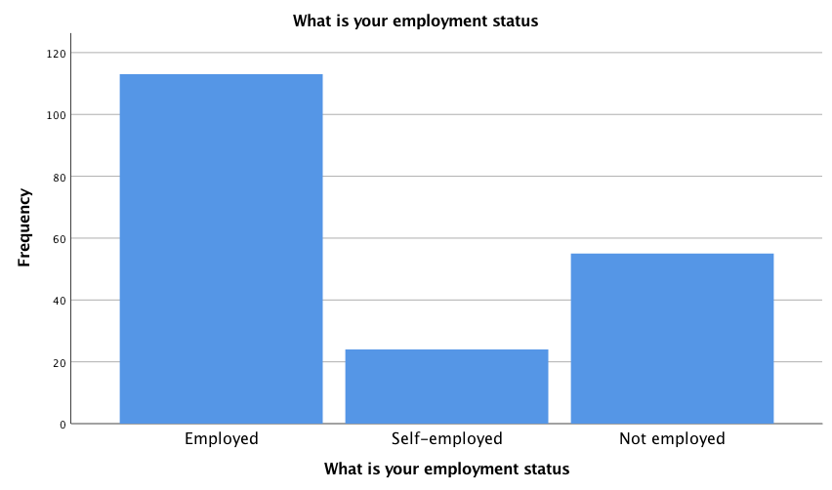
Figure ‎4.7 Demographic indicators - Employment status

Figure 4.8 on income shows that biggest income bracket is an annual income between $50,000 and $74, 999. However, overall, the majority of people earn an annual income of less than $50,000.
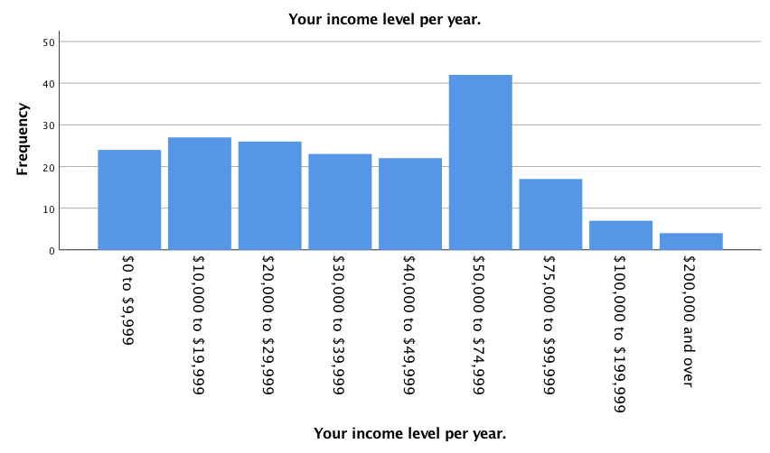
Figure ‎4.8 Demographic indicator - Annual income
The next set of figures look at how the respondents felt about using PayPal. The majority of respondents in the sample thought that learning to operate PayPal would be easy (Figure 4.9). The mean rating is 5.87.
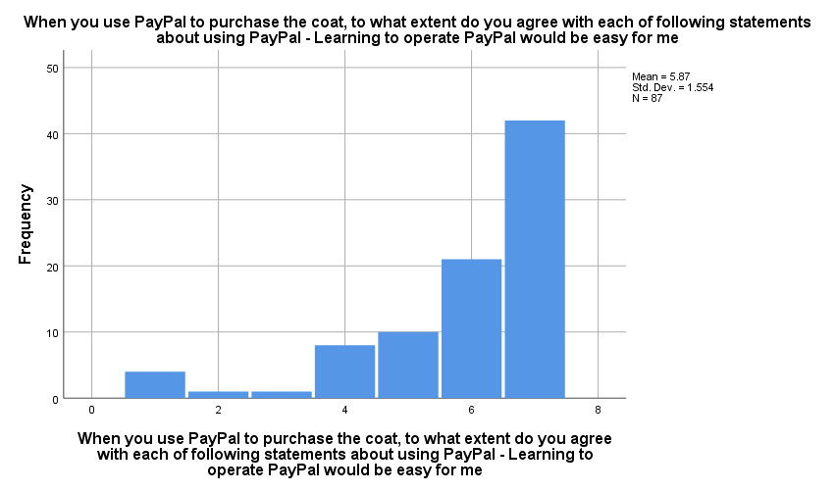
Figure ‎4.9 Ease of learning to use PayPal
Figure 4.10 shows how easy respondents thought it would be to get PayPal to do what they wanted, with a mean value of 5.86 on a 7-point scale, a majority of the respondents found it easy to get PayPal to do what they wanted it to.

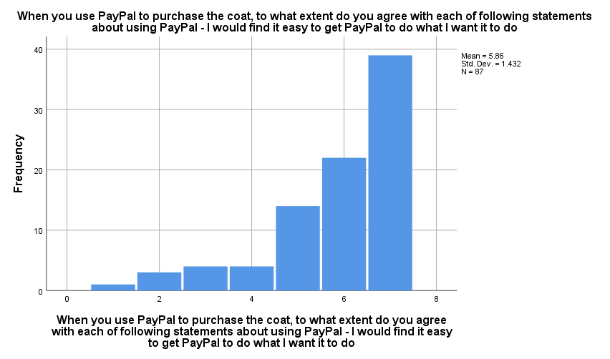
Figure ‎4.10 PayPal tractability
A clear majority of respondents described their interactions with PayPal as clear and understandable (Figure 4.11).

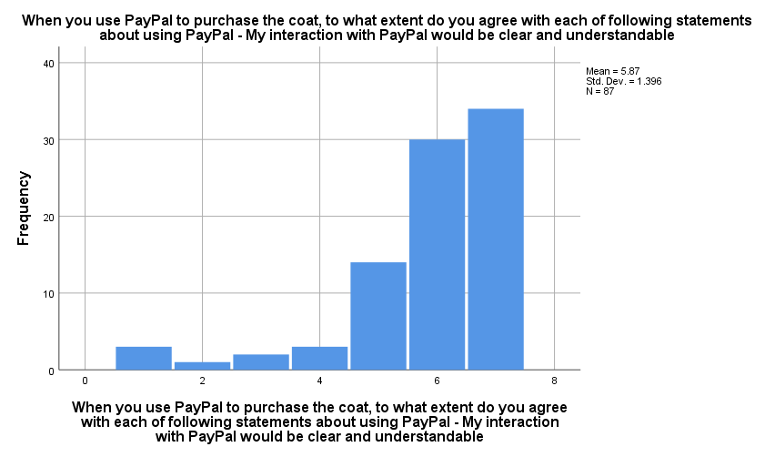
Figure ‎4.11 Interactions with PayPal are clear and comprehensible

With a mean of 5.7, most of the respondents expressed comfort with PayPal’s level of flexibility (Figure 4.12).
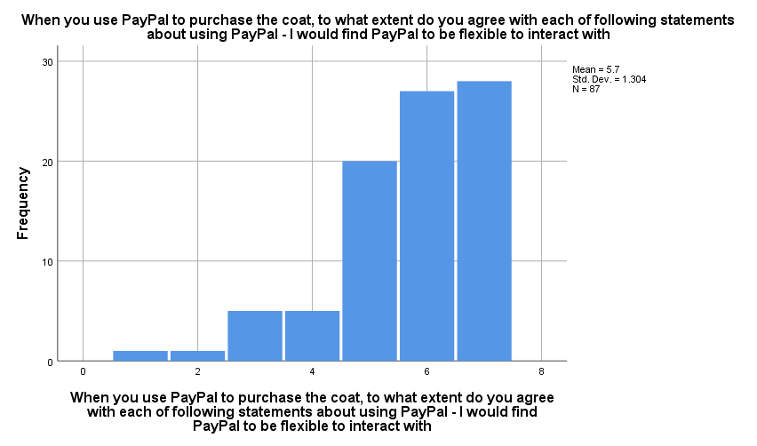
Figure ‎4.12 Flexibility of PayPal
With a 5.98 mean, a majority of the respondents express agreement in regard to becoming skillful at using PayPal (Figure 4.13).
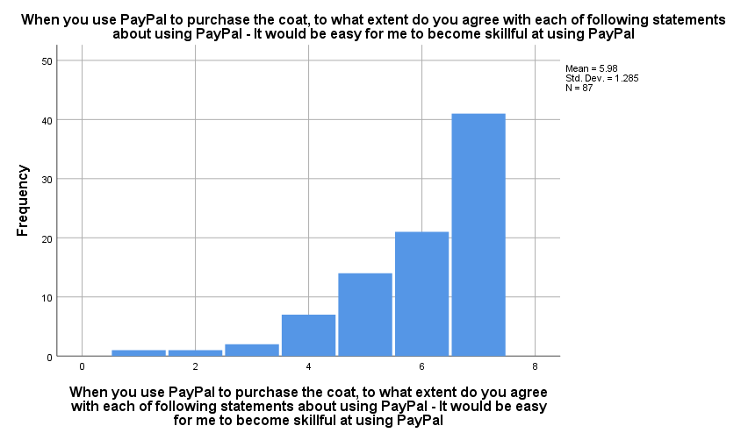
Figure ‎4.13 Ease of learning PayPal

PayPal’s ease of use scored a mean of 6.06; as a large majority of the sample found PayPal easy to use (Figure 4.14).
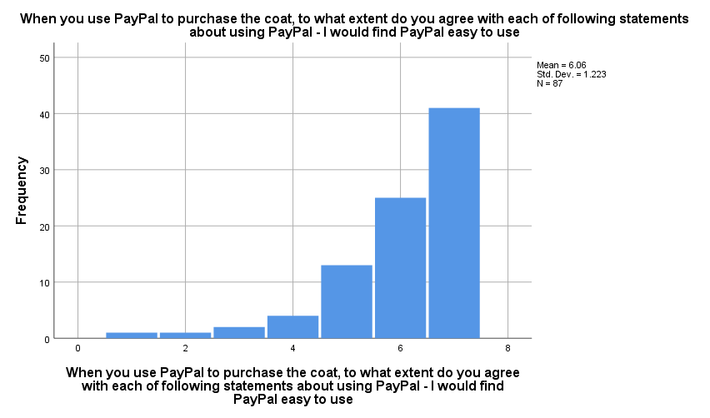
Figure ‎4.14 PayPal's perceived ease of use

Most of the respondents expressed a high level of trust in using PayPal services. When asked if they did not trust PayPal, the mean was only 3.09 (Figure 4.15).
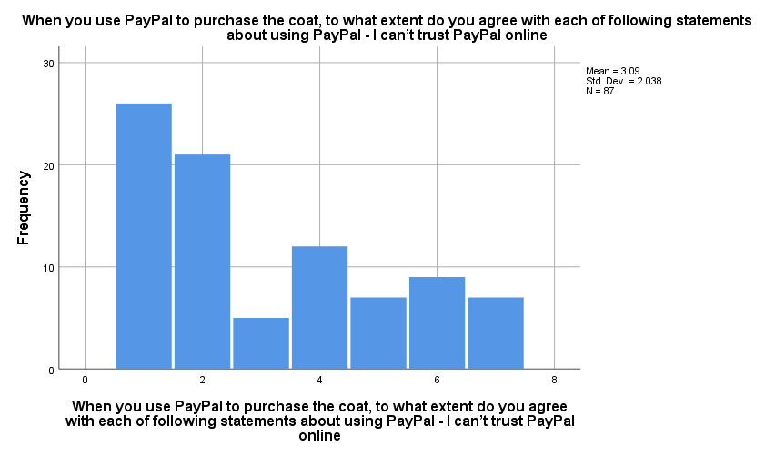
Figure ‎4.15 PayPal cannot be trusted online

With respect to the statement “My personal information may not be kept private”, no particular pattern was found, there being a spread of opinions across the range (Figure 4.16). The mean rating is 3.62.
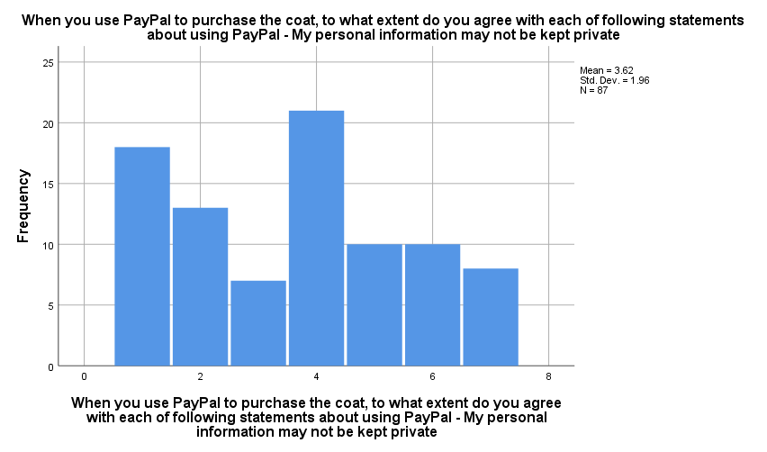
Figure ‎4.16 PayPal may not keep personal information private

On the other hand, with a mean of 2.99, most of respondents expressed confidence in the PayPal’s security measures when asked if PayPal were not secure (Figure 4.17). However, a small percentage of respondents expressed concerns.

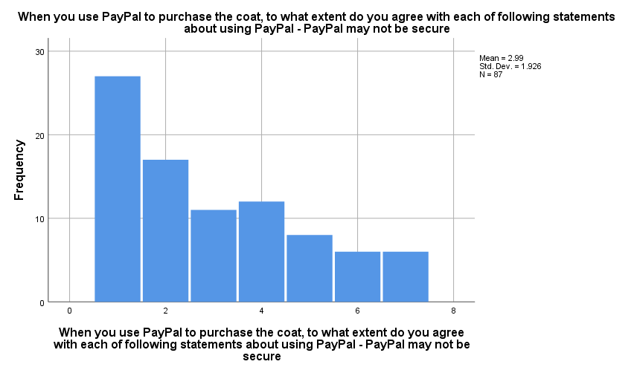
Figure ‎4.17 PayPal may not be secure

The next questions were pertaining to the use of credit cards. With a mean of 6.31, most respondents found it easy to learn to operate credit cards (Figure 4.18).

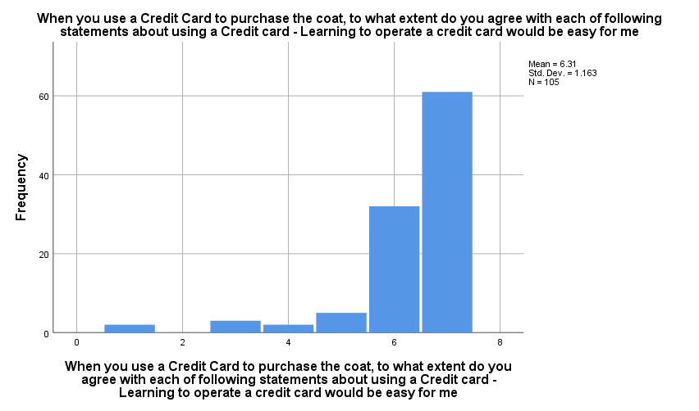
Figure ‎4.18 Credit cards - ease of operation
Most of the respondents believed it was easy to get a credit card to do what they wanted, the mean for this statement was 6.2 (Figure 4.19).
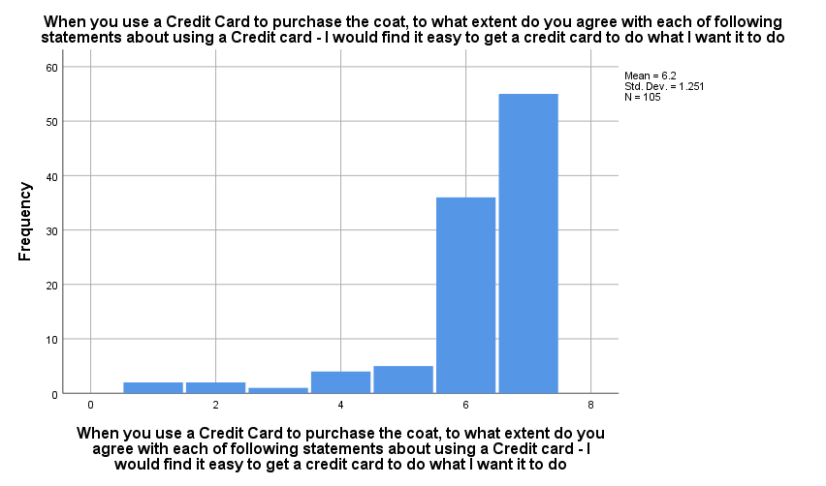
Figure ‎4.19 Credit card tractability
Figure 4.20, below, clearly shows that the majority of the respondents found their interactions with credit cards to be clear and understandable.
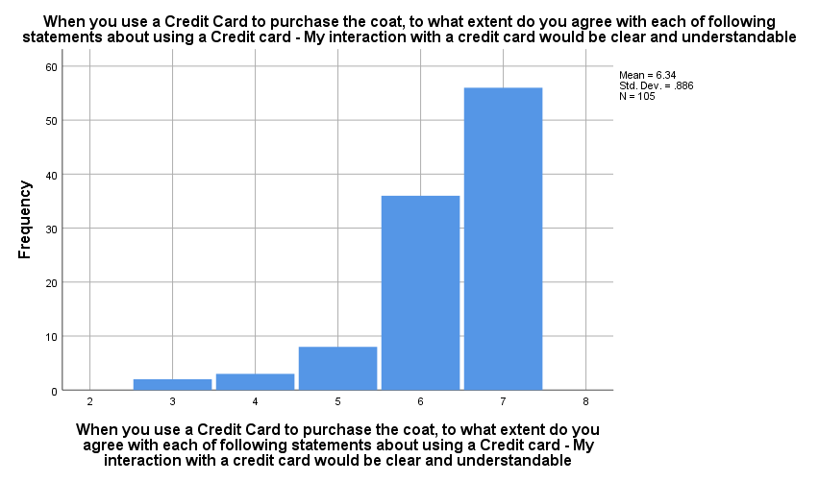
Figure ‎4.20 Interactions with credit cards are clear and understandable

With a mean of 6.1, most of the respondents thought of credit cards as a flexible tool with which to interact (Figure 4.21).
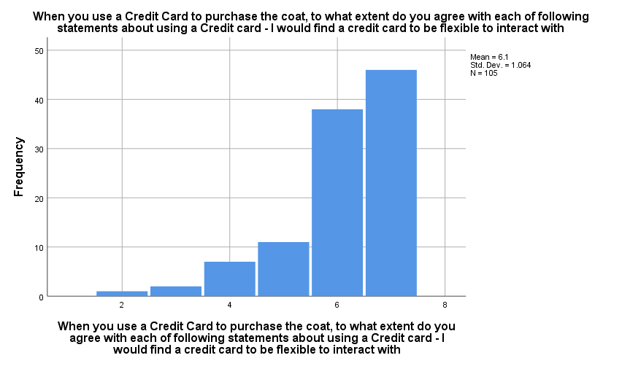
Figure ‎4.21 Credit card flexibility
In Figure 4.22 below we can see that, with a mean of 6.28, most respondents felt that it would be easy for them to gain skills in using a credit card.
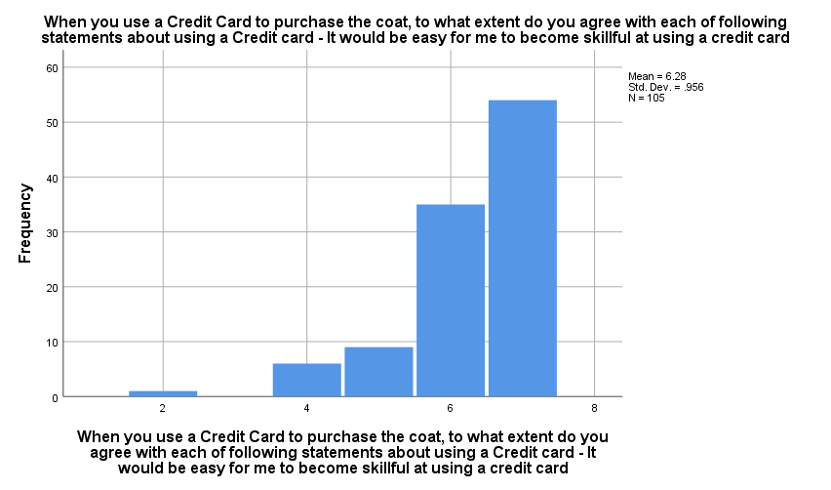
Figure ‎4.22 Ease of becoming skillful at using credit cards

Most of the respondents find credit cards easy to use, the mean of this statement being 6.4 (Figure 4.23).

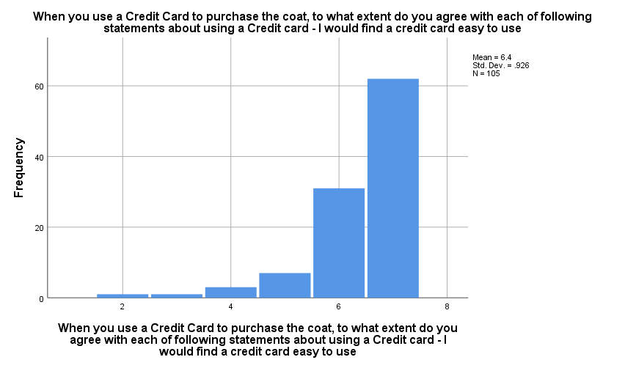
Figure ‎4.23 Credit card ease of use

With respect to the statement, “I can’t trust a credit card online”, opinions among the respondents was mixed and no particular trend in the responses can be noted (Figure 4.24).

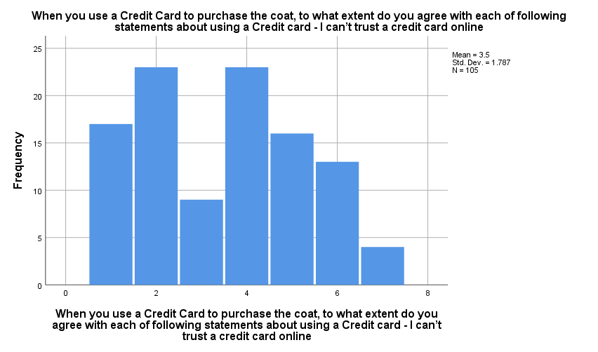
Figure ‎4.24 Level of trust in credit cards

Most of the respondents were not sure credit card companies would keep their personal information private, the mean was only 3.92 for this statement (Figure 4.25).
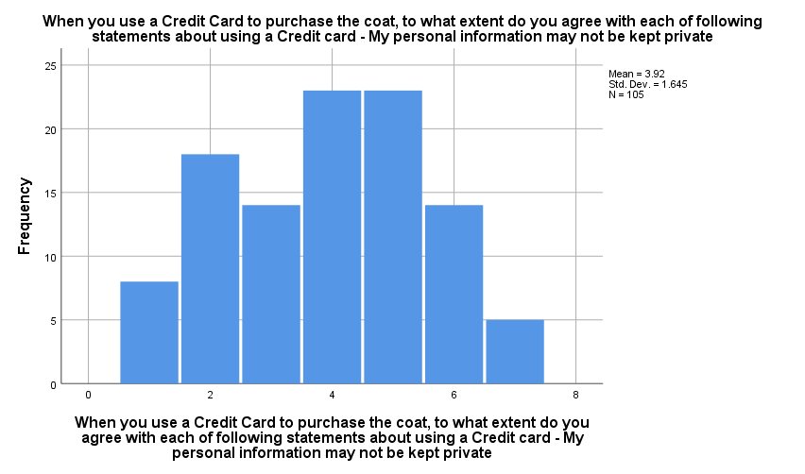
Figure ‎4.25 Privacy of personal information with credit cards

A majority of the respondents were unsure about the security of their credit card number when purchasing online, the mean being only 3.82 (Figure 4.26).

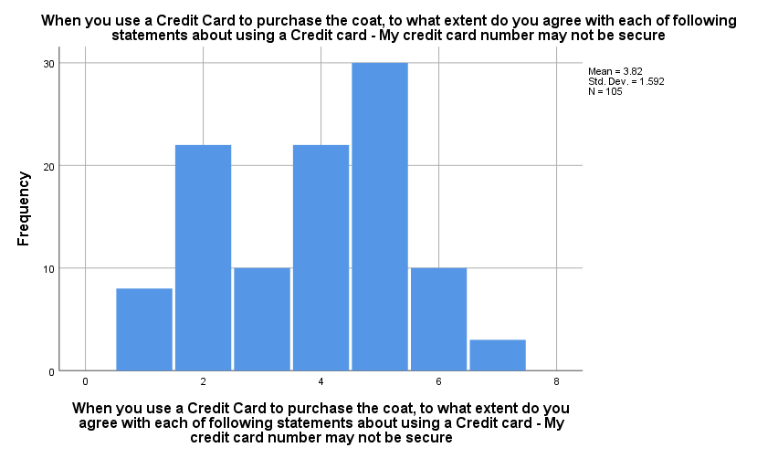
Figure ‎4.26 Security of credit card number during online shopping

Differences between PayPal and Credit Cards
Of the 193 respondents 87 chose to pay with PayPal, 106 chose to pay with a credit card. When rating the statement, “Learning to operate [PayPal/credit card] would be easy for me”, there was a statistically significant difference between PayPal and credit card: F (1, 191) = 5.234, p=.023 (Table 4.1). Credit cards (mean=6.32) were rated higher than PayPal (mean=5.87).

Table ‎4.1 Comparison of PayPal and credit cards on the 9 rating scale items
Statement | Payment Method | N | Mean | F | p
Learning to operate PayPal/credit card would be easy for me | PayPal | 87 | 5.87 | 5.234 | .023
 | Credit card | 106 | 6.32
I would find it easy to get PayPal/credit card to do what I want it to do/ I would find it easy to get a credit card to do what I want it to do | PayPal | 87 | 5.86 | 3.206 | .075
 | Credit card | 106 | 6.21
My interaction with PayPal/credit card would be clear and understandable/ My interaction with a credit card would be clear and understandable | PayPal | 87 | 5.87 | 8.264 | .005
 | Credit card | 106 | 6.53
I would find PayPal/credit card to be flexible to interact with/ I would find a credit card to be flexible to interact with | PayPal | 87 | 5.70 | 5.850 | .017
 | Credit card | 106 | 6.11
It would be easy for me to become skillful at using PayPal/credit card It would be easy for me to become skillful at using a credit card | PayPal | 87 | 5.98 | 3.599 | .059
 | Credit card | 106 | 6.28
I would find PayPal/credit card easy to use/ I would find a credit card easy to use | PayPal | 87 | 6.06 | 5.069 | .025
 | Credit card | 106 | 6.41
I can’t trust PayPal/credit card online/ I can’t trust a credit card online | PayPal | 87 | 3.02 | 3.503 | .063
 | Credit card | 106 | 3.54
My personal information may not be kept private | PayPal | 87 | 3.57 | 2.139 | .145
 | Credit card | 106 | 3.95

PayPal may not be secure/  My credit card number may not be secure | PayPal | 87 | 2.93 | 13.326 | .000
 | Credit card | 106 | 3.85

The respondents agreed that their interactions with both methods of payment would be clear and understandable. However, credit card method has a significantly higher mean, 6.53, while PayPal was 5.87, (F=8.264, p =.005). Both methods of payment were found to have a significant level of flexibility (F= 5.850, p =.017). The means for credit card and PayPal were 6.11 and 5.7 respectively. In this instance, the credit card method was still rated higher by a majority of the respondents. The ease of use factor was also similar for the two methods, there being only a narrow, small difference in the means, 0.35 (F= 3.599, p=.059). Finally, security was also an aspect where the two methods were nearly equal, the credit card recording a mean of 3.85 against PayPal’s 2.93 (F= 13.326, p=.000). Overall, from all nine statements, the credit card method consistently recorded higher means than PayPal. This supports the credit card method of payment being the choice of most of the respondents when compared with PayPal.

Descriptive Statistics
This table provides descriptive statistics to help clarify the difference between PayPal and Credit Cards in the Gucci coat scenario:
Table ‎4.2Descriptive statistics for Gucci coat scenario
Statement | Option |  | N | Mean | Std. Deviation | Std. Error | 95% Confidence Interval for Mean |  | Minimum | Maximum
 |  |  |  |  |  |  | Lower Bound | Upper Bound
Learning to operate PayPal/credit card would be easy for me |  | Option A: PayPal | 39 | 6.10 | 1.314 | .210 | 5.68 | 6.53 | 1 | 7
 |  | Option B: Credit Card | 56 | 6.20 | 1.381 | .184 | 5.83 | 6.57 | 1 | 7
 |  | Total | 95 | 6.16 | 1.347 | .138 | 5.88 | 6.43 | 1 | 7
I would find it easy to get PayPal/credit card to do what I want it to do |  | Option A: PayPal | 39 | 6.03 | 1.246 | .199 | 5.62 | 6.43 | 2 | 7
 |  | Option B: Credit Card | 56 | 6.05 | 1.420 | .190 | 5.67 | 6.43 | 1 | 7
 |  | Total | 95 | 6.04 | 1.344 | .138 | 5.77 | 6.32 | 1 | 7
My interaction with PayPal/credit card would be clear and understandable |  | Option A: PayPal | 39 | 6.10 | 1.119 | .179 | 5.74 | 6.47 | 2 | 7
 |  | Option B: Credit Card | 56 | 6.29 | 1.022 | .137 | 6.01 | 6.56 | 3 | 7
 |  | Total | 95 | 6.21 | 1.061 | .109 | 5.99 | 6.43 | 2 | 7
I would find PayPal/credit card to be flexible to interact with |  | Option A: PayPal | 39 | 5.77 | 1.224 | .196 | 5.37 | 6.17 | 3 | 7
 |  | Option B: Credit Card | 56 | 6.20 | 1.086 | .145 | 5.91 | 6.49 | 3 | 7
 |  | Total | 95 | 6.02 | 1.158 | .119 | 5.79 | 6.26 | 3 | 7
It would be easy for me to become skillful at using PayPal/credit card |  | Option A: PayPal | 39 | 5.92 | 1.156 | .185 | 5.55 | 6.30 | 3 | 7
 |  | Option B: Credit Card | 56 | 6.25 | 1.066 | .142 | 5.96 | 6.54 | 2 | 7
 |  | Total | 95 | 6.12 | 1.110 | .114 | 5.89 | 6.34 | 2 | 7
I would find PayPal/credit card easy to use |  | Option A: PayPal | 39 | 6.13 | 1.005 | .161 | 5.80 | 6.45 | 3 | 7
 |  | Option B: Credit Card | 56 | 6.34 | .978 | .131 | 6.08 | 6.60 | 3 | 7
 |  | Total | 95 | 6.25 | .989 | .101 | 6.05 | 6.45 | 3 | 7
I can’t trust PayPal/credit card online |  | Option A: PayPal | 39 | 2.69 | 1.749 | .280 | 2.13 | 3.26 | 1 | 7
 |  | Option B: Credit Card | 56 | 3.41 | 1.766 | .236 | 2.94 | 3.88 | 1 | 7
 |  | Total | 95 | 3.12 | 1.786 | .183 | 2.75 | 3.48 | 1 | 7
My personal information may not be kept private |  | Option A: PayPal | 39 | 3.26 | 1.712 | .274 | 2.70 | 3.81 | 1 | 6
 |  | Option B: Credit Card | 56 | 3.95 | 1.623 | .217 | 3.51 | 4.38 | 1 | 7
 |  | Total | 95 | 3.66 | 1.686 | .173 | 3.32 | 4.01 | 1 | 7
PayPal/credit card may not be secure |  | Option A: PayPal | 39 | 2.69 | 1.454 | .233 | 2.22 | 3.16 | 1 | 6
 |  | Option B: Credit Card | 56 | 3.75 | 1.575 | .211 | 3.33 | 4.17 | 1 | 7
 |  | Total | 95 | 3.32 | 1.606 | .165 | 2.99 | 3.64 | 1 | 7

Differences between PayPal and credit cards for the Gucci Scenario (ANOVA)
ANOVA enables a comparison of means between groups and within groups (PayPal/ credit cards) for the high-priced, branded (Gucci) scenario. Table 4.4 presented below shows findings from the one-way ANOVAs. The table shows if the difference between responses is significant or not. In this regard, if the p value (sig) is less than 0.05 then the difference between PayPal and credit cards is significant. Findings from analysis of variance in this case show a considerable difference compared to the previous ANOVA findings. In this case, except for statements 4, 5, 7 and 8, the p values show a significant difference in the mean values of the groups being analyzed.

Table ‎4.3 ANOVA analysis of Gucci scenario
Statements |  | Sum of Squares | df | Mean Square | F | Sig.
Learning to operate PayPal/credit card would be easy for me | Between Groups | 14.614 | 1 | 14.614 | 8.122 | .005
 | Within Groups | 172.733 | 96 | 1.799
 | Total | 187.347 | 97
I would find it easy to get PayPal/credit card to do what I want it to do | Between Groups | 10.373 | 1 | 10.373 | 6.026 | .016
 | Within Groups | 165.259 | 96 | 1.721
 | Total | 175.633 | 97
My interaction with PayPal/credit card would be clear and understandable | Between Groups | 13.140 | 1 | 13.140 | 8.979 | .003
 | Within Groups | 140.493 | 96 | 1.463
 | Total | 153.633 | 97
I would find PayPal/credit card to be flexible to interact with | Between Groups | 3.429 | 1 | 3.429 | 2.319 | .131
 | Within Groups | 141.959 | 96 | 1.479
 | Total | 145.388 | 97
It would be easy for me to become skillful at using PayPal/credit card | Between Groups | 2.192 | 1 | 2.192 | 1.699 | .196
 | Within Groups | 123.859 | 96 | 1.290
 | Total | 126.051 | 97
- I would find PayPal/credit card easy to use | Between Groups | 5.642 | 1 | 5.642 | 4.283 | .041
 | Within Groups | 126.480 | 96 | 1.318
 | Total | 132.122 | 97
I can’t trust PayPal/credit card online | Between Groups | 3.693 | 1 | 3.693 | .903 | .344
 | Within Groups | 392.797 | 96 | 4.092
 | Total | 396.490 | 97
My personal information may not be kept private | Between Groups | .393 | 1 | .393 | .109 | .742
 | Within Groups | 346.587 | 96 | 3.610
 | Total | 346.980 | 97
PayPal/credit card may not be secure | Between Groups | 17.075 | 1 | 17.075 | 4.615 | .034
 | Within Groups | 355.170 | 96 | 3.700
 | Total | 372.245 | 97

Descriptive statistics for the unbranded coat scenario
This table provides descriptive statistics to understand the difference between PayPal and credit cards, for the unbranded coat scenario:
Table ‎4.4 Descriptive statistics for the unbranded coat scenario
Statement and options |  | N | Mean | Std. Deviation | Std. Error | 95% Confidence Interval for Mean |  | Minimum | Maximum
 |  |  |  |  |  | Lower Bound | Upper Bound
Learning to operate PayPal/credit card would be easy for me. | Option A: PayPal | 48 | 5.69 | 1.715 | .248 | 5.19 | 6.19 | 1 | 7
 | Option B: Credit Card | 50 | 6.46 | .838 | .119 | 6.22 | 6.70 | 3 | 7
 | Total | 98 | 6.08 | 1.390 | .140 | 5.80 | 6.36 | 1 | 7
I would find it easy to get PayPal/credit card to do what I want it to do | Option A: PayPal | 48 | 5.73 | 1.567 | .226 | 5.27 | 6.18 | 1 | 7
 | Option B: Credit Card | 50 | 6.38 | 1.008 | .143 | 6.09 | 6.67 | 1 | 7
 | Total | 98 | 6.06 | 1.346 | .136 | 5.79 | 6.33 | 1 | 7
My interaction with PayPal/credit card would be clear and understandable | Option A: PayPal | 48 | 5.69 | 1.573 | .227 | 5.23 | 6.14 | 1 | 7
 | Option B: Credit Card | 50 | 6.42 | .702 | .099 | 6.22 | 6.62 | 4 | 7
 | Total | 98 | 6.06 | 1.259 | .127 | 5.81 | 6.31 | 1 | 7
I would find PayPal/credit card to be flexible to interact with | Option A: PayPal | 48 | 5.65 | 1.376 | .199 | 5.25 | 6.05 | 1 | 7
 | Option B: Credit Card | 50 | 6.02 | 1.040 | .147 | 5.72 | 6.32 | 2 | 7
 | Total | 98 | 5.84 | 1.224 | .124 | 5.59 | 6.08 | 1 | 7
It would be easy for me to become skillful at using PayPal/credit card | Option A: PayPal | 48 | 6.02 | 1.391 | .201 | 5.62 | 6.42 | 1 | 7
 | Option B: Credit Card | 50 | 6.32 | .819 | .116 | 6.09 | 6.55 | 4 | 7
 | Total | 98 | 6.17 | 1.140 | .115 | 5.94 | 6.40 | 1 | 7
I would find PayPal/credit card easy to use | Option A: PayPal | 48 | 6.00 | 1.384 | .200 | 5.60 | 6.40 | 1 | 7
 | Option B: Credit Card | 50 | 6.48 | .863 | .122 | 6.23 | 6.73 | 2 | 7
 | Total | 98 | 6.24 | 1.167 | .118 | 6.01 | 6.48 | 1 | 7
I can’t trust PayPal/credit card online | Option A: PayPal | 48 | 3.29 | 2.173 | .314 | 2.66 | 3.92 | 1 | 7
 | Option B: Credit Card | 50 | 3.68 | 1.867 | .264 | 3.15 | 4.21 | 1 | 7
 | Total | 98 | 3.49 | 2.022 | .204 | 3.08 | 3.90 | 1 | 7
My personal information may not be kept private | Option A: PayPal | 48 | 3.83 | 2.066 | .298 | 3.23 | 4.43 | 1 | 7
 | Option B: Credit Card | 50 | 3.96 | 1.726 | .244 | 3.47 | 4.45 | 1 | 7
 | Total | 98 | 3.90 | 1.891 | .191 | 3.52 | 4.28 | 1 | 7
PayPal/credit card may not be secure | Option A: PayPal | 48 | 3.13 | 2.160 | .312 | 2.50 | 3.75 | 1 | 7
 | Option B: Credit Card | 50 | 3.96 | 1.665 | .236 | 3.49 | 4.43 | 1 | 7
 | Total | 98 | 3.55 | 1.959 | .198 | 3.16 | 3.94 | 1 | 7

Differences between PayPal and credit cards for the unbranded scenario (ANOVA)
Applying the same rule, as in the previous section, the significance of the difference between mean values of the two groups (PayPal/ credit cards) can be understood in the case of purchasing the unbranded coat. Apart from the last two statements, there is no significant difference between the mean values of responses from the two groups.
Table ‎4.5 ANOVA analyses of unbranded coat scenario
Statement |  | Sum of Squares | df | Mean Square | F | Sig.
Learning to operate PayPal/credit card would be easy for me | Between Groups | .203 | 1 | .203 | .111 | .740
 | Within Groups | 170.429 | 93 | 1.833
 | Total | 170.632 | 94
I would find it easy to get PayPal/credit card to do what I want it to do | Between Groups | .018 | 1 | .018 | .010 | .921
 | Within Groups | 169.814 | 93 | 1.826
 | Total | 169.832 | 94
My interaction with PayPal/credit card would be clear and understandable | Between Groups | .771 | 1 | .771 | .683 | .411
 | Within Groups | 105.018 | 93 | 1.129
 | Total | 105.789 | 94
I would find PayPal/credit card to be flexible to interact with | Between Groups | 4.196 | 1 | 4.196 | 3.204 | .077
 | Within Groups | 121.762 | 93 | 1.309
 | Total | 125.958 | 94
It would be easy for me to become skillful at using PayPal/credit card | Between Groups | 2.457 | 1 | 2.457 | 2.017 | .159
 | Within Groups | 113.269 | 93 | 1.218
 | Total | 115.726 | 94
I would find PayPal/credit card easy to use | Between Groups | 1.024 | 1 | 1.024 | 1.048 | .309
 | Within Groups | 90.913 | 93 | .978
 | Total | 91.937 | 94
I can’t trust PayPal /credit card online | Between Groups | 11.865 | 1 | 11.865 | 3.833 | .053
 | Within Groups | 287.861 | 93 | 3.095
 | Total | 299.726 | 94
My personal information may not be kept private | Between Groups | 10.946 | 1 | 10.946 | 3.972 | .049
 | Within Groups | 256.275 | 93 | 2.756
 | Total | 267.221 | 94
PayPal/credit card may not be secure | Between Groups | 25.719 | 1 | 25.719 | 11.032 | .001
 | Within Groups | 216.808 | 93 | 2.331
 | Total | 242.526 | 94

Comparison between branded and unbranded scenarios

Table ‎4.6 Comparison of branded and unbranded scenarios on the 9 rating scale statements
Statement | Scenario | F | p
Learning to operate PayPal would be easy for me/ Learning to operate a credit card would be easy for me | Gucci | 8.122 | .005
 | Unbranded | .111 | .740
I would find it easy to get PayPal to do what I want it to do/ I would find it easy to get a credit card to do what I want it to do | Gucci | 6.026 | .016
 | Unbranded | .010 | .921
My interaction with PayPal would be clear and understandable/ My interaction with a credit card would be clear and understandable | Gucci | 8.979 | .003
 | Unbranded | .638 | .411
I would find PayPal to be flexible to interact with/ I would find a credit card to be flexible to interact with | Gucci | 2.319 | .131
 | Unbranded | 3.204 | .077
It would be easy for me to become skillful at using PayPal/ It would be easy for me to become skillful at using a credit card | Gucci | 1.699 | .196
 | Unbranded | 2.017 | .159
I would find PayPal easy to use/ I would find a credit card easy to use | Gucci | 4.283 | .041
 | Unbranded | 1.048 | .309
I can’t trust PayPal online/ I can’t trust a credit card online | Gucci | .903 | .344
 | Unbranded | 3.833 | .053
My personal information may not be kept private/ My personal information may not be kept private | Gucci | .109 | .742
 | Unbranded | 3.972 | .049
PayPal may not be secure/ | Gucci | 4.615 | .034
My credit card number may not be secure | Unbranded | 11.032 | .001

Table 4.6 shows that the significant difference between rating of Paypal and credit card largely relates to the high-priced, branded Gucci coat scenario.

Demographic differences in choice of payment method

Table ‎4.7 Analysis of payment choice by demographic indicator
Demographic identifier | Chi-square | df | p
Age | 3.354 | 4 | .500
Civil status | 3.364 | 2 | .186
Education | 3.395 | 3 | .335
Employment | .448 | 2 | .799
Income | 13.225 | 8 | .104
Gender | 8.223 | 1 | .004

Cross tabulations with chi-square tests were run to investigate whether demographic variables could predict the choice of PayPal versus credit card.. Out of all the demographic variables examined, only gender presented a significant difference in regard to the choice between PayPal and credit card with chi-squar =8.223, df=1, p=.004. This translates to men being more likely to select PayPal whereas women are more likely to choose credit card.

Factors which most strongly predict choice of payment method
Logistic regression was undertaken to see which factors (e.g. ease of payment, security) most strongly predicted choice of payment method
Table 4.9 reminds us about the sample of respondents and their preferred method of payment. Out of the 202 respondents in the research, 106 of them preferred using credit card over PayPal. Credit card users represent 53 % of total respondents compared to 47 % who prefer PayPal.

Table ‎4.8 Preferences for payment method
 |  |  |  | I select to pay with (Please tick the most preferred choice)
 |  |  |  | Option A: PayPal |  | Option B: Credit Card |  | Percentage Correct
Step 0 | I select to pay with (Please tick the most preferred choice) | Option A: PayPal | 0 |  | 87 |  | .0
 |  | Option B: Credit Card | 0 |  | 106 |  | 100.0
 | Overall Percentage |  |  |  |  |  |  | 54.9

Table 4.10 shows the results of the logistic regression. Using information on the various factors that might predict choice of payment method, a logistic regression is built (in two steps) that successfully predicts 67.9 percent of cases.
Table ‎4.9 Results of the logistic regression (1)
 | Observed |  |  | Predicted
 |  |  |  | I select to pay with (Please tick the most preferred choice)
 |  |  |  | Option A: PayPal |  | Option B: Credit Card |  | Percentage Correct
Step 1 | I select to pay with (Please tick the most preferred choice) | Option A: PayPal | 45 |  | 42 |  | 51.7
 |  | Option B: Credit Card | 30 |  | 76 |  | 71.7
 | Overall Percentage |  |  |  |  |  |  | 62.7
Step 2 | I select to pay with (Please tick the most preferred choice) | Option A: PayPal | 54 |  | 33 |  | 62.1
 |  | Option B: Credit Card | 29 |  | 77 |  | 72.6
 | Overall Percentage |  |  |  |  |  |  | 67.9

Table 4.11 shows two factors are responsible for this high prediction rate – firstly “My interaction with PayPal/credit card would be clear and understandable” and secondly “PayPal/credit card may not be secure”.

 |  |  |  | Equation variables
 |  |  |  |  | B |  | S.E. |  | Wald |  | df |  | Sig |  | Exp(B)
Step 1 |  | –PayPal/credit card may not be secure |  |  |  | .301 |  | .087 |  | 12.057 |  | 1 |  | .001 | 1.351
 | Constant |  |  |  |  | -.821 |  | .325 |  | 6.387 |  | 1 |  | .011 | .440
Step 2 | My interaction with PayPal/credit card would be clear and understandable |  |  |  |  | .628 |  | .175 |  | 12.910 |  | 1 |  | .000 | 1.875
 | –PayPal/credit card may not be secure |  |  |  |  | .429 |  | .100 |  | 18.445 |  | 1 |  | .000 | 1.536
 | Constant |  |  |  |  | -5.115 |  | 1.265 |  | 16.348 |  | 1 |  | .000 | .006
Table ‎4.10 Results of the logistic regression (2)

Chapter 5 - Discussion
After presenting the findings from analysis of the primary data, it is now possible to discuss these findings in line with the research questions, literature reviewed and research hypotheses. First of all, it is pertinent to note in the findings that a considerable number of respondents indicated that they do make purchases through online means - using credit card or PayPal for making payments for online purchases. When these findings are reviewed in light of the literature reviewed, it can be noted that payment methods and consumers’ buying trends have evolved over time. As noted by Brunnermeier & Schnabel (2015), payment methods have evolved from barter to currency-based transactions, and then to plastic money which gives consumers greater access to global markets.

Online shopping occurrence
The findings obtained in the survey also indicate that people generally prefer using online payment methods, irrespective of the online payment method being used. These findings are in line with what Bertola et al., (2016) mentioned in their work, they estimated that the probability that an individual will have a credit card has increased from 0.63 in 1983 to 0.78 in 2001, and by the year 2016, this probability has matured at 0.8. This indicates that the use of credit cards has continually risen, with almost 80 % of people in developed countries having and using credit cards as a payment method. A similar trend has been noted by Bertola et al. (2016) that online purchasing has also been consistently increasing and has reached a user base of 1.66 billion people with online sales amounting to US$2.3 trillion in 2017, and this trend suggests a projection that by 2021 online sales will reach US$4.48 trillion (Statista, 2018). These statements complement the findings obtained in this study as users have shown a strong inclination towards online payment methods while shopping.
The first question in the survey was an inquiry about online purchasing, and it asked “Have you purchased anything online during the previous 6 months?” The responses to this question indicated that 95 percent of the respondents shopped online. This shows a considerably high percentage of the sample selected for this study shopping online.
The questionnaire asked the respondents about the ease of use with respect to credit card and a majority of respondents regarded credit card as an easy payment option and one that is easy to learn how to use. A very high mean value of 6.3 was determined implying credit cards being perceived as easy to use. In addition around 57 percent of respondents said they preferred to use credit cards over PayPal.
There is another interesting finding noted in this regard, which was that most of the respondents in the survey were employed with only 11.9 percent self-employed and 27.2 percent unemployed. The significance of this can be realized when linked with the literature reviewed. As noted in Chapter 2, Cruijsen et al., (2017) reported that it is usually the employed that uses credit cards more in developed countries as they receive their remuneration on a monthly basis. As employed people have month to month budgeting of their income and expenditure, their expenses can exceed their monthly salary. With the credit card facility they can cover these payments. This suggests that people who are employed are more likely to opt for credit cards than any other payment methods.

Shopping scenarios
After the first question, the researcher presented two different scenarios to the respondents:
Upon reviewing the overall responses, only 43 percent of respondents preferred paying through PayPal, whilst 57 percent of respondents chose credit card payment. These findings are not enough to draw conclusion as to which factors influenced the majority of respondents to prefer making payment through credit card (as opposed to PayPal). To understand the reasons behind these choices, the next section covered the responses to statements (in Questions 3 and 4) in light of the literature review.

Determinants for payment method choice
In order to further understand why respondents select PayPal or credit card as their preferred mode of payment while shopping online, 9 different determinants were given as a basis for their choice of payment method. The following table shows how respondents answered each of the statements in Questions 3 and 4.
Table ‎4.11 Answers to Questions 3 and 4
 | PayPal |  |  | Credit Card
 | Statement | Mean | Standard Deviation | Statement | Mean | Standard Deviation
1 | Learning to operate PayPal would be easy for me | 6.10 | 1.314 | Learning to operate a credit card would be easy for me | 6.20 | 1.381
2 | I would find it easy to get PayPal to do what I want it to do | 6.03 | 1.246 | I would find it easy to get a credit card to do what I want it to do | 6.05 | 1.420
3 | My interaction with PayPal would be clear and understandable | 6.10 | 1.119 | My interaction with a credit card would be clear and understandable | 6.29 | 1.022
4 | I would find PayPal to be flexible to interact with | 5.77 | 1.224 | I would find a credit card to be flexible to interact with | 6.20 | 1.086
5 | It would be easy for me to become skillful at using PayPal | 5.92 | 1.156 | It would be easy for me to become skillful at using a credit card | 6.25 | 1.066
6 | I would find PayPal easy to use | 6.13 | 1.005 | I would find a credit card easy to use | 6.34 | 0.978
7 | I can’t trust PayPal online | 2.69 | 1.749 | I can’t trust a credit card online | 3.41 | 1.766
8 | My personal information may not be kept private | 3.26 | 1.712 | My personal information may not be kept private | 3.95 | 1.623
9 | PayPal may not be secure | 2.69 | 1.454 | My credit card number may not be secure | 3.75 | 1.575

Error! Reference source not found. above shows the mean and standard deviation values in relation to each of the statements presented in Questions 3 and 4 of the survey questionnaire. It is pertinent to note here that respondents have shown a greater extent of agreement or likelihood towards statements pertaining to the use of credit card as a payment method. This implies that they have more confidence in making payments through credit cards for online purchases. When comparing the mean values from the two columns, it can be noted that in most cases respondents have responded with higher values on average for credit cards as compared to PayPal. Specifically, flexibility of use, ease of learning, ease of use, clarity and understanding, becoming skillful at using, trust, privacy and security, all have considerable differences in mean values.
The analysis of variance is helpful in gaining an understanding as to the significance of the differences in the mean values of responses attributable to PayPal and credit card. This further enables coming to a conclusion about which factors show significant difference in the mean values and can be deemed as the determinants of the choice of payment methods for customers shopping online.
The table presented below shows which factors have a significantly different mean values and which factors show an insignificant difference.

Table ‎4.12Mean and Significance of Difference
 | Statement | Mean | Statement | Mean | Significance of Difference
1 | Learning to operate PayPal would be easy for me | 6.10 | Learning to operate a credit card would be easy for me | 6.20 | P value = 0.005, which is < 0.05  Mean difference is Significant
2 | I would find it easy to get PayPal to do what I want it to do | 6.03 | I would find it easy to get a credit card to do what I want it to do | 6.05 | P value = 0.016, which is < 0.05  Mean difference is Significant
3 | My interaction with PayPal would be clear and understandable | 6.10 | My interaction with a credit card would be clear and understandable | 6.29 | P value = 0.003, which is < 0.05  Mean difference is Significant
4 | I would find PayPal to be flexible to interact with | 5.77 | I would find a credit card to be flexible to interact with | 6.20 | P value = 0.131, which is < 0.05  Mean difference is Significant
5 | It would be easy for me to become skillful at using PayPal | 5.92 | It would be easy for me to become skillful at using a credit card | 6.25 | P value = 0.196, which is > 0.05  Mean difference is not Significant
6 | I would find PayPal easy to use | 6.13 | I would find a credit card easy to use | 6.34 | P value = 0.041, which is < 0.05  Mean difference is Significant
7 | I can’t trust PayPal online | 2.69 | I can’t trust a credit card online | 3.41 | P value = 0.344, which is > 0.05  Mean difference is not Significant
8 | My personal information may not be kept private | 3.26 | My personal information may not be kept private | 3.95 | P value = 0.742, which is > 0.05  Mean difference is not Significant
9 | PayPal may not be secure | 2.69 | My credit card number may not be secure | 3.75 | P value = 0.034, which is < 0.05  Mean difference is Significant

Referring to the Error! Reference source not found., it can be noted that there is a significant difference in the mean values of the responses for statements pertaining to PayPal and credit card preferences respectively. Respondents view credit cards as significantly better than PayPal as a payment method for online shopping, due to ease of use, ease of learning, operation, clarity and understanding, flexibility and security.
In other words, these findings suggest that customers who are shopping online would prefer making their payments through a payment mode which is easy to use, flexible, easy to learn and adopt, clear and easy to understand, and secure. These factors can be related back to the literature reviewed.
The researcher discussed the Technology Acceptance Model (TAM) (Trutsch, 2017) in the literature review which provides a framework with which the increasing use of different and innovative technologies can be defined. The TAM is guided by two important factors: ease of use and usefulness. Usefulness is perceived by the consumer on the basis that a technology will enhance the personal efficiency and effectiveness, whereas the ease of use implies the extent to which a person will be free from effort (Trutsch, 2017). This shows that findings in this study comply with the model’s framework. Moreover, Liebana-Cabanillas et al. (2014) noted in their work that enhanced payment facility , reduced transaction costs and better record keeping are important determinants of perceived usefulness. This is in line with the results of this research work where the researcher found that ease of use, flexibility and security are among the key determinants in choosing payment methods for online shopping.
In addition to these factors, another important observation can be made regarding consumers’ behaviour and choice of payment method. Referring back to the literature review, it has been noted in many studies that people are willing to pay more with a credit card and this is for two reasons: there is a temporal separation between payment and consumption, and second is the way money is being represented (Cheng & Chen, 2016). This means where a mental separation exists between payment and the money itself, consumers are inclined to opt for the same. This holds true for credit cards, as a PayPal user must allocate funds to his or her PayPal account before making a purchase. Therefore, another factor which is identified in determining the choice of online payment method for customers is a temporal separation between payment and consumption.
By comparing branded and unbranded scenarios, it is clear that the branded, in that case expensive purchase has more statistical significant differences in the use of PayPal and credit card compared to the unbranded, less expensive purchase. This implies that consumers are more reserved to engage online payment for the cases they are likely to lose more money than the cases they may lose lesser. Another issue was that of demographic effects on the choices of use of different methods of payment (PayPal versus credit card). The study reveals gender as the only identifiable demographic factor that caused difference in the choice between PayPal and credit card. It reveals that men are likely to engage PayPal as their preferred mode of payment than women. On the other hand, women are likely to use credit card than men as their mode of online payment. In this revelation, credit card, a conservative approach to payment, reveal women are less reluctant to adopt new methods of payment. On the other hand, PayPal, a modern way of payment, shows that men are more accepting of the emerging online methods of payment. Finally, in the logistic regression analysis, the factors that lead to the adoption of different online payment methods are clear. For instance, clear and understandable interaction with the mode of payment and security of the mode of payment are the factors making the consumers to choose PayPal and credit card on different occasions. For the method with ease in understanding and high security, consumers tend to trust it with the purchase even of high amount than the method with unclear and complicated processes or lesser security to its features.

Chapter Summary
As mentioned in the Chapter 1, this study aims to understand the factors that affect the choice of payment method and those factors which influence the method of payment choice when consumers purchase online or in retail stores. The researcher has put forward findings obtained through the analysis of primary data obtained by surveying a sample of respondents for this purpose. The findings have been discussed in light of the research aim and have been linked back to the literature review. The majority of the respondents have indicated that they prefer making online payments with credit cards over payments made through PayPal. In addition, the findings in this research work suggest that customers who are shopping online would prefer a payment method which is easy to use, flexible, easy to learn and adopt, clear and easy to understand and secure. Another factor identified in determining cutomers’ choice of online payment method, is a temporal separation between payment and consumption.

Chapter 6 - Conclusion and Recommendations
The conclusion presented in this chapter combines the findings from the data analysis, discussion of findings in light of the research questions and literature review and results obtained thereby. The chapter also includes recommendations for managers and future researchers based on the conclusions and limitations associated with this study.

Limitations of the Research
The following are the limitations of this study:
- Only two methods of online payment, PayPal and credit cards, were used, therefore consumers’ perceptions related to other payment methods could not be evaluated or understood.
- As only respondents from New Zealand were included, so the respondents were of a particular cultural and demographic type. Conducting similar research with respondents from different cultural backgrounds would allow future researchers to understand whether cultural background plays a role in determining the factors affecting online payment method choice.
- Lastly, the respondents to the quesitionnaire had experience with online shopping. In future, it would be interesting to carry out a similar study with respondents who had never shopped online and thereby add a new dimension to this research area.

Addressing the Research Objectives
After reviewing the literature on this subject, the researcher was able to identify a literature gap and aimed at determining factors which affect the choice of payment method for online purchases made by consumers. The researcher also aimed to find if the monetary value of a transaction has an effect on payment method choice. The general aim of the study was broken into various objectives, and it is useful to reiterate them here:
- To review the literature pertaining to the subject of online payment method choice and consumers behaviour;
- To understand which factors influence payment method choice when consumers shop online; and
- To determine whether consumers’choice of payment method depends on whether they are purchasing a branded (more expensive) or unbranded (less expensive) item online.
All these objectives have been met in this study.
The literature review suggested that there are various determinants in choosing the payment method for online payments. In this regard, previous researchers have argued that ease of use, security, privacy, comprehensibility, and other factors influence the choice of payment method. These observations helped the researcher develop a conceptual framework for the study and the primary research conducted was based on this framework.
As far as the findings of this research have indicated, consumers perceive ease of use, security, privacy and understability of the payment method as the primary factors in determining whether a payment method suits them. The researcher was also able to establish that, when it comes to paying for expensive items online, consumers tend to rely on relatively safer and more secure options. This implies that when it comes the monetary value of the transaction, consumers are more likely to choose what they perceive as a safer and more secure option of payment. In this regard, consumers rated credit cards as a more safe and secure option when compared to to PayPal.
This research has found that a majority of the respondents indicated that they prefer making online payments through credit cards over payments made through PayPal. In line with the literature review, the findings of this research suggest that customers who shop online prefer to make their payments through a payment method which is easy to use, flexible, easy to learn and adopt, clear and easy to understand, and secure. Lastly, another factor, which was identified as determining the choice of online payment method for customers, is a temporal separation between payment and consumption.

Answers to the Research Questions

RQ1: What are the factors that influence choice of payment method when consumers shop online?
Factors that affect choice of payment when consumers are buying online are based on the choice, availability, accessibility, and preference among others of the mode of payment consumers adopt. They include flexibility, issues with data management, security of system, risk of losing money, privacy and confidentiality, and function of the system are seen as important factors that influence transaction through online modes of payment.

RQ2: Do perceived usefulness, ease of use, security and risk impact on consumers’ choice of either PayPal or credit card as a payment method?
Consumers tend to prefer the method of payment easy and clear to comprehend and use, with high level of security, and lower their risk of losing money.

RQ3: Does the choice of payment method depend on the monetary value of the product being purchased online?
The choice of the payment depend on the monetary value of the product being bought. The study reveal higher statistical significance in the way consumers bought branded items, epensive ones, than the ways they bought unbranded ones, less expensive. However, gender influence the mode of payment in that women tend to act risk averse (adopt the lesser risky payment methods) while men are risk takers in new methods of payment.

Recommendations
The recommendations section entails suggestions and recommendations for management and future researchers based on the conclusions of this study and limitations faced by the researcher.

Recommendations for Management/Businesses
Before presenting recommendations, it is important to mention that 'recommendations for management/businesses' means suggestions for those who manage or operate online payment methods. The recommendations presented here would help them understand how they can better serve their customers. The most important point is that consumers view certain factors as determinants of their choice of payment method. These factors include; ease of use, comprehensibility of the payment method, security and privacy. By focusing on these factors, businesses would be able to promote their products and positively influence consumers’ perceptions.

Recommendations for Future Researchers
The researcher of this study has following suggestions:
- The researcher considered a mediating variable while looking to understand which factors influence consumers’ choice of payment method when shopping online. The monetary value of online transactions was considered as a mediating variable in this study. The researcher aimed to discover whether customers have a specific perception of using certain payment methods over others when the monetary value of the transaction was higher. There is another area which could be tested as a mediating variable, the emotional value of the transaction.
- In addition, researchers in future could explore the same research problem but with a larger sample size and therefore obtain results which are more representative of the population. Moreover, sampling from a different geographic population would also add a new dimension to the research.
- Researchers in future could also include respondents from varying cultural backgrounds to understand how this affects the choice of payment method when shopping online.
- Moreover, researchers in future could also include respondents from varying cultural backgrounds to understand how it affects the choice of payment methods when shopping online.

Benefits to Managers / Bankers / Marketers
The conclusions reached in this study are beneficial for various stakeholders, such as banks, and managers and marketers for online payment services such as PayPal. This study contributes towards a better understanding of online shoppers’ perceptions of payment methods for online shopping. Businesses and banks who operate such payment methods should consider improving the ease of use, reliability, security and comprehensibility of their products and services as these are what are considered imporstant by their customers.

Benefits for Future Researchers
Future researchers can benefit from this research’s findings and limitations, and to improve their research methodology which would ultimately lead to new understanding of this research area.

References
Abu-Shamaa, R. (2015). Factors influencing the intention to buy from online stores: An empirical study in Jordan. Proceedings of the 8th IEEE GCC Conference and Exhibition. Muscat: IEEE.(pp. 1-6).
Agyapong, H. A. (2017). Exploring the influential factors of online purchase (What kind of thesis?Thesis). Finland: Vaasan Ammattikorkeakoulu University of Applied Sciences, Business Economics and Tourism International Business.
Antonius, R. (2012). Interpreting quantitative data with IBM SPSS statistics. Sage
Avni, S. M. (2015). Paper or plastic?”: How we pay influences post-transaction connection. Journal of Consumer Research, 42(5), 688-708.
Bagnall, J., Bounie, D., Huynh, K. P., Kosse, A., Schmidt, T., Schuh, S., & Stix, H. (2014). Consumer cash usage: A cross-country comparison with payment diary survey data. European Central Bank: Working Paper Series.
Baubonienė, Z., & Gulevičiūtė, G. (2015). E-Commerce factors influencing consumers‘ online shopping decision. Socialinės Technologijos Social Technologies, 5(1), 74-81.
Bauer, R. A. (2015). Consumer behavior as risk taking. AMA Proceedings. Chicago.
Bernard, H. R. (2017). Research methods in anthropology: Qualitative and quantitative approaches. Rowman & Littlefield.
Bertola, G., Disney, R., & Grant, C. B. (2016). The economics of consumer credit.:MIT Press.
Bisht, A., Nair, P., Dubey, R., & Hajela, T. (2015). Analysis of the use of plastic money: A boon or a bane. Journal of Management Research, 1(2), 34-51.
Bless, C., Higson-Smith, C., & Kagee, A. (2006). Fundamentals of social research methods: An African perspective. Juta and Company Ltd
Brunnermeier, M. K., & Schnabel, I. (2015). A financial history of Western Europe.City: Routledge.
Carbo-Valverde, S., Massoud, N., Rodriquez-Fernandez, F., Saunders, A., & Scholnick, B. (2014). The economics of credit cards, debit cards and ATMs. City if book or URL or DOI if online Fundacion BBVA.
Chan, T. K., Cheung, C. M., & Lee, Z. W. (2017). The state of online impulse buying research: A literature analysis. Information & Management, 54(2), 204-217.
Chen, L.-d. (2008). A model of consumer acceptance of mobile payment. International Journal of Mobile Communications, 6(1), 32-52.
Chen, R., Xu, X., & Shen, H. (2017). Go beyond just paying: Effects of payment method on level of construal. Journal of Consumer Psychology, 27(2), 207-217.
Cheng, Y.-H., & Chen, S.-F. (2016). Adoption forecasting of multipurpose smart cards in transit systems. Journal of Intelligent Transportation Systems, 20(4), 263-384.
Colangelo, G., & Maggiolino, M. (2017). Payment cards systems and two-sided markets: The MasterCard and American Express judgements. Mercato Concorrenza Regole, 19(2), 215-248.
Cruijsen, C. V., Hernandez, L., & Jonker, N. (2017). In love with the debit card but still married to cash. Applied Economics, 49(30), 2989-3004.
Daştan, İ., & Gürler, C. (2016). Factors affecting the adoption of mobile payment systems: An empirical analysis. EMAJ: Emerging Markets Journal, 6(1), 17-24.
De Leeuw, E. D., Hox, J., & Dillman, D. (2012). International handbook of Survey Methodology. (New York) Routledge.
Doyle, M.-A., Fisher, C., Tellez, E., & Yadav, A. (2017). How Australians pay: New survey evidence. RBA Bulletin, Reserve Bank of Australia, 59-66.
Drahos, P. (2017). Regulatory theory: Foundations and applications. City: The Australian National University.
Durkin, T. A., Elliehausen, G., & Zywicki, T. J. (2015). An assessment of behavioral law and economics contentions and what we know empirically about credit card use by consumers. Supreme Court Economic Review, 22(1), 1-54.
Featherman, M., & Pavlou, P. (2016). Predicting e–services adoption: A perceived risk facets perspective. Int. J. Huan.-Computer Studies, 59(4), 451-474.
Ferrao, M., & Ansari, A. (2015). A comparative study on credit card usage behavior across leading private sector banks. Reflections-Journal of Management
Forden, Sara Gay. “Survey Shows Gucci Tops Global Brand Competition.” The New York Times, The New York Times, 7 Dec. 2008, www.nytimes.com/2008/02/27/style/27iht-Gucci.10479736.html
Fumiko, H., & Klee, E. (2003). Technology adoption and consumer payments: Eviednce from survey data. Review of Network Economics, 2(2), 175-190.
Gabler, N. (2016). The secret shame of middle-class Americans. The Atlantic, 317
Gratton, C., & Jones, I. (2010). Research methods for sports studies. (London) Routledge.
Groß, V. (2015). Mobile shopping: a classification framework and literature review. International Journal of Retail & Distribution Management, 43(3), 221-241.
Grüschow, R. M., Kemper, J., & Brettel, M. (2016). How do different payment methods deliver cost and credit efficiency in electronic commerce? Electronic Commerce Research and Applications, 18, 27-36.
Guttmacher, S., Kelly, P. J., & Ruiz-Janecko, Y. (2010). Community-based health interventions. .(San Francisco)John Wiley & Sons.
Hamid, N. R., & Cheng, A. Y. (2014). A risk perception analysis on the use of electronic payment systems by young adults. Information Science and Applications, 10(1), 26-35.
Hernandez, L., Jonker, N., & Kosse, A. (2017). Cash versus debit card: The role of budget control. Journal of Consumer Affairs, 51(1), 91-112.
Howell, K. E. (2012). An introduction to the philosophy of methodology. Sage
Hoyer, W. D., MacInnis, D. J., & Pieters, R. (2016). Consumer Behavior. Cengage Learning.
Huang, J. (2017). How mobile payment is changing the world. (Is this a Thesis?)Western Oregon University.
Junadi, S. (2015). A model of factors inﬂuencing consumer’s intention to use e–payment system inIndonesia. ICCSCI 2015 Proceedings, 214-220.
Kang, R., Dabbish, L., Fruchter, N., & Kiesler, S. (2015). “My data just goes everywhere:” User mental models of the internet and implications for privacy and security. Symposium on Usable Privacy and Security (SOUPS) (pp. 39-52). Berkeley, CA: USENIX Association.
Karoubi, B., Paraschiv, C., & Chenavaz, R. (2015). Consumers’ perceived risk and hold and use of payment instruments. Applied Economics, 48(14), 1-13.
Kerviler, G. d., Demoulin, N. T., & Zidda, P. (2016). Adoption of in-store mobile payment: Are perceived risk and convenience the only drivers? Journal of Retailing and Consumer Services, 31, 334-344.
Khan, J., Belk, R. W., & Craig-Lees, M. (2015). Measuring consumer perceptions of payment mode. Journal of Economic Psychology, 47, 34-49.
Kooti, F., Lerman, K., Aiello, L. M., Grbovic, M., Djuric, N., & Radosavljevic, V. (2016). Portrait of an online shopper. In Proceedings of the Ninth ACM International Conference on Web Search and Data Mining, 205-214.
Kuchler, T., & Pagel, M. (2018). Sticking to your plan: The role of present bias for credit card paydown. National Bureau of Economic Research
Lai, P. C. (2016). Design and Security impact on consumers' intention to use single platform E-payment. Interdisciplinary Information Sciences, 22(1), 111-122.
Laudon, K., & Traver, C. (2016). E–commerce: Business Technology Society. Pearson.
Lee, C. F., Lee, J. C., & Lee, A. C. (2000). Statistics for business and financial economics (Vol. 1, p. 712). Singapore: World Scientific.
Liao, C., Lin, H.-N., Luo, M. M., & Chea, S. (2017). Factors influencing online shoppers’ repurchase intentions: The roles of satisfaction and regret. Information & Management, 54(5), 651-668.
Liébana-Cabanillas, F., Sánchez-Fernández, J., & Muñoz-Leiva, F. (2014a). Antecedents of the adoption of the new mobile payment systems: The moderating effect of age. Computers in Human Behavior, 35, 464-478.
Liebana-Cabanillas, F., Sanchez-Fernandez, J., & Muñoz-Leiva, F. (2014b). The moderating effect of experience in the adoption of mobile payment tools in Virtual Social Networks: The m-Payment Acceptance Model in Virtual Social Networks (MPAM-VSN). International Journal of Information Management, 34(2), 151-166.
Lu, Y., Yang, S., Chau, P., & Cao, Y. (2014). Dynamics between the trust transfer process and intention to use mobile payment services: A cross–environment perspective. Information Management, 8, 393-403.
Madu, C. N. (2003). Statistics as easy as 1, 2, 3 with Microsoft Excel for Windows. Chi Publishers Inc.
Marangunić, N., & Granić, A. (2015). Technology acceptance model: A literature review from 1986 to 2013. Universal Access in the Information Society, 14(1), 81-95.
McCusker, K., & Gunaydin, S. (2015). Research using qualitative, quantitative or mixed methods and choice based on the research. Perfusion, 30(7), 537-542.
Montjoye, Y.-A. D., Radaelli, L., Singh, V. K., & Pentland, A. S. (2015). Unique in the shopping mall: On the reidentifiability of credit card metadata. Science, 347(6221), 536-539.
Musa, A., Khan, H. U., & AlShare, K. A. (2015). Factors influence consumers' adoption of mobile payment devices in Qatar. International Journal of Mobile Communications, 13(6), 670-689.
Nadarajan, S. (2017). A comparitive study of financial transaction cards - credit & debit cards. International Journal of Scientific Research in Computer Science, Engineering and Information Technology, 2(6), 694-698.
Ozcan, P., & Santos, F. M. (2014). The market that never was: Turf wars and failed alliances in mobile payments. Strategic Management Journal, 36(10), 1486-1512.
Park, J., Lee, D., & Ahn, J. (2014). Risk–focused e–commerce adoption model: a cross–country study. J. Global. Information.Technology.Management., 9, 6-30.
Peters, G. W., & Panayi, E. (2016). Understanding modern banking ledgers through blockchain technologies: Future of transaction processing and smart contracts on the internet of money. Banking Beyond Banks and Money (pp. 239-278). Cham: Springer.
Rahman, S. (2014). Introduction to E–Commerce Technology in Business. (USA Either City: ISBN:3656745528 9783656745525)GRIN.
Raina, V. K. (2014). Overview of mobile payment: Technologies and security. In F. Liebana, F. Munoz-Leiva, and J. Sanchez-Fernandez (Eds) Electronic Payment Systems for Competitive Advantage in E-Commerce. IGI Global.
Runnemark, E., Hedman, J., & Xiao, X. (2015). Do consumers pay more using debit cards than cash? Electronic Commerce Research and Applications, 14(5), 285-291.
Saka, N. (2017). Contracts constituting barter system. Journal of International Trade, Logistics and Law, 3(1), 51-61.
Shaikh, A. A., & Karjaluoto, H. (2015). Mobile banking adoption: A literature review. Telematics and Informatics, 32(1).
Simon, S. H. (2016). Customers′ risk perceptions of electronic payment systems. International Journal of Bank Marketing, 12(8), 26-38.
Siva Kumar, A., & Gunasekaran, A. (2017). An empirical study on the factors affecting online shopping behavior of millennial consumers. Journal of Internet Commerce, 16(3), 219-230.
Slade, E. L., Dwivedi, Y. K., Piercy, N. C., & Williams, M. D. (2015). Modeling consumers’ adoption intentions of remote mobile payments in the UK: Extending UTAUT with innovativeness, risk and trust. Psychology and Marketing, 32(8), 860-873.
Soman, D. (2003). The effect of payment transparency on consumption: Quasi experiments from the field. Marketing Letters, 14(3), 173-183.
Statista. (2018). Online-shopping and e-commerce worldwide: statistics & facts. Retrieved from https://www.statista.com/topics/871/online-shopping/
Swick, N. K. (2018). Beneﬁts & risks of electronic payment systems. Retrieved from https://thatcreditunionblog.wordpress.com/page/2/
Tan, G. W.-H., & Ooi, K.-B. (2014). NFC mobile credit card: The next frontier of mobile payment? Telematics and Informatics, 31(2), 292-307.
Tatjana, A., Jan, M., & Niklas, A (2016). Stakeholders ' expectations of mobile payment in retail: Lessons from Sweden. International Journal of Bank Marketing, 34(1), 37-61.
Taylor, E. (2016). Mobile payment technologies in retail; A review of potential benefits and risks. International Journal of Retail and Distribution Management, 44(2), 159-177.
Tella, A. (2014). Determinants of e–payment systems success: A user’s satisfaction perspective. International Journal of E-Adoption, 4(3), 15-38.
The UK Cards Association. (2017). UK card payments summary 2017. Retrieved from http://www.theukcardsassociation.org.uk/wm_documents/UK%20Card%20Payments%202017%20-%20Summary%20FINAL.pdf
Thomas, M., Desai, K. K., & Seenivasan, S. (2011). How credit card payments increase unhealthy food purchases: Visceral regulation of vices. Journal of Consumer Research, 38, 126-139.
Trung, N. T. (2015). A research on customer behavior when using payment bank cards at Vietnam Technological and Commercial Joint Stock Bank-Techcombank Nguyen Hue, Danang, Vietnam. URN:NBN:fi:amk-2015061813608. http://www.theseus.fi/handle/10024/97052
Trutsch, T. (2017). The economics of payment: Essays on the impact of payment innovations on individual payment behavior. (Doctoral dissertation, Universität St. Gallen, Switzerland
TSYS. (2016). 2016 U.S. Consumer payment study. Retrieved from https://www.tsys.com/Assets/TSYS/downloads/rs_2016-us-consumer-payment-study.pdf
Verma, J. P. (2012). Data analysis in management with SPSS software. Springer Science & Business Media.http://search.ebscohost.com.ezproxy.aut.ac.nz/login.aspx?direct=true&db=cat05020a&AN=aut.b1948690x&site=eds-live

Walliman, N. (2017). Research methods: The basics. Routledge.
Yaokumah, W., Kumah, P., & Okai, E. (2017). Demographic inﬂuences on e–payment services. Int.J.of E-Business Research, 13(1), 44-65.

Appendices

Appendix A. Ethical Approval and Information Sheet

Appendix C. Survey

End of Block: Introduction

Start of Block: Screening

Q1 Have you purchased anything online during the previous 6 months?
- Yes (1)
- No (2)

End of Block: Screening

Start of Block: First Condition

SCENARIO SCENARIO FOR GUCCI COAT: You have been shopping online for some time to find a suitable coat for yourself. You have just identified two coats that you consider suitable for your needs. They are perfect for you in style, size and price. Although you also like an unbranded coat, selling at $1,155 at another online store, you prefer the branded Gucci coat at $2,700 in the company’s online store. You decide to select the branded Gucci coat at $2,700. After selecting the Gucci coat and selecting your preferred color, you need to pay. Among the many payment options provided by the Gucci online store, are the two payment methods you consider: PayPal and Credit Card (Visa or Master Card). The online store elaborates on the working of each payment method, as set out below.
PayPal :1. Click PayPal option 2. Click enter. This option will redirect you to the PayPal sign up page to register an account.3. Enter your details. At this step you are required to enter your details including the country of residence, first and second names, email, and create a password. Once you have entered all the required information, click on next.4. Link your PayPal account to your Credit card.5. Click Wallet at the top of your PayPal account and then click link card. A form will open allowing you to enter your card information. 6. Fund the PayPal account using your Credit card. Here you should transfer the amount of money that you want to pay from your bank account to the PayPal account.7. Make the payment. In the case of the Gucci coat, you will transfer money to the Gucci PayPal (email) account. The company will acknowledge your payment if it is successful.8. Timing: The entire process will take about 7 to 10 minutes.9. Fee:For the Gucci coat, will be $78.30 (2.9%) of the product value.10: Risk: The rate of annual PayPal fraud is approximately 3 in 1000 Credit Card :1. Click Visa or Master Card option 2. Enter your 16 digit Credit card number3. Enter expiration date4. Enter CVV of the credit card that is written on the back of the card5. Click submit6. Wait for approximately 3 seconds. The company will acknowledge your payment if it is successful. 7. Timing: The process takes about 3 to 4 minutes. 8. Cost: For the Gucci coat, will be $75.60 (2.8%) of the product value.9. Risk: The rate of annual credit card fraud is approximately 1 in 1000

End of Block: First Condition

Start of Block: Second Condition

PayPal : SCENARIO FOR UNBRANDED COAT: You have been shopping online for some time to find a suitable coat for yourself. You have just identified two coats that you consider suitable for your needs. They are perfect for you in style, size and price. Although you like a branded Guicci coat, selling at $2,700 in the company’s online store, you prefer an unbranded coat at $1,155 at another online store.You decide to select the unbranded coat at $1,155. After selecting the unbranded coat and selecting your preferred color, you need to pay. Among the many payment options provided by the unbranded online store, are the two payment methods you consider: PayPal and Credit Card (Visa or Master Card). The online store elaborates on the working of each payment method, as set out below PayPal : 1. Click PayPal option 2. Click enter. This option will redirect you to the PayPal sign up page to register an account. 3. Enter your details. At this step you are required to enter your details including the country of residence, first and second names, email, and create a password. Once you have entered all the required information, click on next. 4. Link your PayPal account to your Credit card. 5. Click Wallet at the top of your PayPal account and then click link card. A form will open allowing you to enter your card information. 6. Fund the PayPal account using your Credit card. Here you should transfer the amount of money that you want to pay from your bank account to the PayPal account. 7. Make the payment. In the case of the Gucci coat, you will transfer money to the Gucci PayPal (email) account. The company will acknowledge your payment if it is successful. 8. Timing: The entire process will take about 7 to 10 minutes. 9. Fee: For the Unbranded coat, will be of $33.49 (2.9%) of the product value. 10: Risk: The rate of annual PayPal fraud is approximately 3 in 1000 Credit Card : 1. Click Visa or Master Card option 2. Enter your 16 digit Credit card number 3. Enter expiration date 4. Enter CVV of the credit card that is written on the back of the card 5. Click submit 6. Wait for approximately 3 seconds. The company will acknowledge your payment if it is successful. 7. Timing: The process takes about 3 to 4 minutes. 8. Cost: For the Unbranded coat, will be of $32.34 (2.8%) of the product value. 9. Risk: The rate of annual credit card fraud is approximately 1 in 1000

End of Block: Second Condition

Start of Block: Payment Type

Q2 I select to pay with (Please tick the most preferred choice)
- Option A: PayPal (1)
- Option B: Credit Card (2)

End of Block: Payment Type

Start of Block: Paypal Payment

Q3 When you use PayPal to purchase the coat, to what extent do you agree with each of following statements about using PayPal
 | extremely unlikely (1) | unlikely (2) | slightly unlikely (3) | neither (4) | slightly likely (5) | likely (6) | extremely likely (7)
Learning to operate PayPal would be easy for me (1)
I would find it easy to get PayPal to do what I want it to do (2)
My interaction with PayPal would be clear and understandable (3)
I would find PayPal to be flexible to interact with (4)
It would be easy for me to become skillful at using PayPal (5)
I would find PayPal easy to use (6)
I can’t trust PayPal online (7)
My personal information may not be kept private (8)
PayPal may not be secure (9)

End of Block: Paypal Payment

Start of Block: Credit Card Payment

Q4 When you use a Credit Card to purchase the coat, to what extent do you agree with each of following statements about using a Credit card
 | extremely unlikely (1) | unlikely (2) | slightly unlikely (3) | neither (4) | slightly likely (5) | likely (6) | extremely likely (7)
Learning to operate a credit card would be easy for me (1)
I would find it easy to get a credit card to do what I want it to do (2)
My interaction with a credit card would be clear and understandable (3)
I would find a credit card to be flexible to interact with (4)
It would be easy for me to become skillful at using a credit card (5)
I would find a credit card easy to use (6)
I can’t trust a credit card online (7)
My personal information may not be kept private (8)
My credit card number may not be secure (10)

End of Block: Credit Card Payment

Start of Block: Demographic

Q5 What is your gender
- Male (1)
- Female (2)

Q6 What is your age?
- 20-22 (1)
- 23-35 (2)
- 36-55 (3)
- 56-65 (4)
- 65+ (5)

Q7 What is your civil status
- Single (1)
- Married (2)
- Other (3)

Q8 What is your highest level of education
- High School (1)
- College/University (2)
- Masters (3)
- PhD (4)

Q9 What is your employment status
- Employed (1)
- Self-employed (2)
- Not employed (3)

Q10 Your income level per year.
- $0 to $9,999 (1)
- $10,000 to $19,999 (2)
- $20,000 to $29,999 (3)
- $30,000 to $39,999 (4)
- $40,000 to $49,999 (5)
- $50,000 to $74,999 (6)
- $75,000 to $99,999 (7)
- $100,000 to $199,999 (8)
- $200,000 and over (9)

End of Block: Demographic

