Workshop 2: Writing a literature review – revision
- Start with a quiz to test previous knowledge of the aim of a literature review
- Organising a literature review
- Macro organisation – chronologically, thematically, according to methodology, schools of thought
- Give students a topic, including the research questions and aims; ask them to come up with a plan for the literature review
- Micro organisation – combining sources
- Discuss combining sources
- Include unreliable sources to draw attention to unreliability of sources
- Draw attention to criticality
- Looking at your own literature review – what can be improved? Provide with a checklist

Quiz – True/False
- The literature review is a description of the research done in my chosen field. F
- The most important source of information for my literature review is the internet. F
- The literature review should communicate my point of view. T
- The argument is one of the most important elements of a literature review. T
- The literature review should show awareness of key trends in your chosen sector/field. T

Task 1: Read the following outlines and decide in what way these students have decided to organise their literature reviews on the post-1965 immigration to New York City.
Student 1 - ___________________________

- Paragraph 1: Immigration to New York in the 1960s and 1970s
- Paragraph 2: Immigration to New York in the 1980s and 1990s

Student 2 - ___________________________
- Paragraph 1: Immigration to the City from Asia
- Paragraph 2: Immigration from Europe
- Paragraph 3: Immigration from South America

Student 3 - __________________________

- Paragraph 1: Review and analysis of authors who interpret demographic data from a census
- Paragraph 2: review and analysis of authors that use ethnographic approaches

Task 2: The following topics have been discussed in different dissertations. If this was your topic, what would you write in the literature review? Come up with a plan.
Topic: The gig-economy and the impact on the millennial generation.
Topic: Examining motivational factors and challenges of ethnic female entrepreneurs: lessons learnt from the UK.
Topic: The effect of Immigration on UK house prices.

Source: University of Leeds & The University of Nottingham

Task 3: Look at the following topic and write a paragraph. You should also incorporate some of the sources below.

Dissertation Topic: The gig-economy and the impact on the millennial generation.
Paragraph Topic: Advantages of gig work.

Source 1: Dobson, B. (2017) Gainful gigging Employment services for the platform economy. Available at: https://reform.uk/research/gainful-gigging-employment-services-platform-economy (Accessed: 15th May 2019).

Source 2: Hall, J.V. and Krueger, A. B. (2017) An Analysis of the Labor Market for Uber’s DriverPartners in the United States. Industrial Labour Relations Review. Available at: https://dataspace.princeton.edu/jspui/bitstream/88435/dsp010z708z67d/5/587.pdf (Accessed: 15th May 2019).

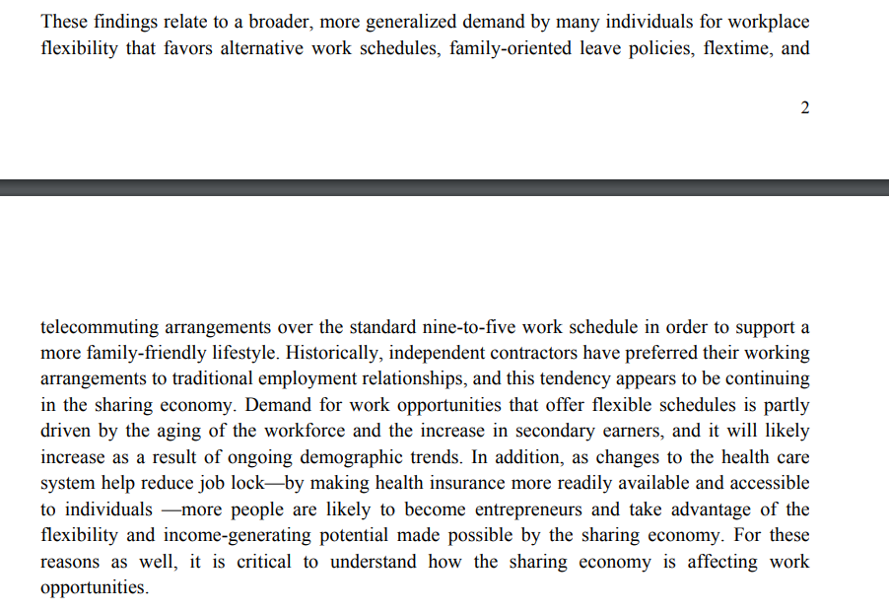
Source 3: Huws, U., Spencer, N.H., and Joyce, S. 2016. Crowd Work in Europe: Preliminary results from a survey in the UK, Sweden, Germany, Austria and the Netherlands. Available at: http://researchprofiles.herts.ac.uk/portal/files/10749125/crowd_work_in_europe_draft_report_last_version.pdf (Accessed: 15th May 2019).

____________________________________________________________________________________________________________________________________________________________________________________________________________________________________________________________________________________________________________________________________________________________________________________________________________________________________________________________________________________________________________
______________________________________________________________________________________________________________________________________________________________________________________________________________________________________________________
______________________________________________________________________________________________________________________________________________________________________________________________________________________________________________________

