Week 4: Final project
For your final project, you will create a PowerPoint presentation that examines a specific event in American history that we have studied. Using the source documents provided in the weekly discussions or the weekly blogs, choose a topic that was of greatest interest to you in the past 4 weeks.
Use those source documents (such as the ones displayed in our discussion or blog post this week) as part of your references for your final project. In other words, the newspaper clippings, the images, the posters, and/or the letters that you have read for your assignments are all available to you as you create your presentation. In addition, use your text and any other scholarly sources to help you create your PowerPoint presentation, explaining the event you are describing.
As with your blogs and discussions, the idea is to:
- Present the main idea of your topic with your thesis statement, and
- Use those source files as evidence of the main point (your thesis statement) that you are trying to make
- Provide context, background, and ultimately analysis to help readers arrive at a conclusion
This is where your text and other scholarly sources you pull from the Parker online library will come in helpful. Explain the background of the event you are writing about, provide the context - the culture of the times, what else was going on in the country at the time, relevant political events or laws - and then share your analysis of the event. Why did it happen? How did it affect the people involved? In what ways did this event affect the United States as a whole?
Your presentation should be approximately 15 slides with speakers' notes, plus your list of references at the end. Ideally, you will have an image on each slide with a few bullet points as if you were presenting this to a large audience. Keep the text on the slides to a minimum. Your speakers' notes at the bottom are where you should write your information. See image:

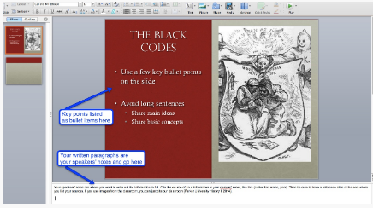

The text above is very small so I will rewrite it here:
Your speakers' notes are where you want to write out the information in full. Cite the source of your information in your speakers' notes, like this (author last name, year). Then be sure to have a reference slide at the end where you list your sources. If you use images from the classroom, you can just cite our classroom (Parker University History I, 2014).

