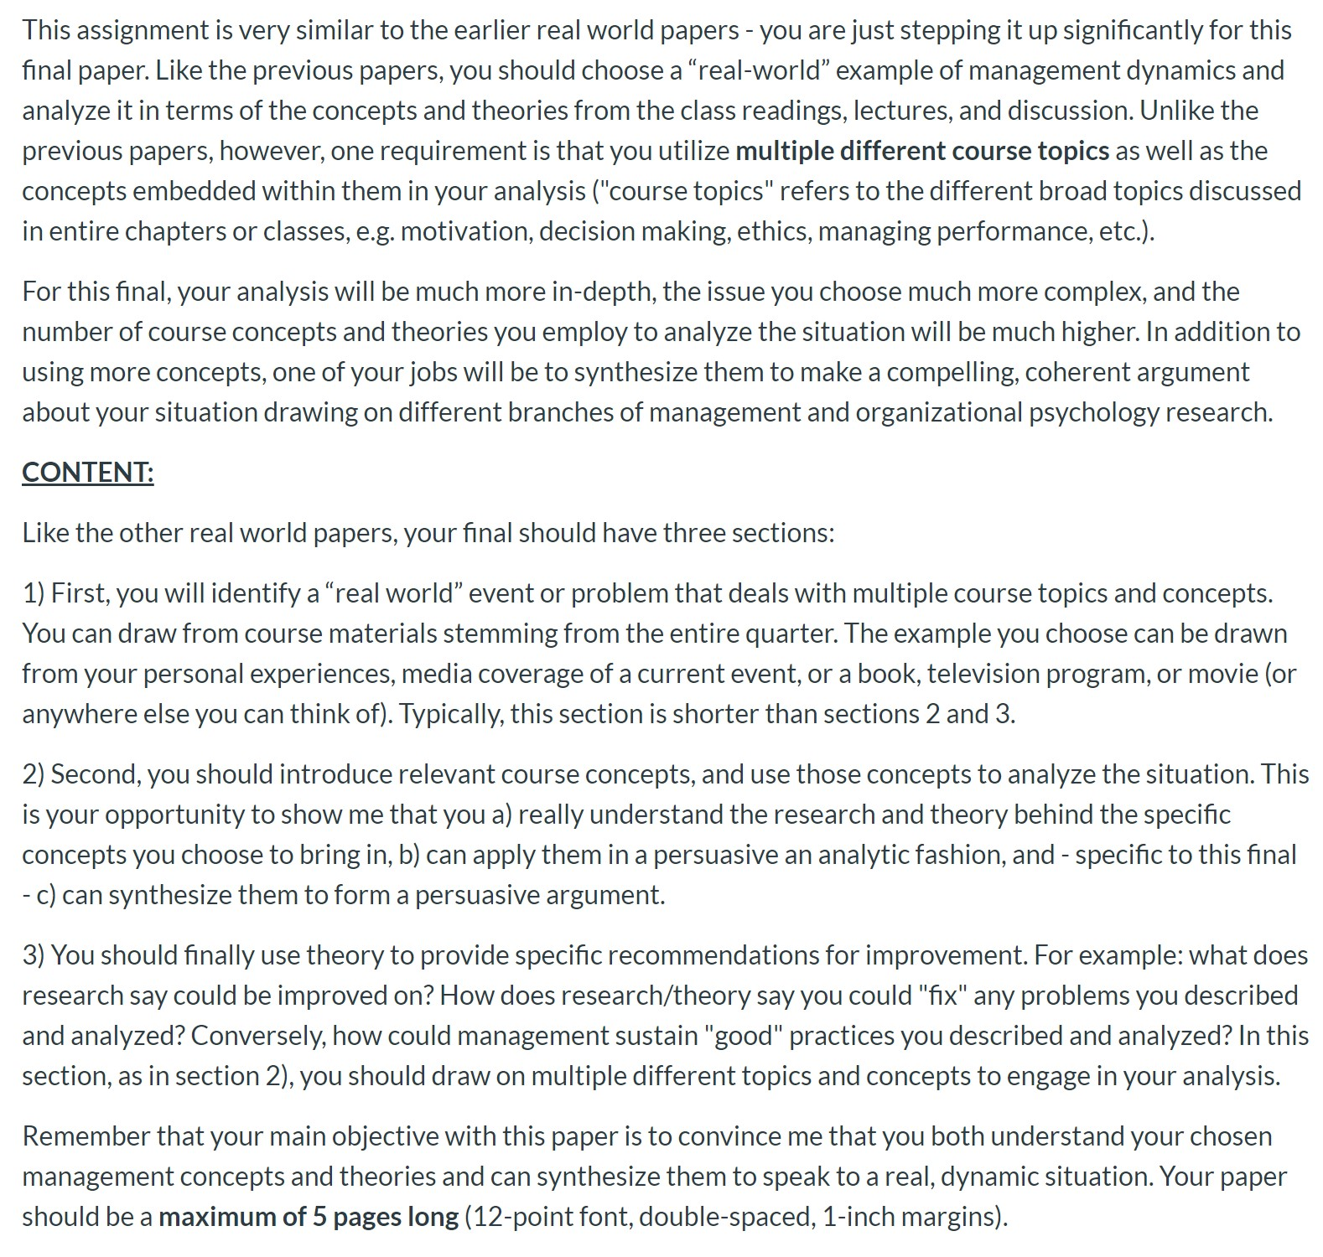
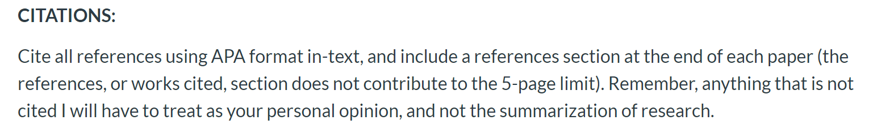
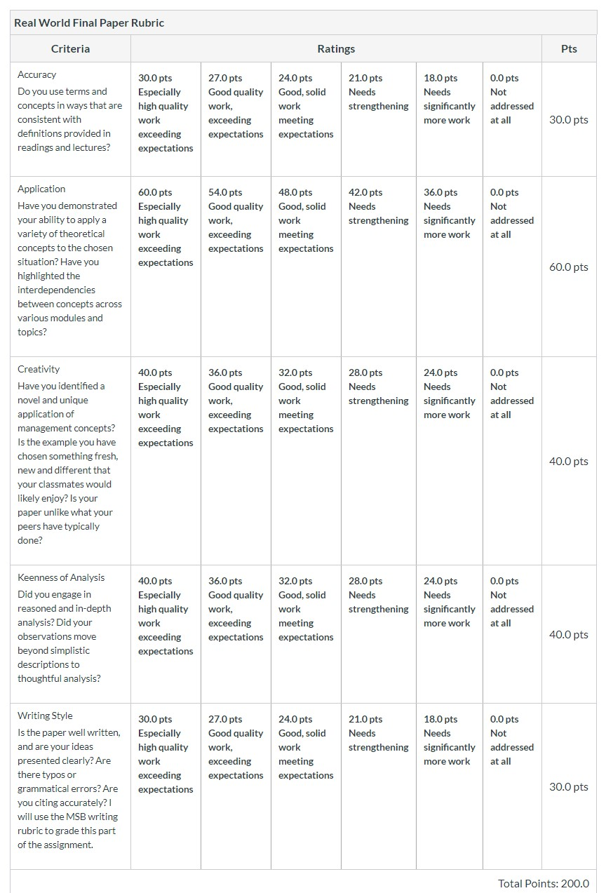
Source Link: https://taskandpurpose.com/community/military-needs-overhaul-personnel-management-practices

