New Balance
March 2020
S M | T | W | T | F | S
1 2 | 3 | 4 | 5 | 6 | 7
8 9 | 10 | 11 | 12 | 13 | 14
15 16 | 17 | 18 | 19 | 20 | 21
22 23 | 24 | 25 | 26 | 27 | 28
29 30 | 31 | 1 | 2 | 3 | 4
5 6 | 7 | 8 | 9 | 10 | 11

$2,825.99
Minimum Payment Due

$67.00
Payment Due Date

03/23/20
®

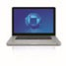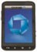POINTS SUMMARY
Previous points balance | 2,640
+ 5% Back on Amazon.com purchases | 2,314
+ 5% Back on Whole Foods Market purchases | 0
+ 2% Back at gas stations | 81
+ 2% Back at restaurants | 205
+ 2% Back at drugstores | 54
+ 1% Back on all other purchases | 686
Total points available for  redemption | 5,980

Late Payment Warning: If we do not receive your minimum payment by the date listed above, you may have to pay a late fee of up to $38.00.
Minimum Payment Warning: If you make only the minimum payment each period, you will pay more in interest and it will take you longer to pay off your balance. For example:

If you make no additional charges using this card and each month you pay... | You will pay off the balance shown on this statement in about... | And you will end up paying an estimated total of...
Only the minimum payment | 12 years | $6,332
$106 | 3 years | $3,829  (Savings=$2,503)
If you would like information about credit counseling services, call 1-866-797-2885.

ACCOUNT SUMMARY
Account Number: 4147 4002 4212 6744
Previous Balance $2,669.46
Payment, Credits -$1,200.00
Purchases +$1,316.89
Cash Advances $0.00
Balance Transfers $0.00
Fees Charged $0.00
Interest Charged +$39.64
New Balance $2,825.99
Opening/Closing Date 01/27/20 - 02/26/20
Credit Access Line $10,000
Available Credit $7,174
Cash Access Line $2,000
Available for Cash $2,000
Past Due Amount  Balance over the Credit Access Line | $0.00  $0.00

"% Back rewards" are the rewards you earn under the program.
% Back rewards are tracked as points and each $1 in % Back rewards earned is equal to 100 pts. You can redeem your points toward millions of items when you shop at Amazon.com or for cash back, gift cards and travel at chase.com/amazonrewards.

To see if your card earns 5% Back or 3% Back on Amazon.com and Whole Foods Market purchases, sign into an Amazon.com account where your card is loaded, visit "Your Account" page, click the "Manage Payment Options" page under the "Payment Methods" section, and expand the details of your credit card. If that Amazon.com account has an eligible Prime membership, and your card could be earning 5% Back on Amazon.com and Whole Foods Market purchases, you'll see how to start earning 5% Back on Amazon.com and Whole Foods Market purchases. You can go to Chase.com to see whether you earned 5% Back or 3% Back on previous Amazon.com and Whole Foods Market purchases.
Have a question about what you ordered at Amazon.com? Sign in to your Amazon.com account and go to "Your Account," then "Your Orders" to view your recent orders. For questions about purchases or returns, call Amazon Customer Service at
1-866-216-1072.

0000001 FIS33339 C 2 Y 9 26 20/02/26 Page 1 of 3 06654 MA MA 26057 05710000020002605701
0510

P.O. BOX 15123 WILMINGTON, DE 19850-5123
For Undeliverable Mail Only

Make your payment at chase.com/paycard

Account number: 4147 4002 4212 6744

26057 BEX 9 05720 C
GARRETT MOSS 533 W 5150 S
WASHINGTON TERRACE UT 84405-6529

$ . Amount Enclosed

CARDMEMBER SERVICE PO BOX 6294
CAROL STREAM IL 60197-6294

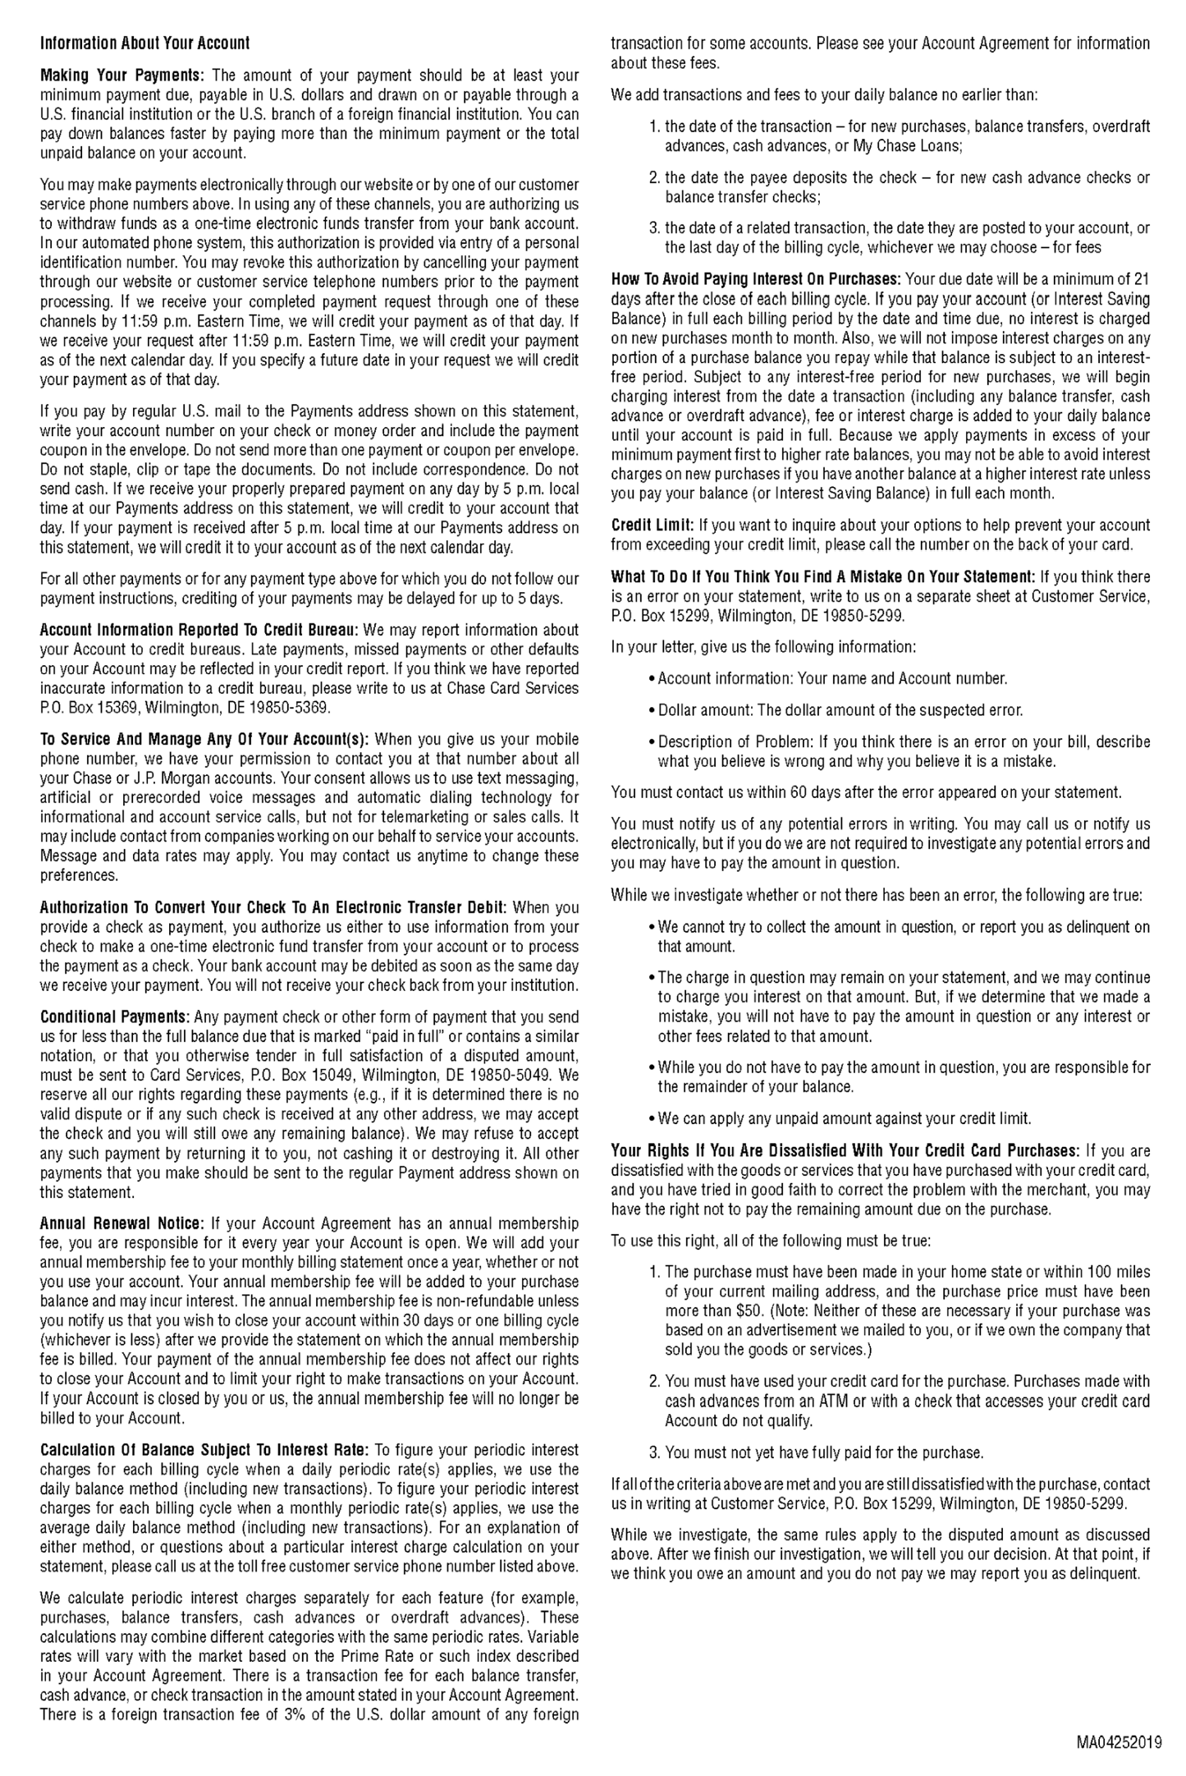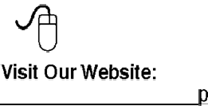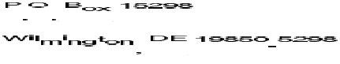

To manage your account, including card payments, alerts, and change of address, visit
or call the customer service number which appears on your account
statement.

®

ACCOUNT ACTIVITY
Date of
Transaction Merchant Name or Transaction Description $ Amount
PAYMENTS AND OTHER CREDITS

01/27 | Payment Thank You - Web | -1,000.00
02/12 | Payment Thank You - Web | -200.00
PURCHASE
01/27 | Amazon.com*7F0NV7S83 Amzn.com/bill WA Order Number 111-3596453-5837820 | 16.08
01/27 | Amazon.com*BM8U10V13 Amzn.com/bill WA Order Number 111-4737861-0189831 | 22.49
01/27 | AMZN Mktp US*0N0MM4GW3 Amzn.com/bill WA Order Number 114-2485460-2436205 | 20.37
01/28 | KENT'S FOODS ROY UT | 7.43
01/27 | HOBBY-LOBBY #751 RIVERDALE UT | 31.98
01/28 | CAMPOS GROUP LLC LAYTON UT | 25.20
01/29 | Prime Video*WI6L66JG3 888-802-3080 WA Order Number D01-8499436-3968242 | 10.71
01/28 | KENT'S FOODS ROY UT | 28.94
01/28 | FREETAXUSA.COM 801-812-1040 UT | 13.89
01/27 | MCDONALD'S F19335 RIVERDALE UT | 4.61
01/29 | SMITH'S FOOD 4030 OGDEN UT | 9.26
01/30 | AMZ*Hulu LLC supportreques CA  Order Number P01-1593981-3658680 | 12.88
01/28 | TACO BELL 033161 OGDEN UT | 14.45
01/30 | Amazon.com*9A0TG1X83 Amzn.com/bill WA Order Number 111-8205548-1177041 | 12.86
01/29 | TCM@DAVIS HOSPITAL LAYTON UT | 5.47
01/31 | Amazon.com*MU9SZ4NR3 Amzn.com/bill WA Order Number 111-7637576-7072264 | 7.95
02/02 | RANCHERITOS MEXICAN FOOD OGDEN UT | 22.80
02/03 | WM SUPERCENTER #1708 RIVERDALE UT | 47.50
02/04 | AMZN Mktp US*OS3W482R3 Amzn.com/bill WA Order Number 112-0939879-0575404 | 10.05
02/04 | AMZN Mktp US*OX7VI3WT3 Amzn.com/bill WA Order Number 112-4124273-7129801 | 44.71
02/05 | WM SUPERCENTER #1708 RIVERDALE UT | 29.76
02/05 | NORTH VIEW PHARMACY LAYTON UT | 4.75
02/06 | Amazon.com*SE1B486U3 Amzn.com/bill WA Order Number 112-7103245-2782661 | 26.68
02/05 | WENDYS #6077 RIVERDALE UT | 6.60
02/09 | Prime Video*SJ8B95ZW3 888-802-3080 WA Order Number D01-7608015-6681824 | 6.42
02/07 | NORTH VIEW PHARMACY LAYTON UT | 3.99
02/08 | NORTH VIEW PHARMACY LAYTON UT | 5.53
02/06 | TERRACE DEPOT WASHINGTON TE UT | 10.97
02/09 | WAL-MART #5206 SOUTH OGDEN UT | 46.86
02/10 | TREEHOUSE CHILDRENS MUSEU OGDEN UT | 6.44
02/12 | AMZN Mktp US*490GT3473 Amzn.com/bill WA Order Number 112-6232677-0260229 | 13.93
02/12 | AMZN Mktp US*MH48L2ZP3 Amzn.com/bill WA Order Number 112-1636616-7263446 | 38.60
02/11 | FREETAXUSA.COM 877-2699027 UT | 16.08
02/11 | TERRACE DEPOT WASHINGTON TE UT | 20.11
02/13 | Amazon.com*UH4FJ4GO3 Amzn.com/bill WA Order Number 112-9104701-5049035 | 12.48
02/12 | NORTH VIEW PHARMACY LAYTON UT | 12.32
02/11 | TERRACE DEPOT WASHINGTON TE UT | 8.95
02/14 | Amazon.com*5X9QM8273 Amzn.com/bill WA Order Number 112-3625949-2452253 | 10.71
02/13 | GRUBHUBFUJIDRAGON GRUBHUB.COM NY | 48.48
02/14 | AMZN Mktp US*AY8TH93Q3 Amzn.com/bill WA Order Number 112-1771270-6570653 | 12.86
02/16 | Amazon.com*5G7KC3PF3 Amzn.com/bill WA Order Number 111-3571644-8462647 | 7.70
02/16 | Amazon.com*KE2FM8DR3 Amzn.com/bill WA Order Number 112-5386411-1584230 | 13.57
02/16 | Amazon.com*H39BK1YK3 Amzn.com/bill WA | 49.59
GARRETT MOSS | Page 2 of 3 | Statement Date: 02/26/20

ACCOUNT ACTIVITY (CONTINUED)
Date of
Transaction Merchant Name or Transaction Description |  | $ Amount
Order Number 112-7869421-5226649
02/17 Prime Video*YR0JB0123 888-802-3080 WA |  | 6.42
Order Number D01-4343630-7334642
02/18 AMZN Mktp US*M55QX4ED3 Amzn.com/bill WA |  | 19.25
Order Number 112-1674852-6409820
02/18 AMZN Mktp US*OR7MN9RS3 Amzn.com/bill WA |  | 8.57
Order Number 114-5739439-3606639
02/18 Amazon.com*837I00033 Amzn.com/bill WA |  | 14.73
Order Number 114-1798320-4001818
02/21 Amazon.com*104E65J83 Amzn.com/bill WA |  | 13.00
Order Number 112-1319038-6438668
02/21 Amazon.com*9J0S76063 Amzn.com/bill WA |  | 15.21
Order Number 112-6739943-1322642
02/20 MOUNTAIN WEST VET SPECIAL LAYTON UT |  | 400.00
02/22 Prime Video*V13AZ3833 888-802-3080 WA |  | 4.28
Order Number D01-7329334-4064218
02/23 Prime Video*656CA0573 888-802-3080 WA |  | 4.28
Order Number D01-8620626-2761803
02/24 AMZN Mktp US*KQ1RK5113 Amzn.com/bill WA |  | 34.97
Order Number 112-1808004-8375413
02/26 Prime Video*851HF7H43 888-802-3080 WA |  | 4.28
Order Number D01-3586187-3273839
02/25 KENT'S FOODS ROY UT |  | 8.89
INTEREST CHARGED
02/26 | PURCHASE INTEREST CHARGE | 39.64
 | TOTAL INTEREST FOR THIS PERIOD | $39.64
$0.00
$84.41
Total fees charged in 2020 Total interest charged in 2020
2020 Totals Year-to-Date
Year-to-date totals do not reflect any fee or interest refunds you may have received.

INTEREST CHARGES
Your Annual Percentage Rate (APR) is the annual interest rate on your account.

Annual

Balance

Balance Type
Percentage Rate (APR)
Subject To Interest Rate
Interest Charges

PURCHASES
Purchases 20.74%(v)(d) $2,250.53 $39.64

CASH ADVANCES
Cash Advances 26.49%(v)(d) - 0 - - 0 -

BALANCE TRANSFERS
Balance Transfer 20.74%(v)(d) - 0 - - 0 -

31 Days in Billing Period
(v) = Variable Rate
(d) = Daily Balance Method (including new transactions)
(a) = Average Daily Balance Method (including new transactions)
Please see Information About Your Account section for the Calculation of Balance Subject to Interest Rate, Annual Renewal Notice, How to Avoid Interest onPurchases, and other important information, as applicable.

