Module Assessment A Questions

Objective: Students will demonstrate their comprehension of and ability to apply the content from Modules 1, 2, and 3 (textbook, online, and in-class).
Assessment Topic: Rec 225 is an on-premise beverage outlet located in the heart of Cocoa Village, Florida that "brings together the fun of Game night with classic Drinks and Eats". This beverage outlet will be the focus of Module Assessment 1. In Webcourses, you will find the links to their website, menu, and social media pages to get you started. From there, you will need to do your own additional investigation/research to complete the Assessment.
Assessment Submission: To complete the Assessment and submit your answers for grading purposes, access the Assessment in Webcourses and click "Take the Quiz". Type in your answers, using the blank essay boxes provided for each question. You can use the Rich Content Editor to edit your text, make use of bullet points and numbering, create tables, and add images.
Assessment Questions: All Assessment Questions (and their corresponding point values) are provided in this document and in Webcourses.
The following questions are based on Module 1 (15 points):
Q1 (5 pts). In Module 1, you learned how to categorize beverage outlets by purpose and by style. How would you categorize Rec 225, and which method are you using?

Q2 (10 pts). Assume you are an owner or manager of Rec 225.
- Identify two resources that would help you make better beverage-related decisions for your operation. Examples include beverage industry/trade associations, reputable industry publications (books, magazines), reputable industry websites/blogs, and/or conferences/trade shows.
- Include a current, valid URL for each resource.
- Why did you choose each of these resources?

The following questions are based on Module 2 (55 points):
Q3 (5 pts). How many red grape varietals are represented on Rec 225's menu? List the varietals.

Q4 (5 pts). How many white grape varietals are represented on Rec 225's menu? List the varietals.

Q5 (10 pts). How many beers on Rec 225's menu are top-fermenting beers? Consider both draft and bottles/cans in your answer. List the beers and the specific type of top-fermenting beer (For example: Elysian Space Dust - American IPA).

Q6 (10 pts). How many beers on Rec 225's menu are bottom-fermenting beers? Consider both draft and bottles/cans in your answer. List the beers and the specific type of bottom-fermenting beer (For example: Bud Light – Light Beer).

Q7 (5 pts). How many cocktails on Rec 225's menu include a white-goods spirit?
List the cocktails and the specific type of white-goods spirit used (For example: Sunk My Battleship - rum).

Q8 (5 pts). How many cocktails on Rec 225's menu include a brown-goods spirit? List the cocktails and the specific type of brown-goods spirit used (For example: Doctors Orders - bourbon).

Q9 (5 pts). How many categories of non-alcoholic beverages are represented on Rec 225's menu? List the categories.

Q10 (10 pts). After reviewing Rec 225's beverage menu, what types of beverage equipment do you think they needed to purchase in order to operate effectively? Be detailed - for example, if you think they needed glassware, tell me what kind(s) of glassware. However, you do not need to include suppliers or exact specifications.

The following questions are based on Module 3 (80 points):
Q11 (10 pts). Below are two images of the interior of Rec 225. Based on these images, answer the following questions:
- Which bar configuration did the designers decide to use?
- What are the advantages and disadvantages of this layout?
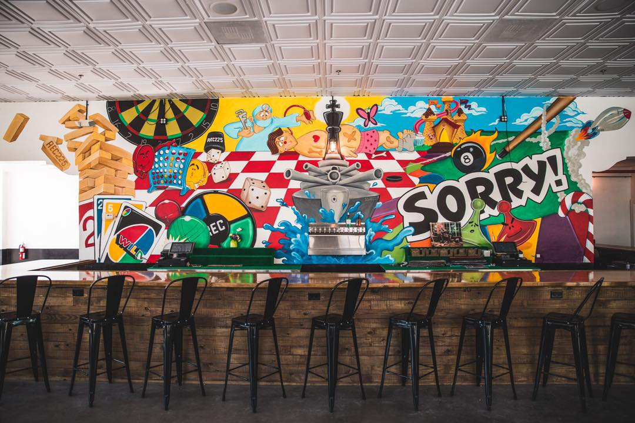
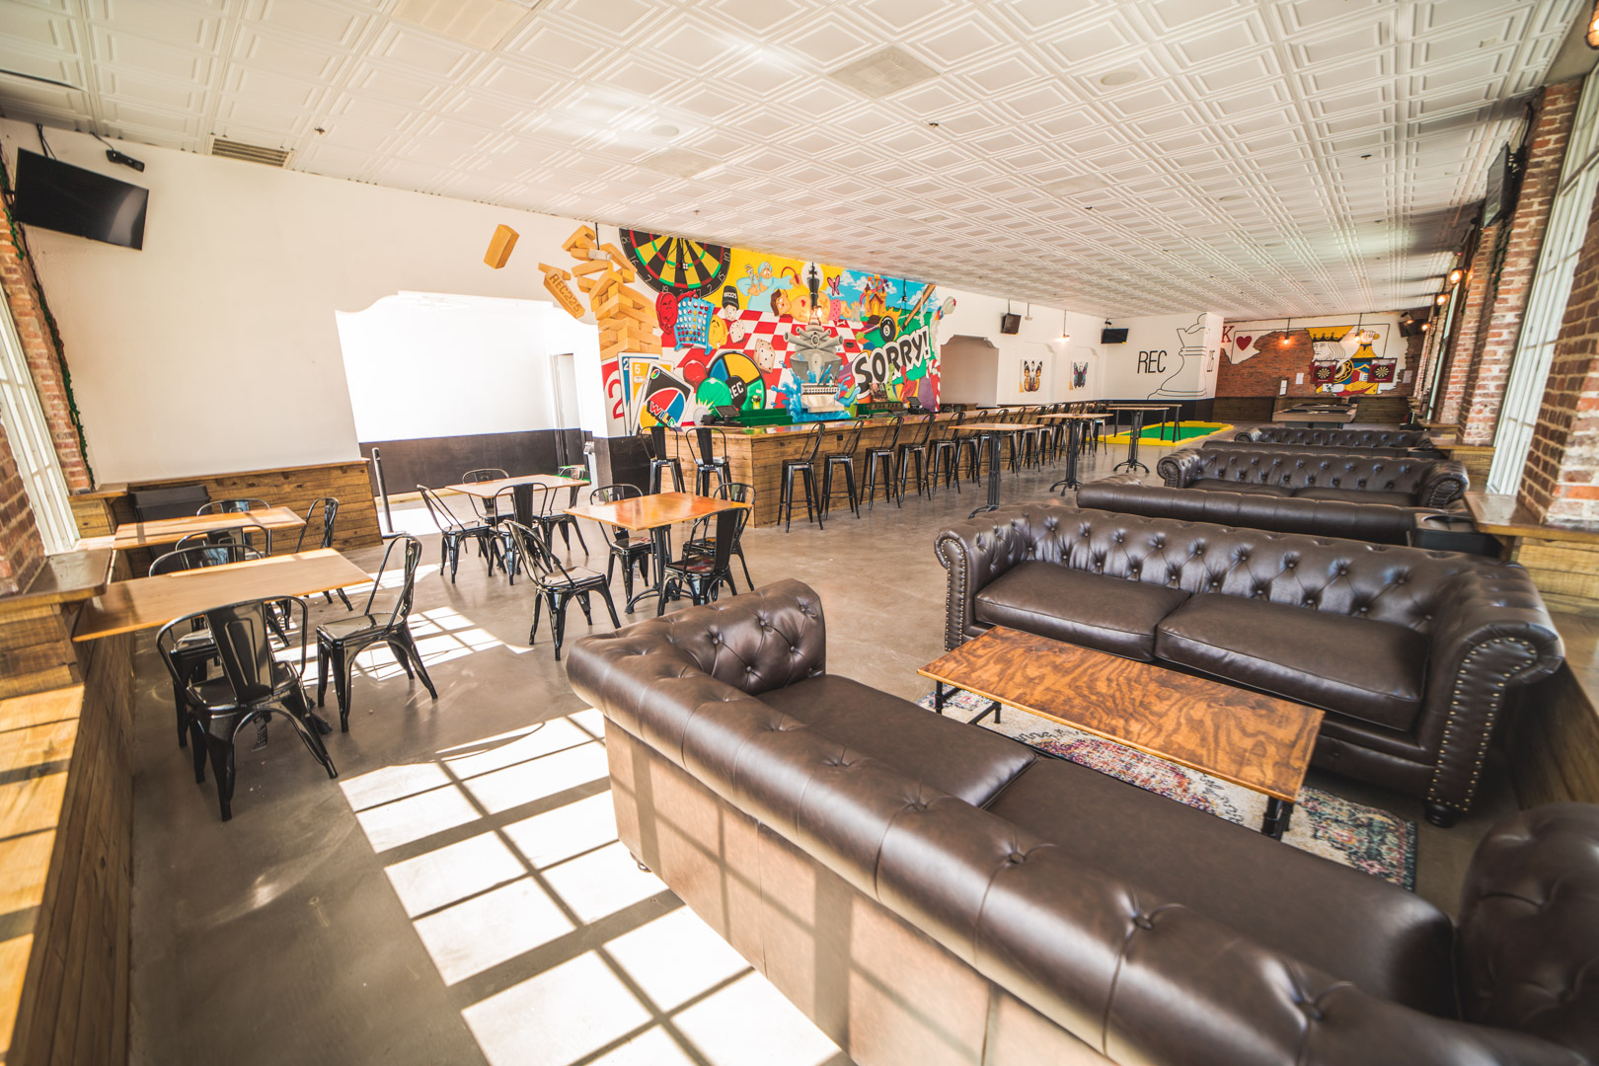
Q12 (30 pts). In Module 3, you learned about menu development and design. After reviewing Rec 225's menu:
- Assess/critique the menu in terms of the menu items
- Think about quantity, variety/range, quality, menu descriptions, POV (these are just a few points to get you started)
- Assess/critique the menu in terms of the menu design
- Think about the visual elements, readability, flow (again, a few points to get you started)
- Is there anything you would you change about this menu?
- Why or why not?
- If you said yes, provide specific examples of the elements you would change

Q13 (40 pts). In Module 3, you learned about marketing & promotions.
- Design a promotion that is appropriate for Rec 225
- Explain the promotion in detail
- Why did you design this promotion? What is the purpose/goal?
- Who is the target audience for this promotion?
- Which communication tool (or tools) would you use to reach this target audience?
- How would you measure the effectiveness of this promotion?
Hint #1: I recommend that you spend some time reviewing Rec 225's website and social media first, to find out what their current promotions are and what they may have done in the past. I also recommend that you spend some time looking at what their competition is doing.
Hint #2: The promotion can be anything you'd like, as long as it makes sense for this beverage outlet. I encourage you to be creative, and not just automatically default to a "cheapest drinks possible/heavy discounts" type of promo!

