M2D1: Climate Zombies and Creating Convincing Climate Change Arguments
The graphic below from the National Center for Atmospheric Research shows that global average temperatures are expected to increase by more than 2 degrees Fahrenheit by the end of the century if no preventative measures are taken. Small changes in global average temperature can lead to large changes in the environment. In this discussion you will get an opportunity to examine some of the most persistent misconceptions about climate change and construct arguments to refute these based on the scientific research.
Completing this activity will enable you to master Module Level Outcomes 1 and 3.
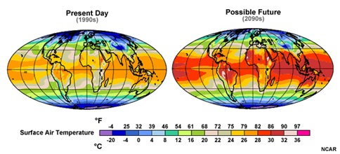
First:
- In Slaying the "Zombies" of Climate Science (Links to an external site.)Links to an external site. [Video, 18:00 mins], Dr. Marshall Shepherd addresses common misconceptions that, from his scientific viewpoint, are continuing to keep the public's concern about climate change issues lower than what the actual science would indicate is necessary. Read the discussion directions below, and then watch Dr. Marshall's presentation while taking careful notes to prepare for the discussion.
Next, post to the discussion board:
- Select one of the "zombie theories" from Dr. Shepherd. Restate the "zombie theory" you have chosen.
- Then, locate specific data and information in the assigned readings and other academic sources that support this idea. Use this information to craft your response to the two following prompts:
  - How important is this misconception in keeping people from appreciating the potential impact of climate change?
  - Create an argument using this data that you could deliver in a 2 minute "elevator speech" that might convince a climate change doubter that the issue of climate change may be more critical than he or she imagines.
Your initial post responding to this assignment should be no shorter than 250 words. Include both in-text citations and complete APA style references for all the sources you used to inform your work. Once you have posted your own discussion response, you are required to comment on the posts of at least two of your classmates. You can agree or disagree with their posts, but you must explain why you have chosen to do so. Also, be sure to read the feedback on your own major postings and reply to it throughout the module.
Always be sure that your posts are respectful, polite, and considerate. Please see the Excelsior policy “Guidelines for Online Interaction (Links to an external site.)Links to an external site.” if you have any questions or concerns.
You are also encouraged to do your own research through our library on the topic. Do not forget to include in-text citations and complete APA style references for all sources. The Excelsior Library Citation Tip Sheets and Resources (Links to an external site.)Links to an external site. will be a helpful guide. You may also wish to use a citation generator – you just insert the information, and it creates the citation in the format you indicate (MLA or APA, for example). Here are 3 citation generators to choose from:
- Citation Machine (Links to an external site.)Links to an external site.
- Bibme (Links to an external site.)Links to an external site.
- EasyBib (Links to an external site.)

