Torsion Test Lab Report

Fatemah Khajah
CVEN 3161 – 012 at 2 pm
LABORATORY OF MECHANICS OF MATERIALS
University of Colorado Boulder
Spring 2019

Abstract
This lab was conducted as a torsion test for two materials; mild steel and cast iron. The two materials were placed in a Tinius-Olsen Torsion Tester and the process was recorded through a computer software. It displayed the angle as the material was twisted and graph the of its shear stress and shear strain. Because iron is brittle, it endured about 2 twists until it broke at a 45º angle. Steel is more ductile and so endured a lot of twists and broke at a 0º angle. Steel would be a better option for structures exposed to torsion.
Table of Contents
- Abstract 2
- Introduction 3
- Experimental Procedure 3
- Results & Figures 4-6
- Calculations 6
- Table of Values 7
- Results Discussion 7
- Analysis & Conclusion 7
- Appendix A 8
- Appendix B 8
- Appendix C 9
- Appendix D 9

Introduction
Materials that make up structures differ based on the structures’ needs. Structures undergo tension, compression, torsion and more. To endure any behavior there are certain properties that the structure’s materials need to have. The structure needs to have materials that can handle the specific behavior it is put under. In this lab, two materials are tested to see which is better for structures that undergo torsion. With the results of this lab, engineers can determine if it is better to use either ductile, or brittle materials for structure that are in torsion.
- Shear strain: Strain that is parallel to the cross section.
- Shear stress: Stress that is parallel to the cross section.
- Shear Modulus: Slope of linear portion of the shear stress vs shear graph.
- Polar Moment of Inertia: Number that represents the object’s ability to resist torsion.

Experimental Procedure
- Measure diameter of solid cylinder steel specimen
- Measure length of steel specimen
- Place steel rod in Tinius-Olsen Torsion Tester
- Perform torsion test
- Measure torque and angle of steel specimen
- Repeat steps 3-5 for cast iron specimen.
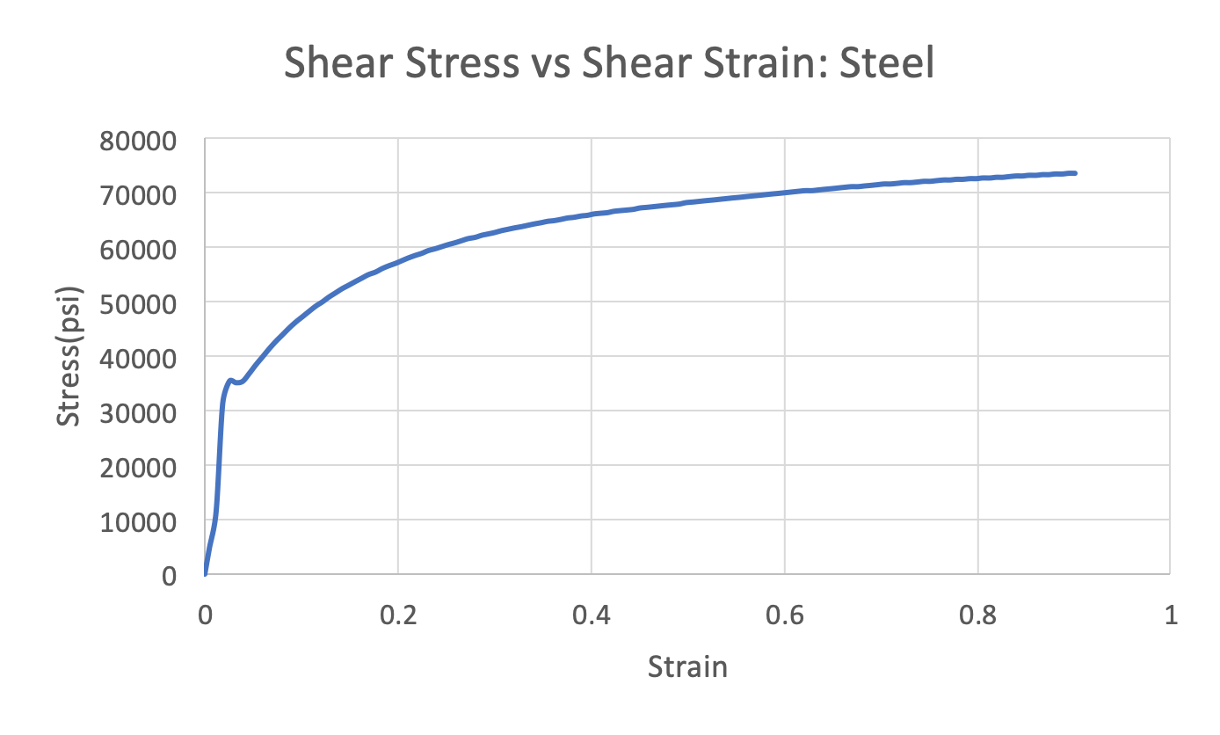
Results
Figure 1
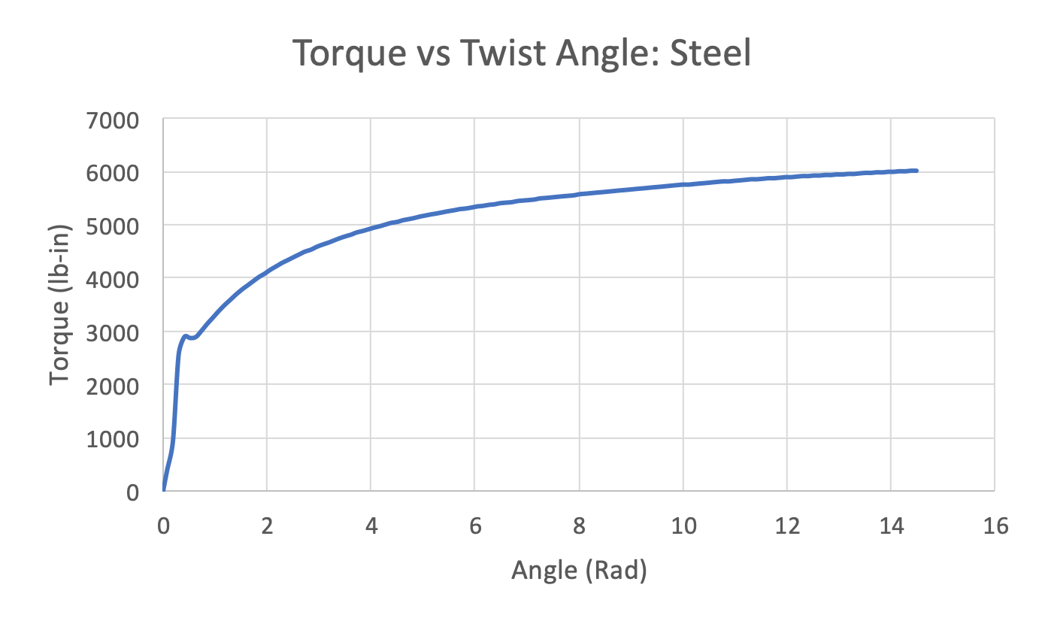
Figure 2
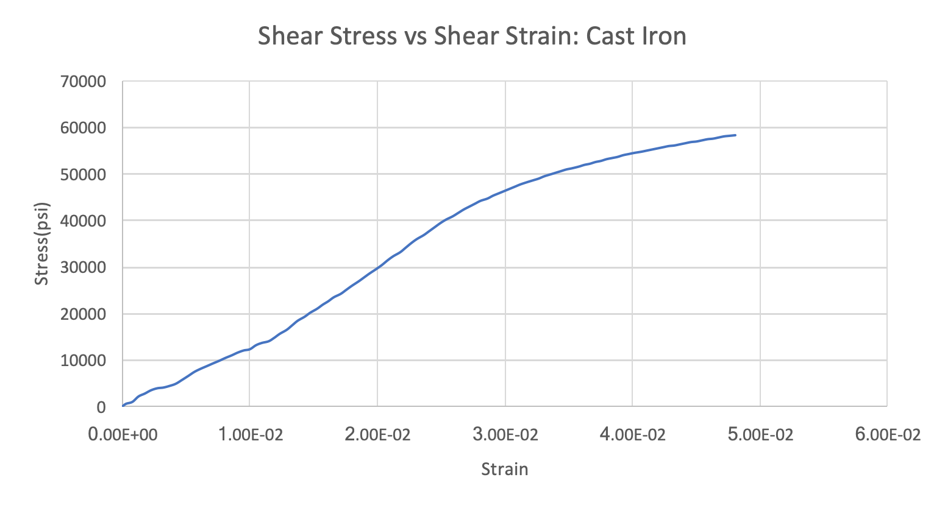
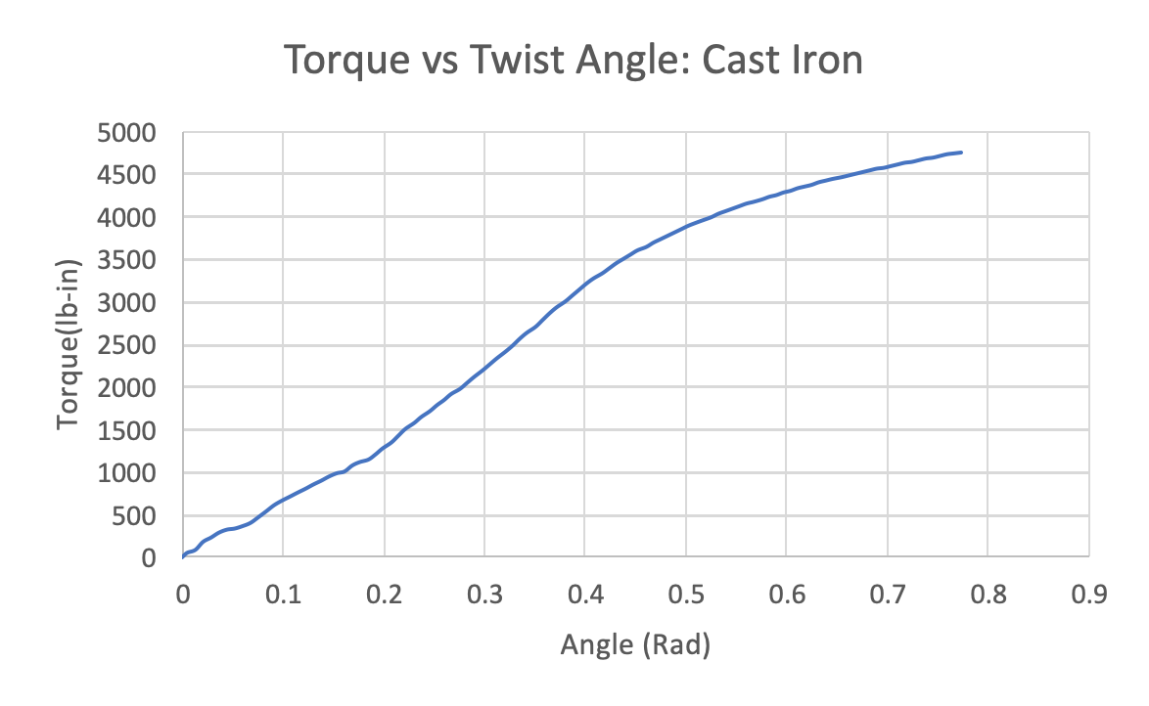
Figure 3
Figure 4

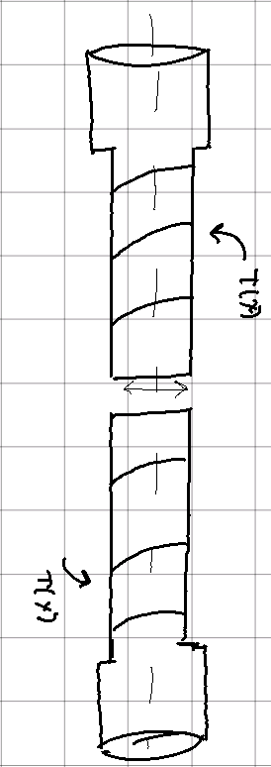

Figure 5: Steel Failure at 0º
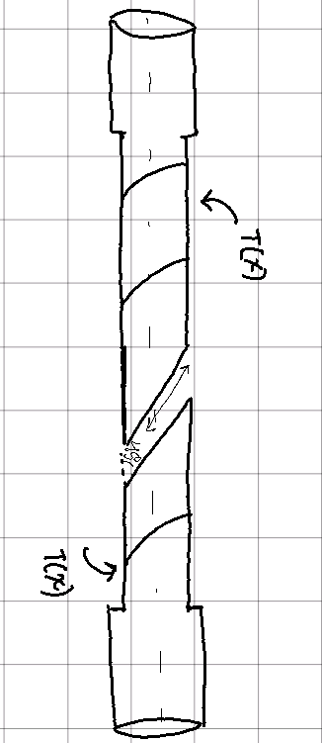
Figure 6: Cast Iron Failure are 45º
Calculations
- Shear Strain: $=\frac{(r)}{L}$
- Shear Stress: $\left(r\right)=\frac{*r}{I_{p}}$
- Shear Modulus: $G = /$
- $r =\frac{Diameter}{2}$
- $Ip =\frac{r^{4}}{2}$
Table of Values
 | Steel | Cast Iron
Length(in) | 6 | 6
Diameter(in) | 0.746 | 0.746
Ip (in⁴) | 0.0304 | 0.0304
G (psi) | 1,600,085.39 | 979,228.92
Torsion Yield Stress (psi) | 31400 | 43100

Results Discussion
Steel endured a flat failure as shown in Figure A in Appendix B. Iron endured a 45º failure as shown in Figure B in Appendix B. Steel had a steep linear slope at the beginning. The cast iron’s slope was not as steep but fairly linear for a long time. The shear modulus was calculated in excel by graphing only the linear portion of the stress vs strain diagram, then finding the trend line and taking the slope. The yield stress was taken by roughly looking at the linear graph and find the last point before it becomes non-linear.
Analysis & Conclusion
Both materials tested were almost identical in physical shape. They both have a length of 6 inches and a diameter of 0.746 inches, as well as the same polar moment of inertia. The torsion yield stress of cast iron was remarkably higher than that of steel. This is because iron is more brittle than steel. It failed at a 45º angle as most brittle materials do. However, steel kept twisting until it broke at a 0º as most ductile materials do. The shear modulus of cast iron is noticeably smaller than the shear modulus of steel. Steel is stronger than iron, as such its slope to the yield point was much steeper. Because iron is more brittle, its yield stress was higher.
Appendix A
 | Steel | Iron
Length(in) | 6 | 6
Radius(in) | 0.373 | 0.373
Torsion Rate(deg/min) | 180 | 15
ITLL Torsion Machine | 10000 lb-in torsion tester | 10000 lb-in torsion tester

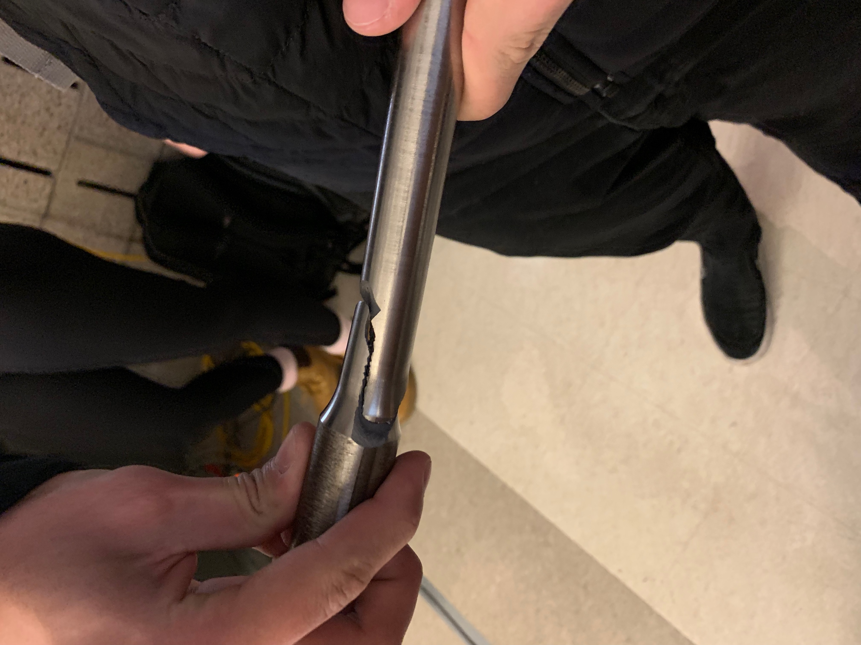
Appendix B
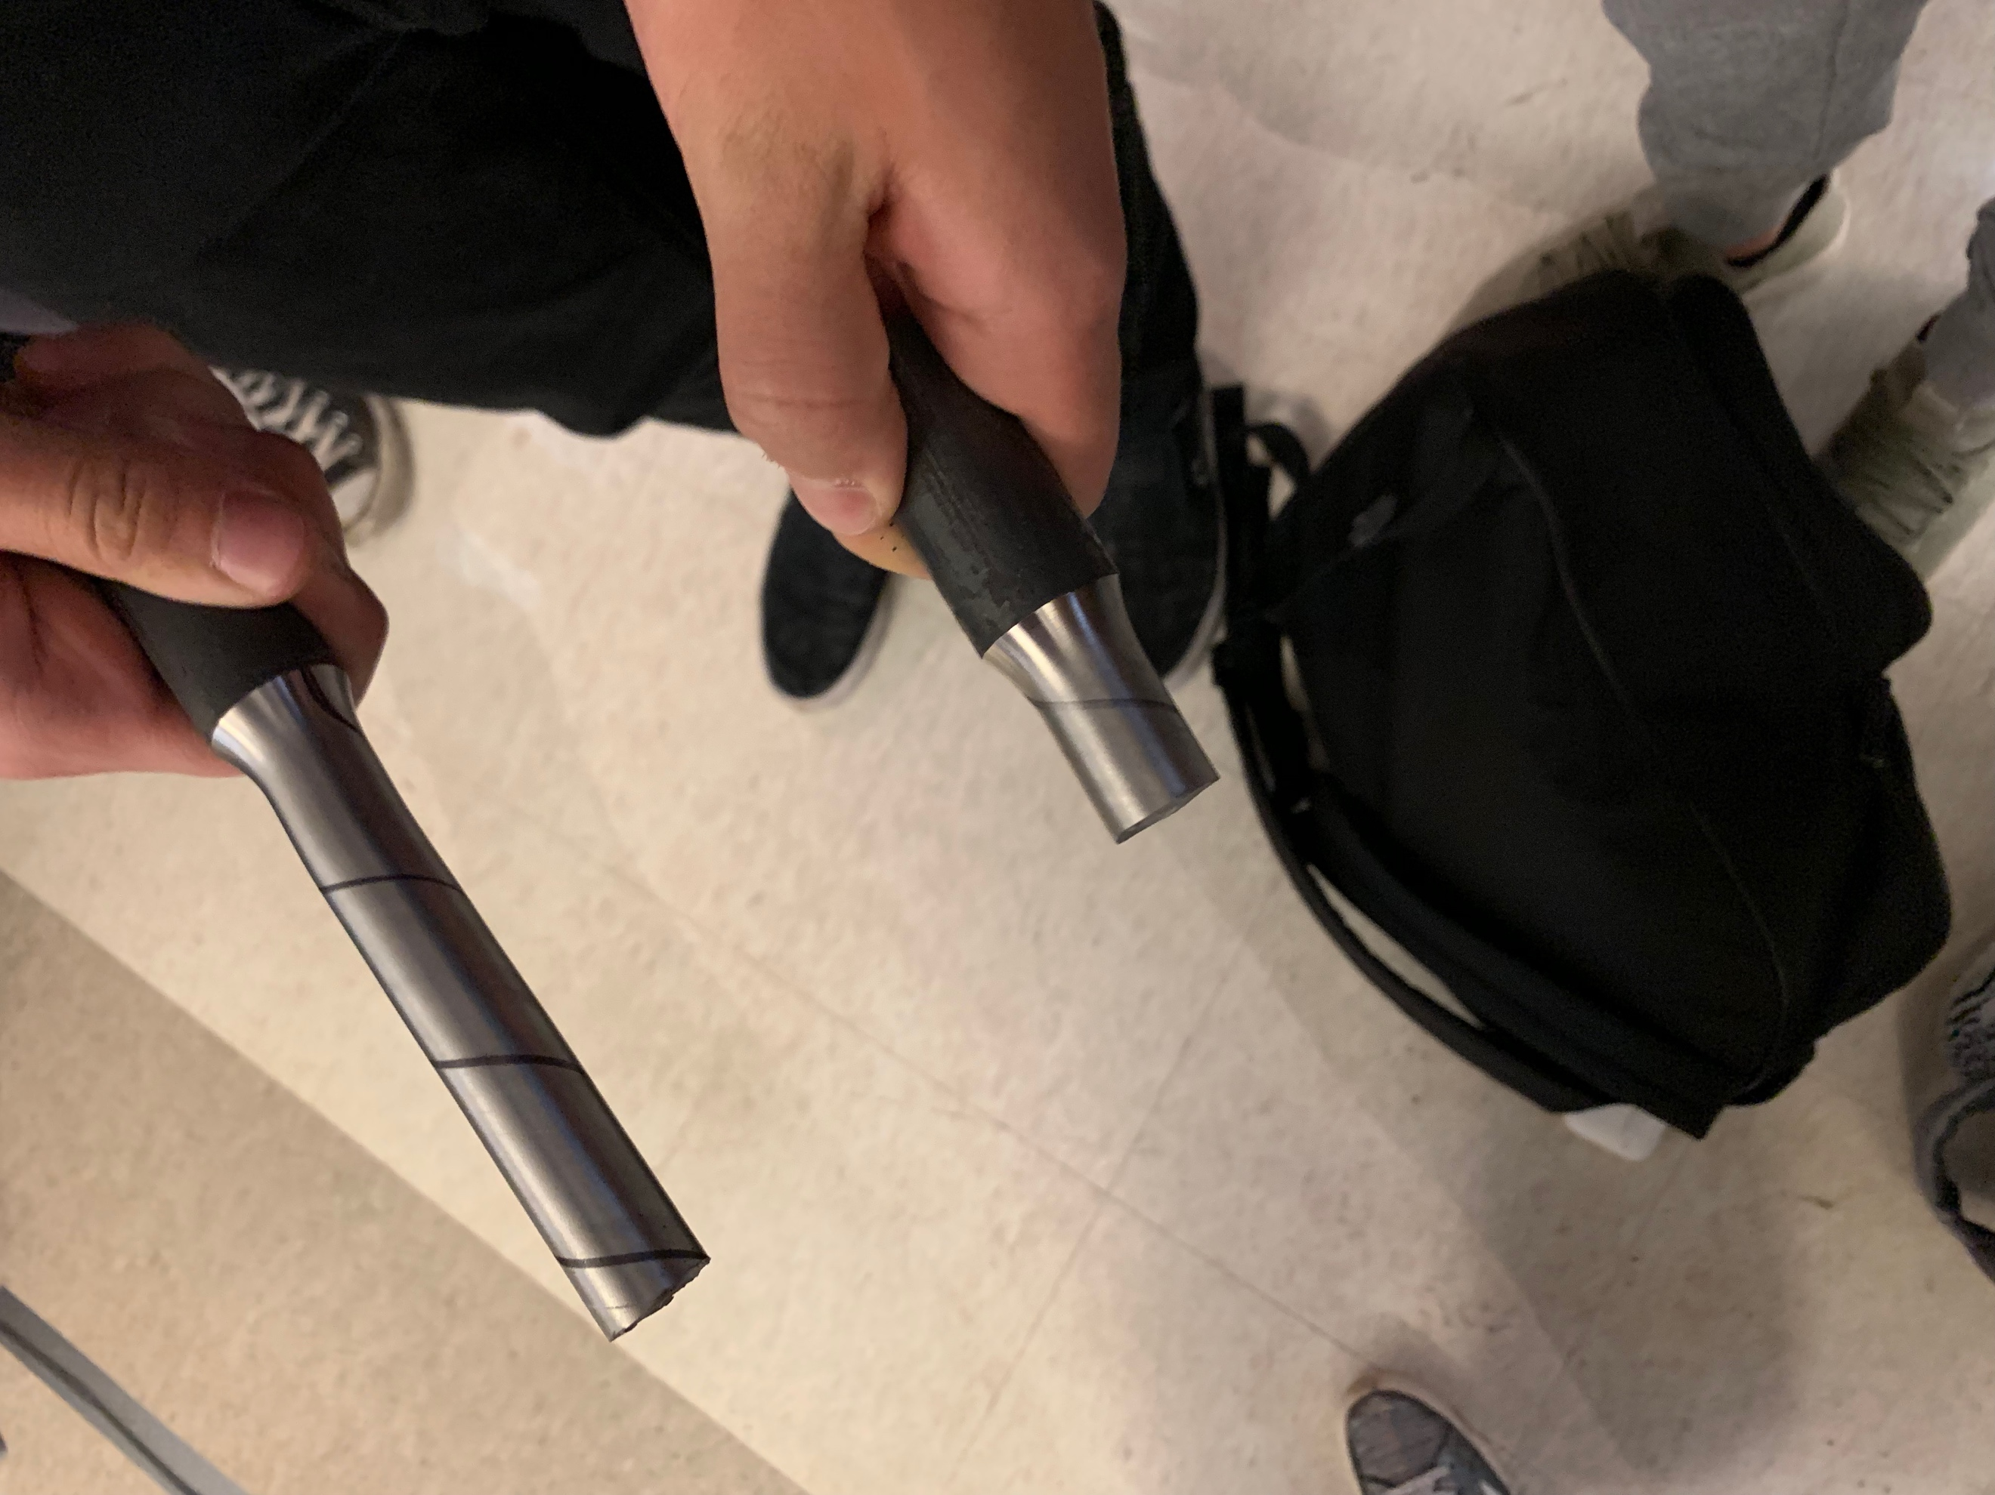

Figure A Figure B

Appendix C
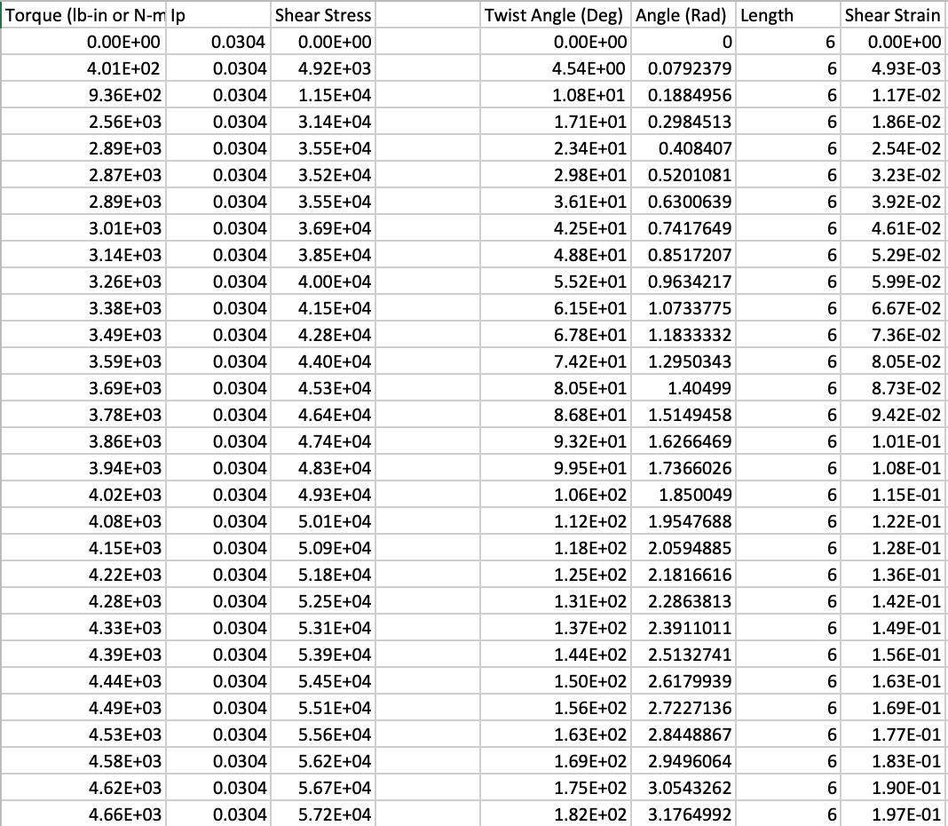

Figure D: Raw excel sheet for steel
Appendix D
Sample Polar Moment of Inertia Calculation
- $Ip =\frac{r^{4}}{2}$ $=\frac{{(0.373)}^{4}}{2}$ = 0.0304 in⁴

