Lab 4 Detection of Glucose with a Self-Made Biosensor Based on Glucose Oxidase

Objective:
Biosensors exploit biomolecules for sensing purposes. They can be built for various analytes and illnesses. In this experiment you will learn:
• What is a biosensor?
• What are the basic principles?
• How can a biosensor be made?
• Why detects glucose?

Introduction
Biosensor:
A biosensor uses a biological recognition element to convert a chemical signal into an electrical one. This very general concept is illustrated in Figure 1. Biological recognition elements can be enzymes or parts of immune systems. An enzyme is a biological catalyst. It speeds up reactions or makes them possible under given conditions; additionally, enzymes are very selective for certain reactions and only convert a specific substance or group of substances.
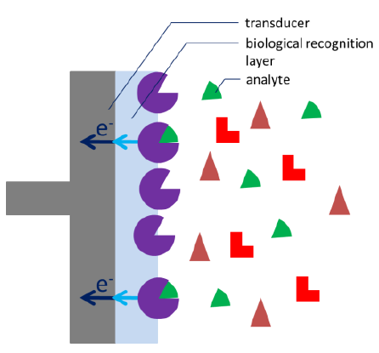
Figure 1 Scheme of a generic biosensor
Glucose and Glucose Oxidase
In this experiment the production of hydrogen peroxide as a stochastic by product by glucose oxidase (GOx) will be exploited (Figure 2). The hydrogen peroxide diffuses towards the electrode and is oxidized at the electrode. After the GOx has oxidized the glucose to gluconolactone, the GOx transfers the electrons from the Glucose to oxygen reducing it to hydrogen peroxide. Gluconolactone is hydrolysed in aqueous solutions to gluconic acid. There are even glucose sensors that exploit the induced pH change.
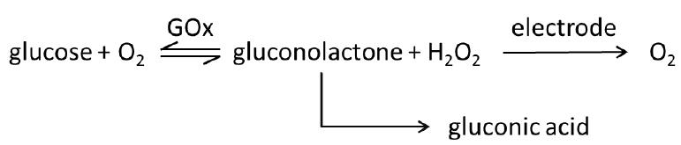
Figure 2 Scheme of glucose oxidation and the electrochemical hydrogen peroxide detection
Michaelis-Menten Kinetics
To characterize biosensors the Michaelis-Menten constant is an important factor. To understand why it is important and where it derives from one has to understand the observations and theories of Michaelis-Menten. This model is still the most used one for enzyme kinetics. An enzyme E is a catalyst that converts its substrate S, a term for the reagent converted by the enzyme, into the product P or products. To perform a substrate selective reaction the substrate and enzyme have to form a complex ES. It can be assumed that the concentration of ES is in a dynamic equilibrium with the enzyme E and the substrate S. The limiting step in this reaction is the conversion of ES to E and P and usually the equilibrium on the side of the product is very strong. The enzymatic reaction is expressed by:
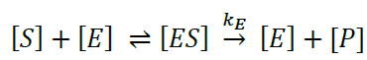 (1)
According to the mass action law the dissociation constant K_{S} of the complex is:
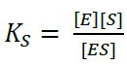 (2)
While the reaction from complex to the product can be treated as irreversible, the kinetics of the ES formation is fast compared to product formation and is reversible. As a result, the velocity of the reaction v_{R} is proportional to the concentration of the enzyme-substrate complex according to
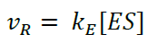 (3)
The concentration of ES depends on the enzyme and substrate concentration. If we have a fixed amount of enzyme solution and observe the velocity while increasing the substrate concentration, a saturation curve is observed (see Figure 3).
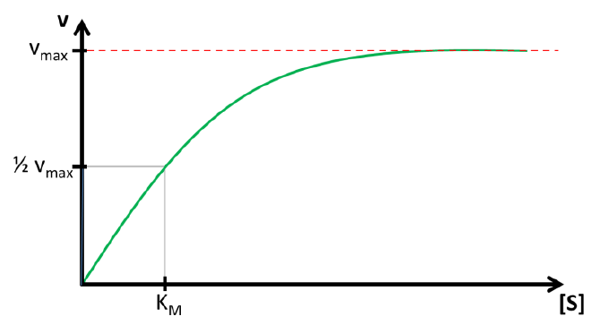
Figure 3 Saturation curve for a fixed amount of enzyme converting the substrate S with velocity v
The maximum velocity v_{max} and the lowest concentration with v_{max} ([S]_{max}) are two parameters that contain important information. The reaction rate or velocity v determines how often S is converted to P and thus how often electrons are transferred to the enzyme. Because these electrons will directly or indirectly be donated or accepted by the electrode, the reaction rate during the measurement is represented by the measured current. This means the higher v_{max} the higher the current per concentration, also known as sensitivity. [S]_{max} determines the range of concentration where the current depends on [S]. If [S]_{max} is very high, a large range of concentrations can be detected with this enzyme. If an enzyme is immobilized [S]_{max} and v_{max} might change compared to their properties during free diffusion. However, it is very difficult to determine these important parameters. This problem can be simplified by introducing the Michaelis-Menten-constant K_{M}. Instead of using v_{max} which is difficult to determine due to the shape of the saturation, the 0.5v_{max} is used as a reference. According to the relation between ES and v_{R} discussed in the last paragraph, half of the total enzyme’s amount is present as ES if v is 0.5v_{max}. The concentration of [S] for 0.5v_{max} is the Michaelis-Menten-constant K_{M} as visible in Figure 4.52.
The value of K_{M} and v_{max} can be determined using the Lineweaver-Burke-equation. The deviation of the equation can be found in Appendix A.
$\frac{1}{v_{R}}=\frac{1}{v_{max}}+\frac{K_{M}}{v_{max}[S]}$ (4)
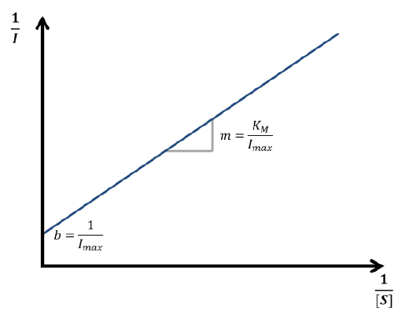
Figure 4 Scheme of a Lineweaver-Burk plot with the slope m and intersection b

Devices and Chemicals
- EmStat
- sensor cable
- sensor connector
- maybe a USB cable
- Laptop with the potentiostat software PStrace installed
- ItalSens IS-C
- retort stand
- retort clamp
- beaker (electrochemical cell)
- stirrer
- Resydrol AY 498w/35WA
- Glucose oxidase (powder)
- 0.1 M phosphate buffer pH 7 (at least 50 mL)
- 1 M glucose solution (has to be prepared one day in advance)
- Sample glucose solution to be tested (e.g. Fanta Cassis)

Instructions

Preparing the Glucose Sensor
By immobilizing glucose oxidase (GOx) on an electrode surface a simple glucose biosensor can be created. Please follow the procedures below to immobilize the GOx on the electrode by electrodeposition of a polymer:
- Take an ItalSens IS-C electrode and insert it into the sensor connector. You may need to cut excess plastic away in order to fit the electrode into the connector. Connect the sensor holder to the potentiostat and fix it in the retort stand. The electrode should be parallel to the table.
- Prepare the polymer enzyme solution by mixing 600 μL Resydrol with 1.4 mL phosphate buffer. Be aware that Resydrol is very viscous and the volume transfer should be done very slowly. Dissolve 16 mg of GOx powder in the polymer solution.
- A droplet of ca. 100 μL is applied to the electrode. Make sure all three electrodes (WE – black circle, CE and RE – the two little arms left and right of the circle) are covered with solution.
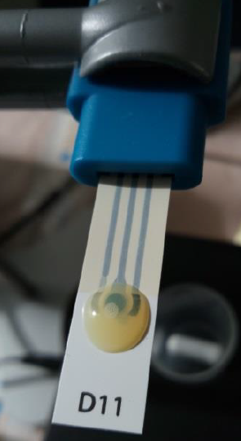
Figure 5 Photo of an ItalSens IS-C with an enzyme-polymer solution drop on it.
- A cyclic voltammetry is performed to create a low pH close to the electrode by water splitting. During the more cathodic potentials the lack of polymer in front of the electrode will be removed due to diffusion. Choose Cyclic Voltammetry from the drop down menu. Choose the current ranges 1 μA to 100 mA. The fields Sample and Sensor are for your own notes. Since we do not want a pre-treatment of the electrode set t condition and t deposition to 0. Set the other parameters to:
    - a. t equilibrium = 8 s
    - b. E start = 0 mV
    - c. E vertex1 = 0 mV
    - d. E vertex2 = 1.9 V
    - e. E step = 0.005 V
    - f. Scan rate = 0.1 V/s
    - g. Number of Cycles = 20
- Start the measurement. And observe the working electrode. Above 1.4 V a gas evolution should be visible.
- Rinse the electrode with buffer.

Determination of the Michaelis-Menten Constant
After preparing the electrode the KM and Imax (vmax) can be determined. Follow the below procedures to perform a chronoamperometry with increasing glucose concentration.
- Fill the cell with 20 mL buffer, put a magnetic stirring bar in the cell and put the cell on the magnetic stirrer. Insert the prepared GOx modified electrode in the sensor connector. Connect the connector to the potentiostat and immerse the electrode in the buffer solution. Switch on the stirrer and adjust it to a velocity that does not create an air tunnel.
- A chronoamperometry is performed to detect the hydrogen peroxide that is produced by the enzyme during the glucose oxidation. Choose Amperometric Detection / Chronoamperometry from the drop down menu. Choose the current ranges 1 nA to 10 μA. The fields Sample and Sensor are for your own notes. Since we do not want a pre-treatment of the electrode set t condition and t deposition to 0. Set the other parameters to:
    - a. t equilibrium = 8 s
    - b. E dc = 800 mV
    - c. t interval = 0.5 s
    - d. t run = 7200 s
- Start the measurement and wait for a constant background current. This can take quite a while (20 minutes or more).
- After a constant current is reached 1 M glucose solution is added. This is done in multiple steps. First add a volume of 1 M glucose solution that will raise the concentration to 2 mM. Wait until a steady current is reached (ca. 90 seconds). Repeat this twice and neglect the volume change inside the cell. After these three steps perform 2 steps that will each increase the concentration by 5 mM. Two final steps follow and each of these two additions increases the glucose concentration by 10 mM. The final glucose concentration of the cell should be 36 mM, assuming the volume change had no impact. When a stable current is reached after the last addition, you can press Abort (the orange square) and save the curve (Curve menu – Save …).
Copy and paste the curve here:

- Remove the sensor from the solution and rinse it with buffer or water.
- Calculate the true concentrations of glucose for each step by taking the volume change due to glucose solution addition into consideration. Read the steady current after each addition from the curve. Plot the current versus the Glucose concentration. Does the curve show the expected behavior?

- Plot 1/I versus 1/c(Glucose) to make a Lineweaver-Burke plot. Determine Imax and KM. Do the values match the estimations you would have made looking at the plot from point 6). What might cause differences between the KM of your sensor and the values found in literature for free diffusing GOx?

Determination of an Unknown Glucose Content
There are two basic strategies to perform a quantitative analysis with a linear relationship between analyte concentration and signal, in this case current. One is the use of a calibration curve and the other one is the use of the standard addition. A calibration curve can only be used if the sensor will not change its properties for a long period and the sample matrixes will not influence the sensitivity of the sensor. For this glucose sensor both conditions are not given. Therefore, the standard addition will be used.
- Fill the cell with 20 mL buffer, put a magnetic stirring bar in the cell and put the cell on the magnetic stirrer. Insert the prepared GOx modified electrode in the sensor connector. Connect the connector to the potentiostat and immerse the electrode in the buffer solution. Switch on the stirrer and adjust it to a velocity that does not create a tunnel.
- A chronoamperometry is performed to detect the hydrogen peroxide that is produced by the enzyme during the glucose oxidation. Choose Amperometric Detection / Chronoamperometry from the drop down menu. Choose the current ranges 1 nA to 10 μA. The fields Sample and Sensor are for your own notes. Since we do not want a pre-treatment of the electrode set t condition and t deposition to 0. Set the other parameters to:
  - a. t equilibrium = 8 s
  - b. E dc = 800 mV
  - c. t interval = 0.5 s
  - d. t run = 7200 s
- Start the measurement and wait for a constant background current. This can take quite a while (20 minutes or more).
- If a steady base current is reached add 40 μL sample solution to the solution in the cell. When a steady current is reached again add 40 μL 1 M glucose solution. Repeat this step two more times. After the last steady current is reached stop the measurement and save the curve. You should take care that the glucose from the sample and the addition of glucose solution do not produce a glucose concentration above the KM of your sensor in the cell. If necessary adjust the sample dilution or volumes of sample and standard solution added to the cell.
Paste curve here:

- Analogous to the calculation of KM and Imax extract the current values for each of the additions. Plot the current versus the concentration due to the added glucose solution. Make a linear fit of the measured points. The absolute value of the intersection of the line and the x-axes is the concentration of the sample, so the null of the line shows the concentration that was in the solution before glucose solution was added.

Appendix A: Determine KM and vmax
The Michaelis-Menten-constant KM can be discovered by solving equation (2) at
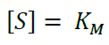 (5)
At this point half of the total amount of enzyme Et is converted to ES:
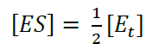 (6)
If we insert equation (5) and (6) into equation (2) we discover:
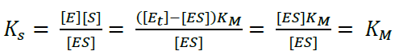 (7)
The complex constant KS for an enzyme is the Michaelis-Menten-constant K_{M}, because a constant will be the same for this special and a general case. To find a way for measuring K_{M}, we need to look at equation (2) in a general case, that is for any value of [S], and connect it to the measured current. As we know from the previous chapter the current depends on the reaction rate v_{R}. From equation (3) we already know the connection between v_{R} and [S] and we can deduct the connection to the more interesting v_{max}, because v_{max} is reached when all enzyme is converted to ES.
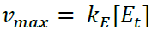 (8)
Equation (8) shows this conclusion. Using equation (7) with (2) leads to a new expression for [ES].
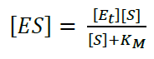 (9)
Our goal is an expression with all the parameters in which we are interested and the ones we can determine with a measurement. Equation (9) does not include v_{R} and we need it to make a connection to our measurement, because it is correlated to the current. The missing v_{R} can be introduced by substituting [ES] in equation (3) with equation (9).
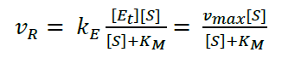 (10)
During an amperometric measurement we can control the concentration of substrate [S] and we measure the v_{R} as the current I. The unknown values of equation (10) are the two values we want to evaluate: v_{max} and K_{M}. Scientists like to turn an equation into a linear form, because this often allows a good determination of missing parameters via a linear fit. If equation (10) is inverted a linear form can be achieved:
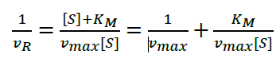 (11)
Equation (11) is known as the Lineweaver-Burk equation. According to the Lineweaver-Burk equation a plot of 1/v_{R} versus 1/[S] should deliver a line with the intersection 1/v_{max} and slope K_{M}/v_{max}.

