- The name of the entrepreneur and the organization he/she/they started.

Kevin Dewhitt started a company in 2004. His dream at the time was to convert garbage into energy. Ultimately, he created a company that converts plastic garbage into liquid, black gold! He is a chemist and a physicist with a real passion and dream to do something good for communities and the world. The original company name was Plas2Fuel. Kevin remarked that it was a particularly cumbersome name, and he eventually came to hate having to spell it every time he used it in conversation. He, laughingly, dismisses its creatively challenged origin by saying that it was as creative as a scientist could make it. In an after note, he explains, “that means it wasn’t very creative”. The new name that his marketing friends suggested for him was Agilyx, a made-up word that he still has to spell every time it’s mentioned in conversation but sounds to him like it “has a little more to do with science and fuel than his first name”.

- Start-up Team: If the venture has a start-up team (rather than a solo entrepreneur), a description of the team members. Include information about what each person brings to the venture.

Kevin’s initial start-up team consisted of himself, his wife Elisabeth, his five kids and his cat. His wife was working a full-time job and gave him the greenlight to be what he refers to as an “unpaid founder”. There are many spouses who would refer to an “unpaid founder” as a ne’er-do-well or in other terms a bum. Without this buy-in from his immediate start up team none of this would have happened. His start-up team expanded when his friend Chris, who had a job, a big job, bought-in. Chris Ulum was a Sun Microsystems manager who Kevin sold on this idea, and who spent his spare time as the premier CEO, also unpaid, of this new Agilyx Company. Kevin mentions several first-round funders and angels, who I gather were friends of friends, and possibly even relatives, which young Agilyx needed in order to buy the raw materials to make their first machine, who are all, also, part of the start-up team. The start-up team expanded yet again when, to run this machine, they finally had to get somebody full-time, Nick. Kevin calls this his first real hire. Nick Smith was the first plant manager who is also, clearly, a strategic core member of the start-up team.

- Opportunity Recognition: A description of how the entrepreneur(s) came up with the idea.

Kevin’s opportunity recognition has been a little one-sided, possibly myopic. On the one hand, Kevin fully understood that he began this venture knowing that he was a well-trained chemist and physicist, having studied physics, chemistry and engineering at Oregon State, as well as, having privately researched plastic-petroleum conversion, so he understood that he had something on the supply side of opportunity: knowledge.

Also, on the supply side of opportunity, he hypothesized, as part of his opportunity recognition, that garbage is inexpensive, sometimes free. He realized over time, however, that he was dead wrong, there. Plastic garbage is not free; it is difficult to get plastic garbage separated from general-waste garbage. Nonetheless, on the supply side of his opportunity recognition is: garbage is abundant and inexpensive.

On the demand side of opportunity recognition, however, Kevin is a little murky. He tells us in his interview that he’s been very bad at identifying customers, mostly because he doesn’t understand the difference between share-holder money and customer money. His original vision was of large conversions of plastic garbage into crude oil, but that meant sales to garbage harvesters that would cost as much as 20 million, making the number of potential customers of his end-use product very, very small. There’s not that much opportunity there. He tells us that in the beginning he felt that people wanted the garbage cleaned up, but not that they wanted to pay to have plastic cleaned up. Therefore, the only demand-opportunity he thought up would’ve been with the government and heavily government-subsidized recycling companies who could potentially use tax-payer money to afford such huge sums. Kevin has changed his demand recognition, since starting 2.0, to smaller sales, thus believing the demand side of his opportunity might be stimulated by lower price points; however, he still cites non-profit government companies as his primary market, conflating the ideas of selling shares of his company and selling his actual product, petroleum.

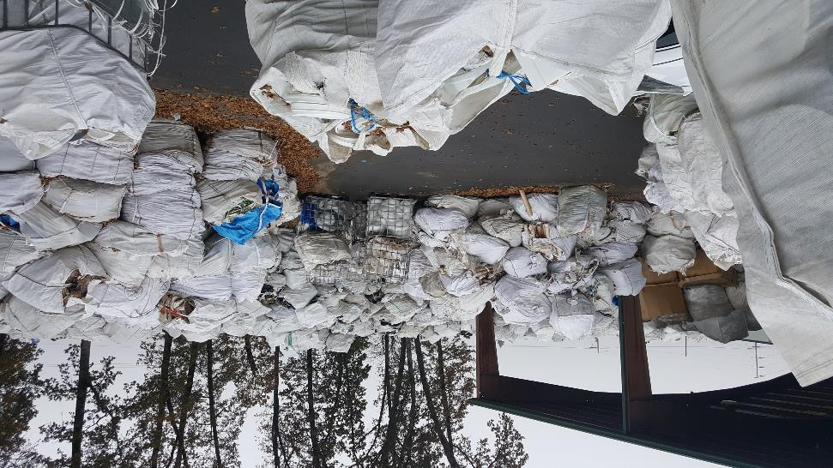
- Product or Service: A description of what it is that the organization sells.

Kevin tells us simply, “Agilyx sold a technology that converted a problem (waste plastic) into a resource (crude oil or hydrocarbon fuels)”; however, Kevin now produces and delivers a product and service that has transmogrified over time. In the beginning Kevin accumulated plastic garbage, converted it in his machine at his plant into crude oil and then sold it. Above is a picture of the separated raw plastic garbage. At first, his deliverable was a product, drums of oil. At some point that quantity rose considerably. Then he pivoted, and the deliverable became the machine itself. And then, from his talk, it appears it became the technology associated with the machines. Now, in 2.0, it appears Kevin has come full circle back to selling the oil; however, a big pivot is that, instead of crude oil, he will sell petroleum and diesel for farm vehicles.

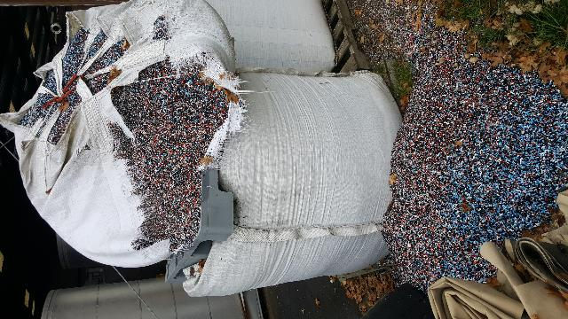

Plastic is chopped up and cleaned prior to entry to the converting machine. The cannon (right) is Kevin’s secret sauce.

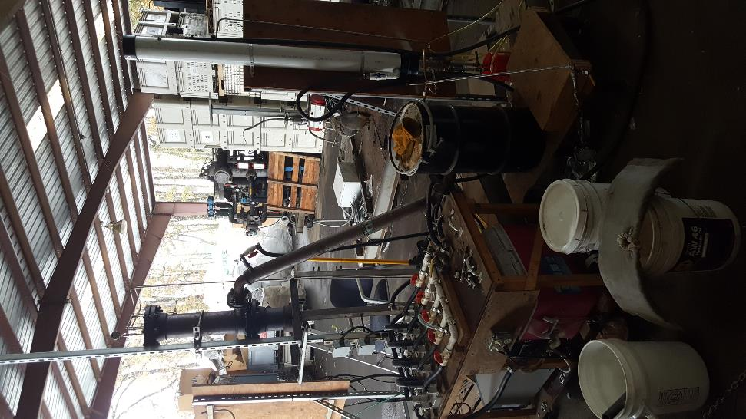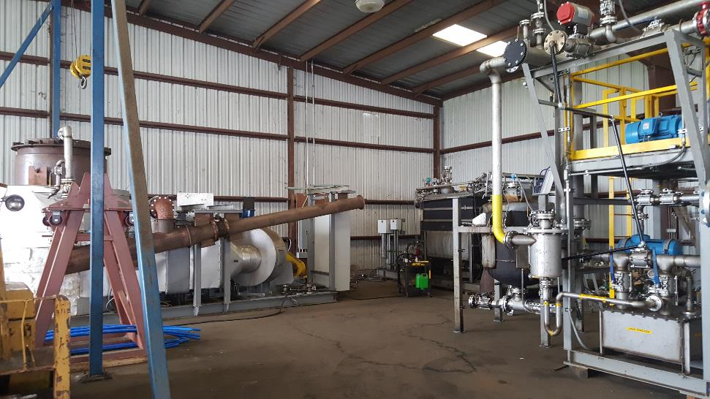
- Customer: Who is the customer? Why was that particular market segment chosen by the entrepreneur?
- Value Proposition: A description of the benefit being provided to the customer.

Investopedia defines customer as “an individual or business that purchases another company's goods or services. Customers are important because they drive revenues; without them, businesses have nothing to offer.” Revenue driver.

Kevin tells us: “We did not do a good job of identifying the best customer for our technology; initially, anyone in contact with or in charge of a waste material flow seemed like a prospective customer. In reality, anyone who aggregates source-separated plastics is the ideal customer, which removes waste companies from consideration. Two of our three clients were project developers, which are probably the worst client, since they typically are a jack of all trades, but master of none.

“Industrial manufacturers that produce waste plastic are an ideal customer, but we did not realize a sale into that sector of the marketplace. We chose our customers based on their ability to say “yes” to a brand-new, as yet unproven technology, which most people don’t do if the risk profile is too high (with a $15MM price tag, for example).”

Agri-Plas, a recycling plant, subsidized by the government, which supplies separated plastic to Kevin as a raw resource is not functioning as a customer. However, Kevin now believes is the best customer for 2.0.

It is clear that no producer of waste is going to be paying for Kevin’s final product, right? Kevin’s product is the oil. From our Investopedia definition, the only true customer would be the farmers paying for the oil as diesel or petroleum. The only value proposition, therefore, would not be “anyone in the waste plastic business to up-value a portion of their material flow that heretofore had no value, and to produce a localized (and valuable) source of energy to boot.” but, in fact, any purchaser of either the technology, a government agency or non-profit subsidiary, or any purchaser of the final product, oil.

- Distribution: How the product or service reaches the customer. This should include a comprehensive analysis of the business model, including customer acquisition, fulfillment and retention as well as product or service fulfillment.

Up until 2.0, distribution followed a simple route, plastic in, oil out. The most important part of this distribution model is completely ignored, however, namely, how to get the customers in the store. In addition, the manufacturing and raw material processing system was under-defined. Who ultimately sifted through the garbage to pull out the plastic? He didn’t really mention that. He did mention that now, as of 2.0, Agri-Plas will collect from local farmers and deliver sorted plastic to Kevin’s plant, in which machines built and serviced by Kevin and two employees and a few contract workers will make the conversion. Kevin’s plant is geographically close to Agri-Plas, so, then after processing, Agri-Plas will freight the resultant fuel in drums and sell it at a lower-than-market price back to the farmers. Agri-Plas will handle all of the marketing and customer-acquisition as well as customer-service duties.

- Interesting Story: Include at least one interesting story about a success, failure, challenge, or goal that the entrepreneur faced in bringing the organization to this point.

An interesting story Kevin left us with was that he left Agilyx in 2014, having spent about 10.5 years trying to reach a successful outcome. Along the way, he experienced what too much money can do, what too much growth can do, what greed actually looks like, and what too much complexity (paired with real-time chaos) can do to an organization and the team of people that comprise it. By the time he left, he had raised (and spent) around $100MM, had almost gone public in late 2011, completely changed his senior management team (except him), and completely went away from the reason he started the company to begin with. He tells us that his technology succeeded, but was not profitable, which was disappointing and yet tantalizing. He tells of how one week in 2011 no less than five major investment bankers came to his small town and small factory in rural Oregon, begging him to let them be the bank to run an IPO for Kevin’s company, promising him b-zillions of dollars in the outcome. He remarked that it was very off-putting to see these bankers, one a day, for a week, dog-and-ponying him when at the time, he had not produced a single thing yet. Crazy!

A Look Forward: Include a description of what the entrepreneur sees in the future.

In asking for Kevin’s look to the future, he remarks, “I have not given up on my goal to clean up the Citarum River in Indonesia, but realize now just how difficult it is to get something like this not only started, but actually operational and profitable, which is to say, sustainable. My dream is to see this technology able to address almost all of the waste plastic that is generated; my belief is that localized deployment of this technology will address a localized waste problem, create localized jobs and generate localized energy products (offsetting the need to import as much energy as a locality currently needs). This should generate a win-win-win (win3) scenario, which would be absolutely breathtaking.”

By retrofitting the old assets with a much simpler approach to operation, and by introducing a patent-pending change to the chemistry that results in fuel products instead of oil, Kevin believes that those elements will help in producing a profitable venture for his customers (and himself by extension). China’s National Sword program (no more foreign plastic allowed to enter China’s ports) means the marketplace has drastically changed in the USA, putting pressure on waste plastic producers, aggregators, disposers, etc. of coming up with better methods to deal with the multitude and variety of this waste stream. He believes he is in a good fit in being able to address all these market drivers.

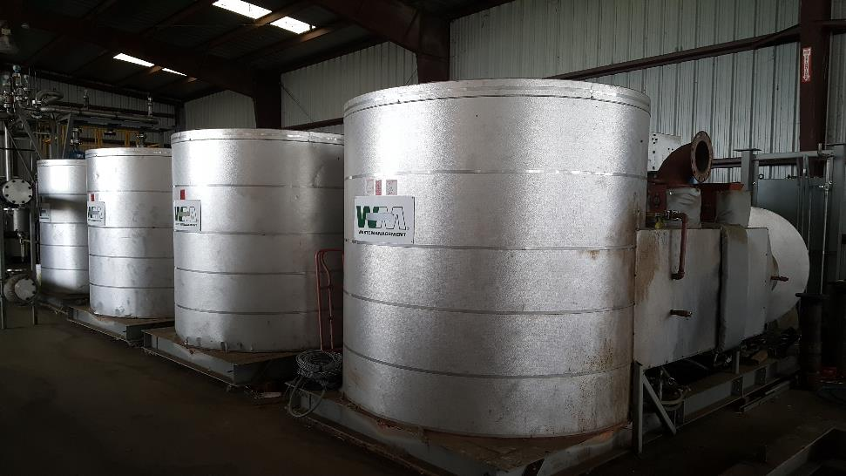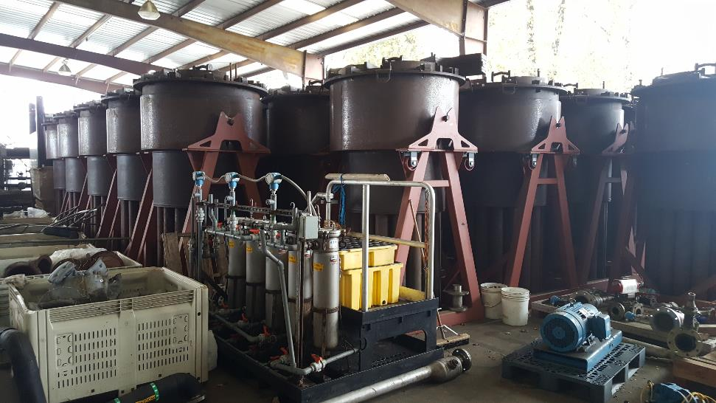
- Your Thoughts: Add your critical thoughts about the organization and entrepreneur to your Entrepreneur Profile. Critical includes a shrewd SWOT analysis of the business.

Kevin continues by describing three buckets, “Most people in this space are only slowly beginning to realize that a successful technology rollout or deployment requires the ability to successfully address three interrelated, yet distinct, “buckets”. Bucket 1 is feedstock (waste plastic) – the ability to obtain it and prepare it for the technology should cost as little as possible, and preferably have a negative cost (i.e. the waste producer pays you to “get rid of it”). Bucket two is the technology, which has to be more versatile and robust, yet simple, in an effort to sustain operations but at a low cost. Any complicated technology that requires large amounts of service (and associated downtime), no matter how “cool”, simply won’t win the day. Bucket three is the revenue generated from the sale of the resulting product(s). Buyers (customers) have to be abundant, have to be local to the operation, and maybe have to pay a slight premium to the general marketplace (and be provided a branding opportunity to compensate). All three buckets must be solved, and this is just not as easy as it appears to be on the surface. Having spent 20 years in this space, I now have a substantial amount of clarity around this thesis, which is something I clearly did not have when I first began my endeavor. Time will tell if I have learned the appropriate lessons…”

Herein, in this quotation, is the summation and final analysis. Kevin, unfortunately, has no idea who his customer is, nor, for that matter, what a customer is, and, even more unfortunately, believes he has twenty years of clarity and now does know, which he still doesn’t.

Until, he understands who his customer is, and what a customer is; that a customer is one whose pain (need and problem) are assuaged by helpful solution and will pay for an end-user need; it is unlikely that much will change. Kevin felt that his investment money was revenue, and a sign of the success of the technology. The success of the technology is not investment, but that it is doable by Kevin and that it solves a pain (cheaper fuel) and that it generates actual revenue from either an end user or a super-user of his product: gas, oil, petroleum, or diesel. I believe working on getting his technology better at turning plastic into cheap fuel and developing actual, sustaining fuel sales is the only possible way forward for 2.0. Below is a preliminary pain-grid for Kevin.

At present there is no clear path. However, below is suggested future research for Kevin:

References:

Investopedia, Retrieved on 11/6/19 from: https://www.investopedia.com/terms/c/customer.asp

K. DeWhitt (personal communication, November 6, 2019).

