Topic: Changes of corporate and social responsibility for Aviva
This is a group assignment, my part is the company background.
Assignment structure:
Introduction
Company Background
Contribution to Community
- volunteering
- charity work
Legal influence
- Government regulations
- Restrictions
Pressure from society-Logan Richardson
- Pressure groups/ environmental groups and their influence
Theories which can be applied to the change (models)
- Van De Ven and Poole
- Lewin’s model
- Nadler and Tushman
Stakeholders analysis
- Employees, clients, shareholders
Conclusion
Reference: Harvard style
Please indicate in the article where you use the references. For example, Among them, digital advertising expenditure increased by 15.9%, reaching 83 billion in 2017 (David, 2017). Advertising is one of the important factors to create and maintain a product, which is conducive to establishing a good brand image, thus helping to build consumer brand loyalty.

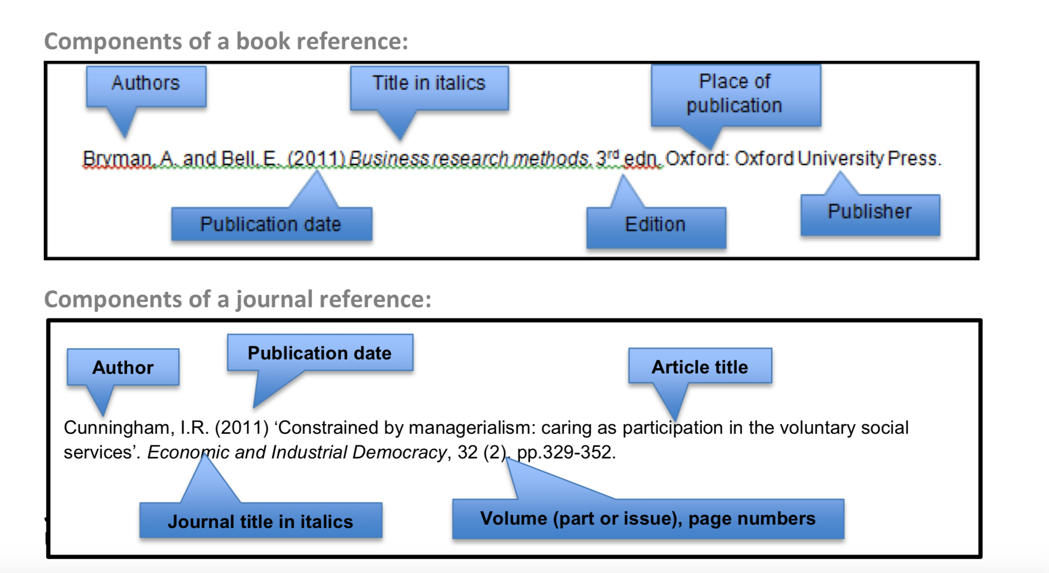
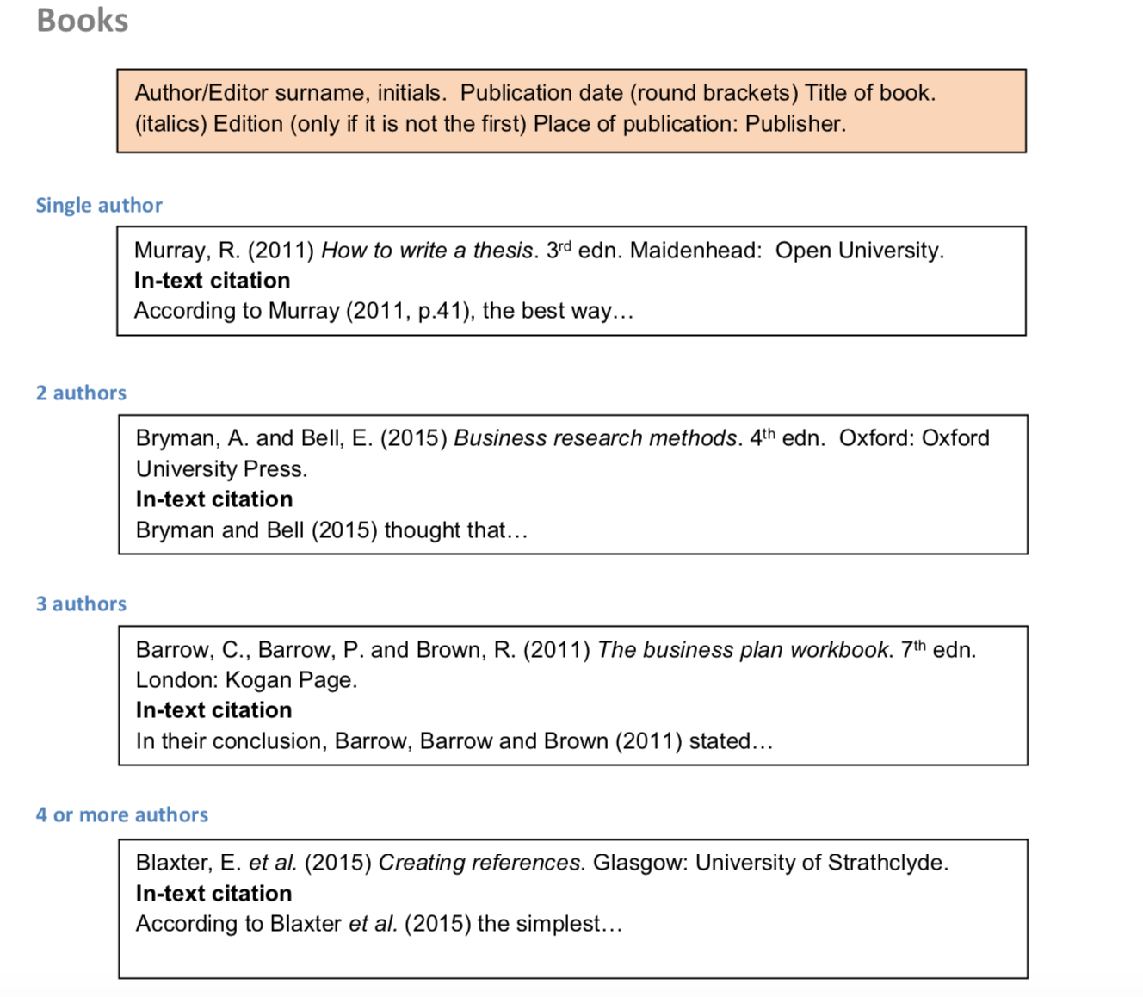
Information:
Aviva is one of the largest and most successful insurance companies in the world today which is leading international savings, retirement and insurance business, serving 33 million customers. The insurance market is very competitive, and if Aviva wants to progress and grow, it must constantly adapt to market demand and change, in order to maintain its position and reputation in the insurance industry.

Corporate and social responsibility (CSR)
The face of CSR is changing - it’s no longer a fluffy nice to have department but now links in to form the backbone of Aviva goals and strategy.
- volunteering
- understand what is important to staff, the business and local charities
- Reviewed current process and established points we can change
- Surveys for staff feedback
- Trials of new thinking to test appetite (Aviva community fund and ethical investments)

The sustainability and Climate strategy
invest in sustainable growth, excel at the fundamentals, deliver great customer outcomes
- Climate change poses significant risk to Aviva.
- moving the world to a low carbon future
The climate strategy
- Modern Slave Trade
Aviva already expressed support for this proposal during the government review of the Modern Slavery Act 2015, and we disclosed our support for a register in our modern slavery statement.
a robust vetting process
Volunteering
- Community
3 days paid volunteering
Local charities
Over 35000 hours of volunteering
volunteering hours in 2019 is almost triple the 2018 number
Re-engage 2020 tea party a collaborative initiative linking
- How?
Volunteer Co-Ordinator role
Volunteering roadshow
Web page to list opportunities
Took the complex out by creating generic risk assessments for staff
Created the charity connections
Offered opportunities at regular intervals
Made volunteering fun – its not all litter picking e.g. kayak clean ups, football 180

The smaller initiatives
•Car park solar panels
•Single use plastics
•Bee hives
•Food bank drop off stations in Aviva
•Wind turbine
•Bra banks
•Wellbeing initiative

