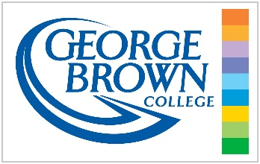

ASSIGNMENT INFORMATION

Centre for Business

School of Management

Business Law

BUS1044

Professor: James Bruce Blain

Assignment #2

Due: 11:59pm Friday, April 3, 2020

Instructions
This assignment asks you to answer 4 short answer questions based upon the case excerpts from 2049390 Ontario Inc. v. Leung, 2020 ONCA 164 (https://www.canlii.org/en/on/onca/doc/2020/2020onca164/2020onca164.html?resultIndex=1)
This assignment is worth 15% of your final mark. Each question is equally weighted. All answers should be typed, in full sentences and 1.5 spaced. You will be graded on the quality of your writing.
Each answer should be between 100-400 words. Focus on what is asked of you in the question. All answers will be evaluated based upon the rubric that has been posted to Blackboard.
Where you see […] it indicates that material has been removed.
All assignments are to be submitted via Blackboard.
Your answers must be your own work (see: https://coned.georgebrown.ca/policies/plagiarism-academic-honesty/) No direct quotes or citations should be used in your answers..

Questions

- This appeal involves a numbered corporation. Explain one benefit and one drawback to being incorporated (25%)

- At paragraphs 15 and 39 Thorburn J.A. refers to Kan as “a sophisticated insured who was involved in supervising the renovations to the building and had experience as a mortgage broker.” Explain the significance of being a sophisticated insured or an accredited investor. How does this apply to the level of protection that one might expect under the law? (25%)

- At paragraph 31 Thorburn J.A. says that based on these facts “insurance brokers are not qualified to give replacement cost advice to their clients and that it is a best practice to advise clients about the need to obtain expert advice.”

In the context of tort law, what constitutes an expert? What are the expectations of an expert as opposed to a reasonable person? Provide one example of an expert recognized at law (25%)

- At paragraph 52 Thorburn J.A. remarks upon the significance of mitigation of harm. Explain this concept and why she agreed with the trial judge’s findings on this point. Why is it important to understand this concept when it comes to conducting business? (25%)

Bonus

T / F – You can collect damages in both contract and tort law based upon the same case? (2% bonus)

