Case Study: Exercise Risky Business

Background
You are a security manager at ACME Electronics, a small to medium sized company that designs
and manufactures computer components for use in the educational sector. The company has just re-located to an Oxfordshire business park where they have rented a Unit. The company has a staff of 15 persons working 9am-5pm Monday-Friday.

The Business Park
The Business Park is open access and covers approx. 40 acres of landscaped grounds. The
accommodation is a mixture of offices, industrial units, and warehouses. There is plentiful parking and the business park provides 24hr security cover including CCTV monitoring.

Figure 1 shows the industrial block rented by ACME Electronics.

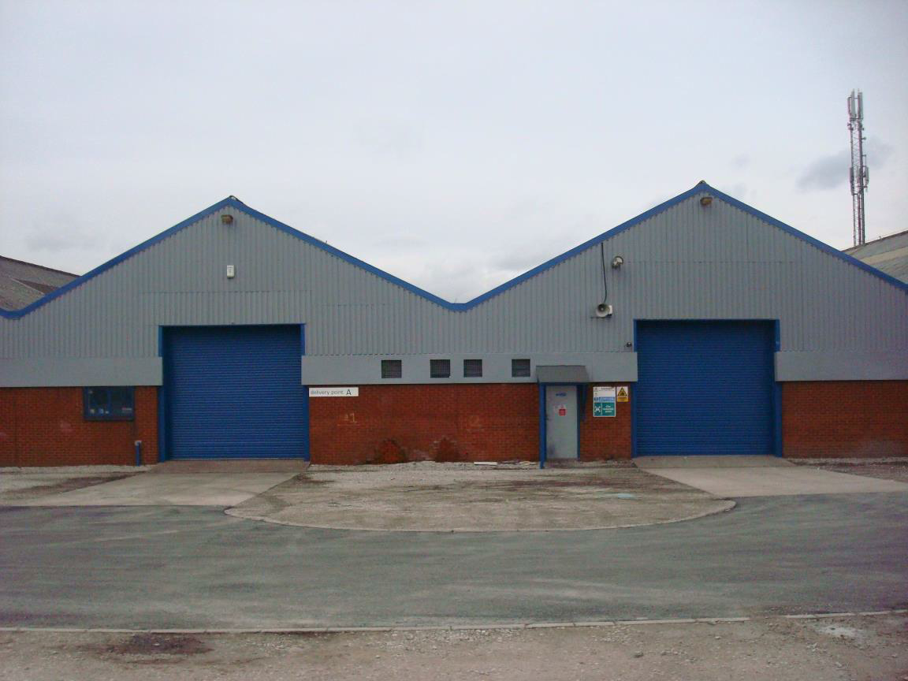

Figure 1: ACME Electronics

Figure 2 shows the layout of the industrial estate, with ACME Electronics in Block 4 on site F.

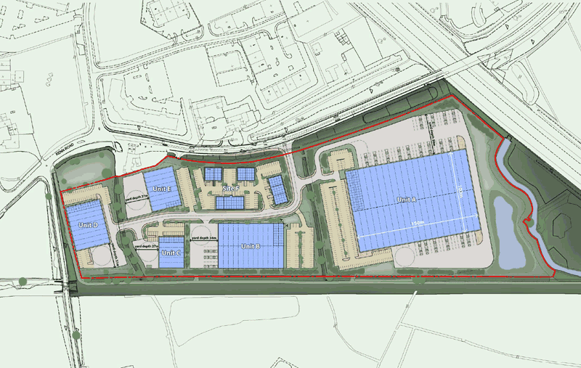

4 3

Figure 2: Industrial Estate Layout

Table 1 lists which companies occupy blocks on the site. It also provides information about the number of acres each company is responsible for.

Table 1: Unit occupation

 | Unit |  |  | Company |  |  | Acres

 | Unit A |  |  | IKEA |  |  | 20
 | Unit B |  |  | ABC Pharmaceuticals |  |  | 6
 | Unit C |  |  | Royal Mail |  |  | 2
 | Unit D |  |  | Bobs Scrap Metal |  |  | 4
 | Unit E |  |  | Inland Revenue |  |  | 3
 | Site F – unit 1
 | Site F – unit 2
 | Site F – unit 3
 | Site F – unit 4

Park Management Office Frank & Millar Solicitors Sally’s Haircare Products ACME Electronics
3

Task
You have been asked to brief the Board of ACME Electronics on your new initiative to manage
risk within the organisation.

Your report should include the following:

1. An explanation of what is meant by assets, threats, vulnerabilities and countermeasures
and include examples of each in relation to ACME Electronics

2. An explanation of how you will conduct your risk assessment of ACME Electronics (list the
data you will need, your methodology and the steps you will take).

3. An explanation of how you will measure the risks and supply an example template.
Remember to identify and evaluate your threats, and evaluate your vulnerabilities

4. An explanation of what is meant by risk mitigation / countermeasures and give examples
of mitigation for the following:
a. Fire
b. Flooding
c. Production line failure d. Transportation failure e. Supplier failure

5. An explanation of the benefits of effective risk communication, including political and
public approaches and why it is important to ACME Electronics

6. An in-depth description of the mitigation (physical and electronic) systems to be
implemented at the new location

7. State how you will use cost benefit analysis to help inform your risk management
approach

8. Describe in detail the necessary policies, plans and procedures required for the new
location e.g. BCP, CMP etc.

9. In the report, include a Critical Incident Plan in terms of pre-crisis, operational crisis and
post crisis management. Include and explain emergency preparedness for crisis and
disaster management, and detail what is meant by post crisis legitimation.
10. Evaluate different levels of response required during a serious incident

11. Please advise the Board at ACME Electronics on the differentiation between a crisis and
a disaster (this includes the difference between natural and man-made crises and
disasters)

The report should include photographs and statistical information where relevant.
Your report should be 1,500 - 2,500 words in length and you may wish to use references. Your quotes, references, charts and bibliography will not be included in your word count.

Outcomes of Learning and Assessment Criteria
To pass this unit, the learner needs to demonstrate that they can meet all the outcomes of learning. The assessment criteria determine the standard required to achieve the unit. Each outcome of learning will have one or more assessment criterion.

Risk Analysis and Risk Management

 | Outcomes of learning |  |  |  | Assessment criteria
1 |  | Understand the  concept of assets,  threats, and  vulnerabilities  within the risk  management  process
2 |  | Understand risk  communications  and the risk culture |  | 2.1 |  | Evaluate political approaches to risk communication
 |  |  |  | 2.2 |  | Evaluate public approaches to risk communication
 |  |  |  | 2.3 |  | Analyse the benefits of risk communications
3 |  | Understand the  concept of the risk  assessment and  relevant mitigation  strategies |  | 3.1 |  | Identify data required for a risk assessment
 |  |  |  | 3.2 |  | Explain component parts required to construct a risk  assessment
 |  |  |  | 3.3 |  | Identify the processes required to measure risk
 |  |  |  | 3.4 |  | Critically evaluate mitigation strategies in relation to the  risk assessment

1.1 Identify assets within a risk assessment
1.2 Evaluate threats within a risk assessment
1.3 Evaluate vulnerabilities within a risk assessment
1.4 Explain how to conduct a cost benefit analysis
1.5 Justify countermeasures required for risk management

Crisis and Disaster Management
Outcomes of learning Assessment criteria
1 Understand
disaster
management

 |  |  |  | 1.1 |  | Evaluate different levels of response required during a  serious incident
 |  |  |  | 1.2 |  | Analyse the difference between crisis and disaster
 |  |  |  | 1.3 |  | Explain emergency preparedness for crisis and disasters  management
 |  |  |  | 1.4 |  | Explain the difference between man-made and natural  crisis and disaster
2 |  | Understand the  crisis management  approach |  | 2.1 |  | Analyse the processes required for pre-crisis management
 |  |  |  | 2.2 Ex |  | Explain what is meant by post crisis legitimation
 |  |  |  | 2.3 |  | Justify what is required for operational crisis management

