Primary Source Analysis Assignment #3 (worth 10%)
This assignment will ask you to think like a historian. You will be asked to analyse evidence from the past (primary sources) in order to form conclusions. To do this assignment well you will need to be creative and think critically.
Choose ONE (1) of the analyses projects below (either A or B). Consider carefully the primary source images or document excerpts presented and write a response to each question. You may use the textbook readings to help provide further context.
Requirements
- Compose your Analysis as a Microsoft Word file, 12 pt. Times New Roman font.
- Include your name and student number at the top of the page.
- Submit your Analysis into the Analysis #3 Dropbox by the posted deadline.
You should also refer to the corresponding Rubric in the Orientation Module for information on how this assignment will be evaluated.
CHOICE A: Large-Scale Cacao Production
Source 1: Earl of Oxford writing about cacao in the British and Spanish colonies, 1690
Cocoa is now a commodity to be regarded in our colonies, though at first it was the principal invitation to the peopling of Jamaica, for those walks the Spaniards left behind them there, when we conquered it, produced such prodigious profit with so little trouble that Sir Thomas Modiford and several others set up their rests to grow wealthy therein, and fell to planting much of it, which the Spanish slaves had always foretold would never thrive, and so it happened: for, though it promised fair and throve finely for five or six years, yet still at that age, when so long hopes and cares had been wasted upon it, withered and died away by some unaccountable cause … Those slaves gave a superstitious reason for its not thriving, many religious rites being performed at its planting by the Spaniards, which their slaves were not permitted to see. But it is probable that, where a nation as they removed the art of making cochineal and curing vanilloes [a kind of vanilla] into their inland provinces, which were the commodities of those islands in the Indians’ time, and forbade the opening of any mines in them for fear some maritime nation might be invited to the conquering of them, so they might, likewise, in their transplanting cocoa from the Caracas and Guatemala, conceal willfully some secret in its planting from their slaves, lest it might teach them to set up for themselves by being able to produce a commodity of such excellent use.
Excerpted from: Brandon Head, The Food of the Gods: A Popular Account of Cocoa (London: R. Brimley Johnson, 1903).
Source 2: Robert Louis Stevenson writing about planting cacao in the Samoan Islands (South Pacific), 1891
You should have seen us; the veranda was like an Irish bog, our hands and faces were bedaubed with soil, and Faauma was supposed to have struck the right note when she remarked (à propos of nothing), ‘Too much eleele (soil) for me.’ The cacao, you must understand, has to be planted at first in baskets of plaited cocoa-leaf. From four to ten natives were plaiting these in the wood-shed. Four boys were digging up soil and bringing it by the boxful to the veranda. Lloyd and I and Belle … were filling the baskets, removing stones and lumps of clay; Austin and Faauma carried them when full to Fanny, who planted a seed in each, and then set them, packed close, in the corners of the veranda. From 12 on Friday till 5 p.m. on Saturday we planted the first 1,500, and more than 700 of a second lot. You cannot dream how filthy we were, and we were all properly tired.
Excerpted from: Brandon Head, The Food of the Gods: A Popular Account of Cocoa (London: R. Brimley Johnson, 1903).
Source Background
Robert Louis Stevenson was a 19th century Scottish author whose most famous works include Treasure Island and the Strange Case of Dr Jekyll and Mr Hyde. He also was a travel writer and traveled extensively in the South Pacific. He eventually moved to the Samoan Islands where he died in 1894.
Source 3: Painting of Indian workers on a cacao plantation in Trinidad, 1903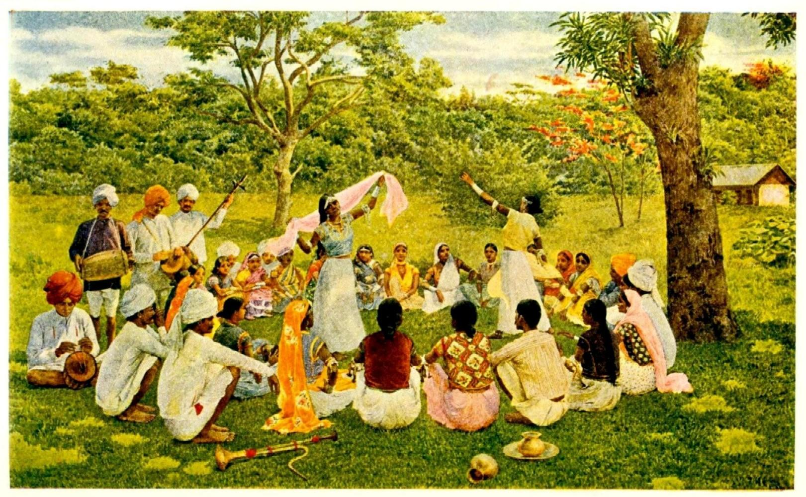
Excerpted from: Brandon Head, The Food of the Gods: A Popular Account of Cocoa (London: R. Brimley Johnson, 1903).
Analysis Questions
Write at least 1 full paragraph (5-6 sentences) per question.
- What kind of picture do the documents give of life on the cacao plantations?
- Write out the series of steps it takes to plant cacao, as described in Source 3. Is it a labor-intensive process?
- Do you think that Source 3 gives an accurate impression of life on the plantation? Explain your answer using evidence from the other documents.
CHOICE B: 19th and 20th Century Chocolate Advertisements
Source 1: Advertisement for Hershey’s 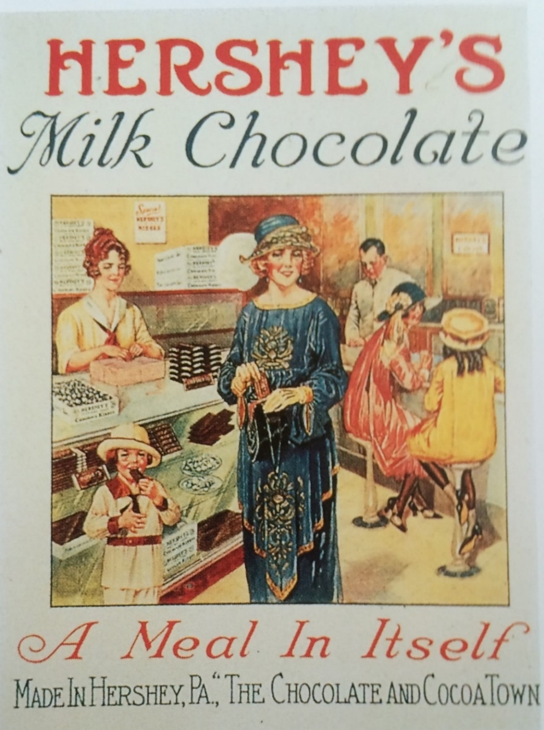

Source 2: Advertisement for Cadbury’s 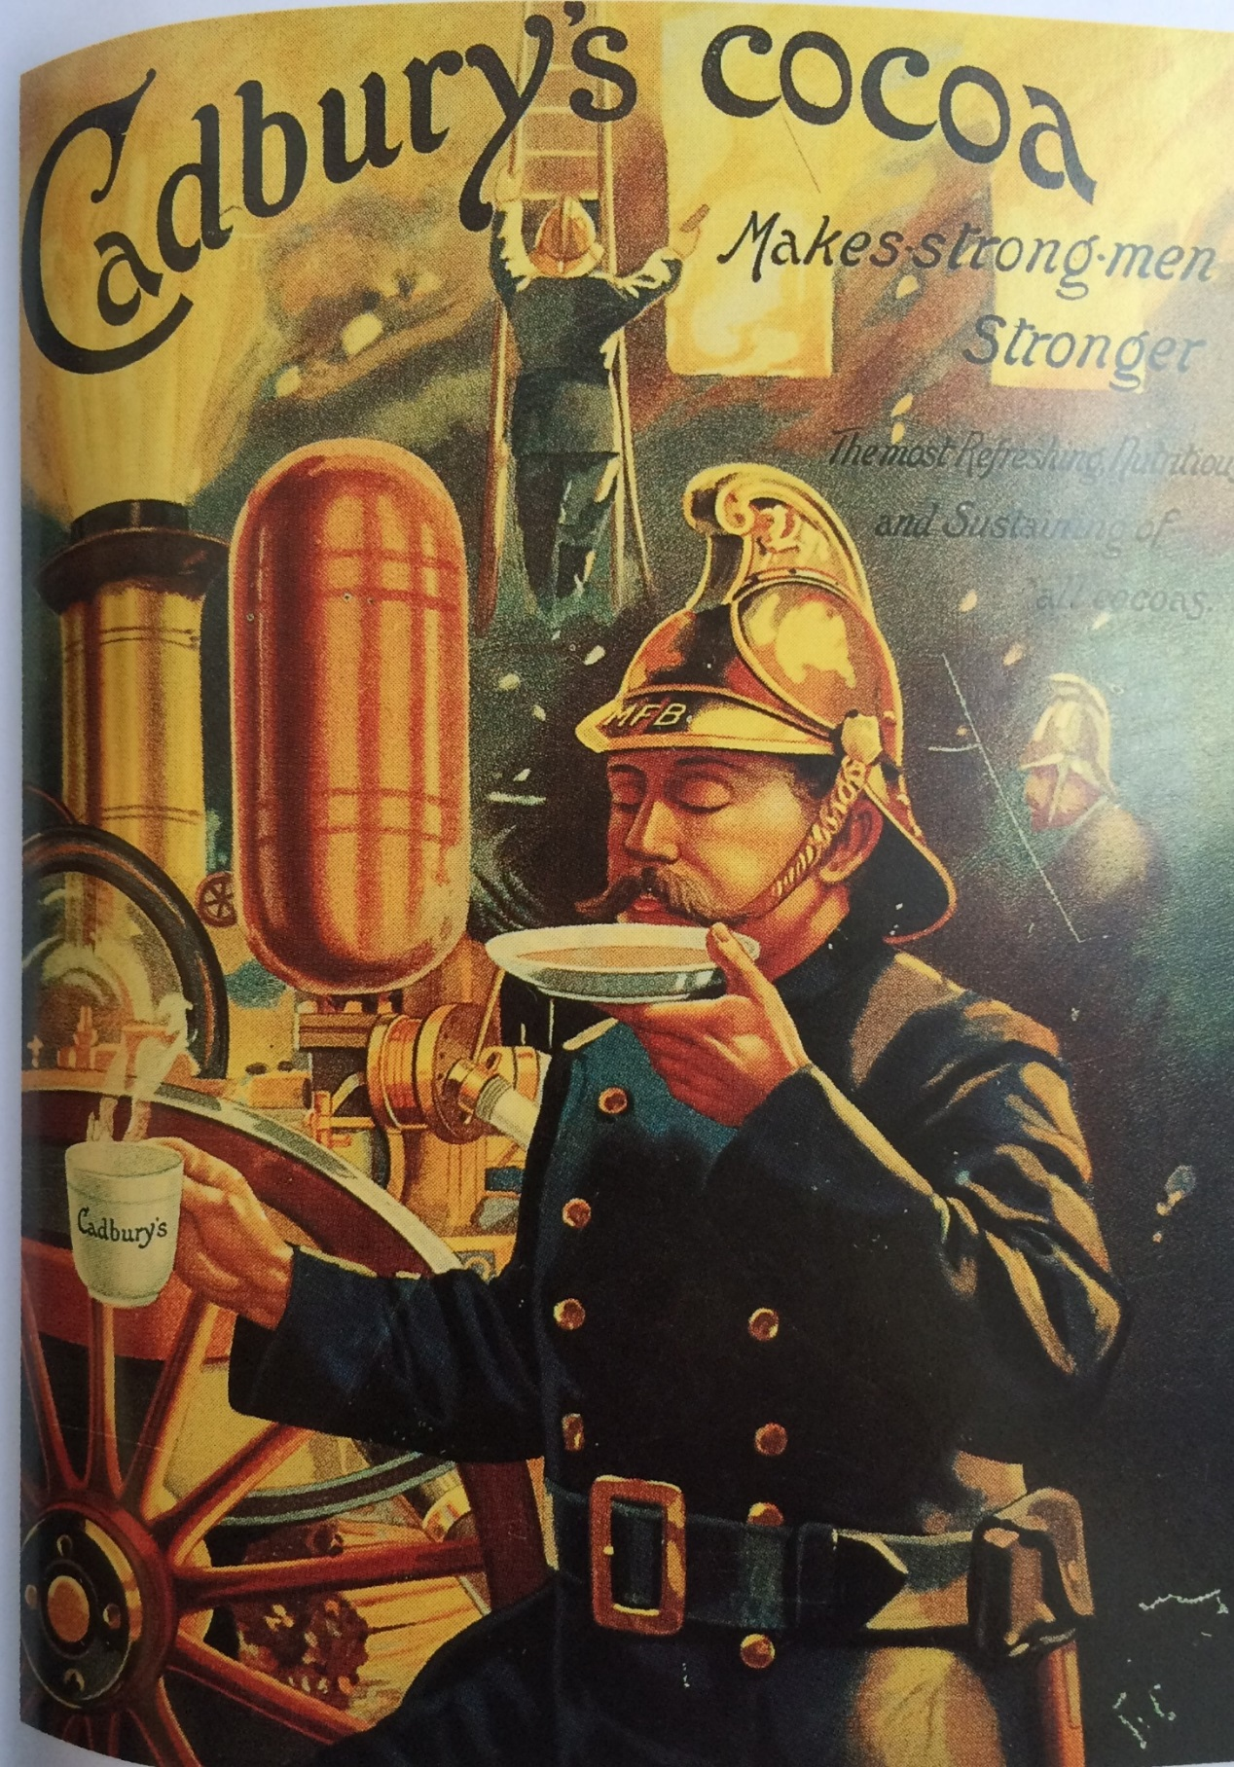

Source 3: Bird’s eye view of Fry’s Chocolate Factory in 19th-century Bristol
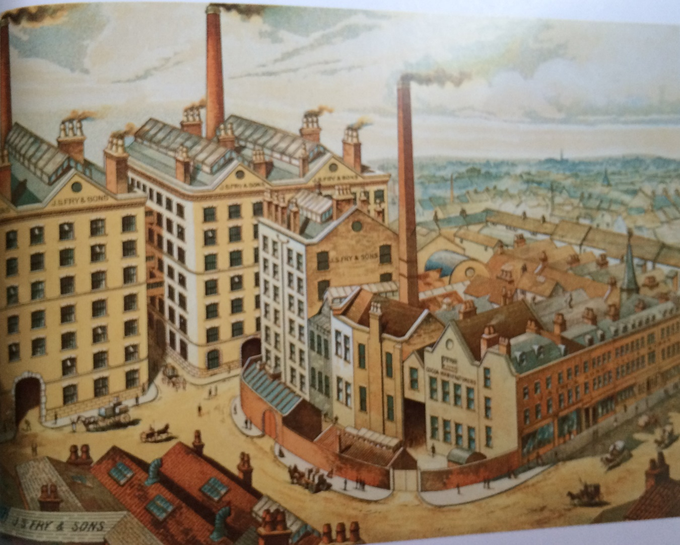
Analysis Question:
Write at least 1 full paragraph (5-6 sentences) per question.
- What message(s) is each advertisement trying to communicate?
- What kind of images and techniques does each advertisement use to deliver its message(s) and appeal to the consumer?
- What can these advertisements tell us about the time period in which they were produced?

