Abstract

Results showed an increase in root length, hypocotyls length, of seeds treated with 50% H2SO4 for 60 min. Followed by 98% H2SO4 for 10 min. Mechanical scratch gives the highest germination percentage of the used treatments. The lowest germination percentage was observed with the seeds treated with water and boiling water and hydrogen peroxide. It is recommended that the conservation of acacia trees have been succeed in increasing significantly their vegetation due the combination to both effects of H2SO4 and scratching.
Introduction

The seed phase is the most important stage in the life cycle of higher plants as regards survival. Dormancy and germination are two crucial seed traits that are often considered keycomponents in plant life history strategies (Rees, 1997).
Seeds often have specific requirements and conditions that need to be met before they can germinate. This is to prevent the seedlings from sprouting when there is inadequate water, poor climate and other detrimental conditions.
The method employed to prevent germination is called dormancy. Seed dormancy is a block to the completion of germination of an intact viable seed under favourable conditions that allows seasonal timing of germination for seeds in a population(Finch and Leubner 2006). Dormancy may be strong to weak, and the extent of dormancy present at any particular moment is referred to as the degree of dormancy (Kirmizi et al., 2010). If the seed coats are not pre-treated, germination can be erratic and prolonged (Fordham , 1965). In leguminous family many species, have hard and impermeable coats that they are impenetrable to wear and gasses thus they have physically dormancy (Ellis et al., 1985) .
Some seed coatings are too thick to allow water into the seed without harsh treatment. Any process that breaks down the outer wall of the seed enough to allow water in is scarification.

Different methods are used to break seed dormancy dependly on the type of plant species and dormancy (AOSA, 1993). Many kind of treatment are used for overcome to physically dormancy such as mechanical scarification, chemical scarification (especially sulphuric acid and Hydrogen Peroxide ), hot water, normal water (Isvand, 2004).Some plants need a chilling period, others need to have the hulls scratched and still others require a drought experience.
Therefore, we employed this mechanism on Acacia species because in recent years many of these species are threatened by genetic erosion as a result of increasing human population, aridity and human activities. The continuous overgrazing, overcutting, and uprooting are leading to the disappearance of pastoral plant communities, a reduction of plant cover and soil erosion.
Acacia species belong to the family Leguminosae (Fabaceae) sub-family Mimosoideae. with nine subspecies presently recognized, is naturally distributed in the drier areas of Africa and Asia (Fagg, 2001)

Acacia is an economically important genus, all parts of various Acacia species are used for one purpose or another as sources of food, high quality animal fodder, fire-wood and variety of natural products, such as wood, timber ,gum exudates, tannins and honey, also they improve soil fertility through nitrogen fixation (Springuel and Mekki, 1993) . Most of the Acacia species are of medicinal benefits to man and his livestock.
The factors which affect seed germination of Acacia species in a given micro environment are water availability, soil type, seed dormancy and insect infestation.
So it requires further study in order to maintain Acacia species from deterioration by subjected to some physical or chemical treatment such as braking seed dormancy. Immersion in concentrated sulphuric acid ( H₂SO₄), increases germination in some species of Opuntia (Potter et al., 1984). Teketay (1996) remarked that treated 20 leguminous species seeds with sulphuric acid, improved germination in all the species. H₂SO₄ was effective to overcome seed coat imposed dormancy in the species studied.
The aim of the present study is:
1- To investigate the seed germination of Acacia and the best treatment to attain the highest germination percentage.
2- Since breaking the seed dormancy is one the strongest programs used in conservation of certain valuable plants . So our work can be used as a step for the regeneration of Acacia spp., in general and Acacia seyal in specific , and ecosystem restoration in desert habitat in Al Ula region, Saudi Arabia.

Materials and methods

Materials:
Seeds of Acacia seyalwere collected in May 2014 from Al-Hijr about 20 km north of the Al Ulatown. The seeds were selected for symmetric of size , shape and color.
Description of Acacia seyal tree:
Acacia is a small to medium-sized tree, growing to 17 m tall and 60cm in diameter , crown is umbrella shaped Large spines occur on the branches, and smaller, curved thorns are present near the tips of the branches. Leaves bipinnate , dark green, 4-12 pairs of pinnate Flowers clustered in shining, yellow, globose heads, 1.5 cm diameter, on stems 3 cm long. Pods 10-15 x 1 cm, slightly curved, light brown when mature and indehiscent, containing 6-10 seeds. Seeds are elliptic (5-6 x 2.5-3.5 mm)
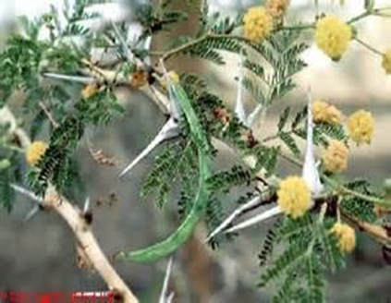
Photo (1):Branch of Acacia tree showing the compound leaves with two large spines , clusters of flowers and long green pods

Methods:
Different methods used in breaking the dormancy of Acacia
Our work divided into two parts:
Part 1: The preliminary test
Seeds were germinated by placing them on wetted filter papers, covering the bottom of 28 cm diameter Petri- dishes, under laboratory condition.
Breaking dormancy treatments
In this experiment we use different ways (treatments) we expect their effect on breaking the dormancy of Acacia seeds, through reading the literatures .

1-We started the experiment by selecting of vigorous seeds, based on differentmorphological criteria such as color, size, and uninfectedseeds.
2- prepare , Petri-dishes, tubes, distilled water and filter papers.
3- Acacia seedswere subjected to the following pre- treatments beforesowing ( 10- seeds were chosen for each treatment X 2).

Table 1. Different treatments used for breaking the dormancy of Acaciaseeds:

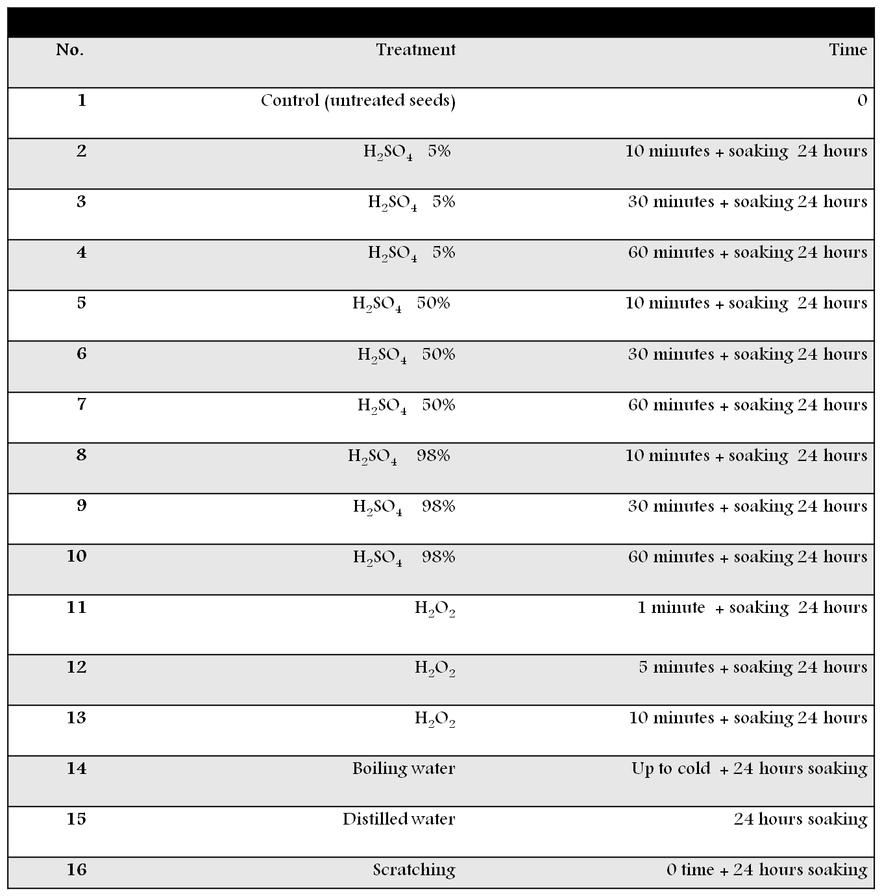

4-After 24 hr seeds were put in Petri-disheslined with filter paper.
5- keep in a dark room.
6- Germination percentage (G%) was calculated as ( total number of germinating seeds)/ (total number of germinated seeds) X 100 , according to Bewley and Black ( 1994).

Part 2: Main experiment
- We selected the healthier and uniform seeds.
- From the previous experiment, the treatments with the pest germination rate were selected for the second experiment.
- The treatments are:
- Sulfuric acid, 98% for 10 minutes then washed with distilled water several times, dry them out. Scratch the seeds with sand papers then washed with distilled water.
- then washed with distilled water several times, dry them out. Scratch the seeds with sand papers then washed with distilled water.
- Hydrogen peroxide from the bottle for 5 minutes, then washed with distilled water several times, dry them out Scratch the seeds with sand papers then washed with distilled water.
- Boiling water, was applied and left to cool for 24 h.
- Control, the seeds were washed with distilled water, then dry them out.
3- prepare the plastic boxes by washing them first by tap water followed by distilled water and dry them out by paper towels .
4- line the bottom of the plastic boxes with paper towels (2-3 layers).
5- Put 5 cotton beds on the paper towels and wet them with distilled water .
6- Add 2-3 seeds ready for germination from each treatment used in the experiment on each cotton pad.

7- Cover the seeds with cotton beds and wet with water.
8- Put on the cover of the plastic boxes.
9- Keep all boxes in dark room.
10- different morphological characteristic were measured in each treatment combination in three stages , after 7days, 9days and 12days of germination.
11- Length of radical and hypocotyls were the main morphological parameters measured in addition to the number of compound leaves (1st or 2nd) leaves and number of lateral roots if any.
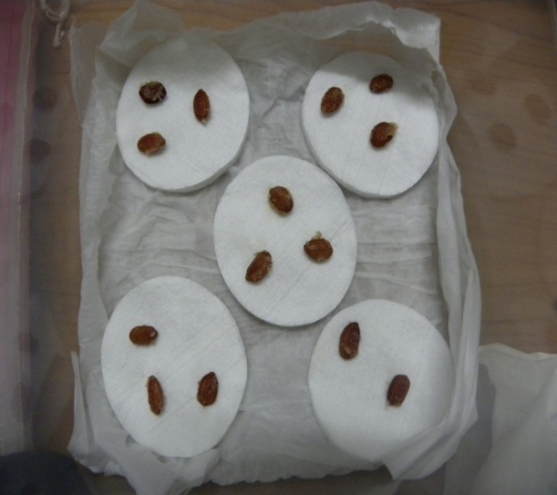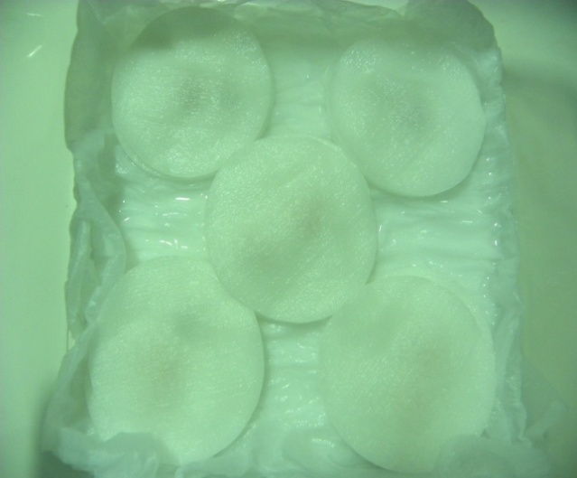
Photo (2): Steps of sowing Acacia seeds in the second experiment
Results and discussion
The present study focused on how to break the dormancy of Acacia species in Saudi Arabia . according to testing the best method of germinating and establishing, Acacia seyal species.
In the preliminary test in which we use different pre- sowing treatments as in table ( 1) the highest percentage of germination was observed in seeds treated with H₂SO₄ , 50%, 60 min (75%) followed H₂SO₄ , 98%, 10 min. (70%), mechanical scratching gives (73%) then H₂O₂ ₅ min.,( 45%), boiling water ( 40%) and control (0 %).
Effect of the different dormancy breaking, treatments on the percentage of germination in Acacia seyal Seeds
Treatment with H₂SO₄ followed by mechanical scratch, was effective in breaking the seed dormancy and the result is shown in Figure 1. Seeds soaked in H2SO4 for 50 min gave the highest germination percentage. Non significant germination percentage was recorded from seeds in the control for the period of the experiment.
Figure (1): Percentage Of Germination (%) In Response To Different Breaking Dormancy Treatments

Effect of the different dormancy breaking treatments on the radical length of Acacia sayal seeds

Figure (2): effect of the different dormancy breaking treatments on the radical length of acacia sayal seeds

It was observed in Figure (2) that there is a significant increase in radical length was observed in all treatments with special increase in case of H₂SO₄ , 50%, 60 min. with mechanical scratch, followed by H₂SO₄ , 98%, 10 min. with scratch. Hydrogen peroxide also increased the radical length with a significant increase at the third stage of measurements. A significant increase in radical length was observed in seedlings pretreated with boiling water followed by mechanical scratching.
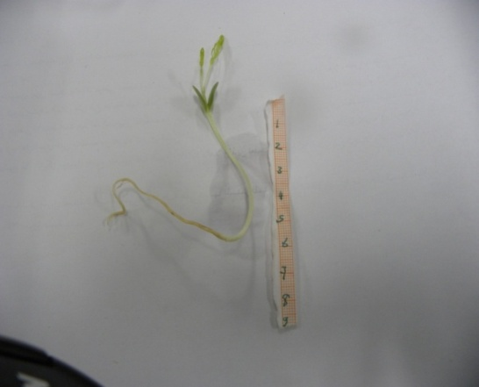 | 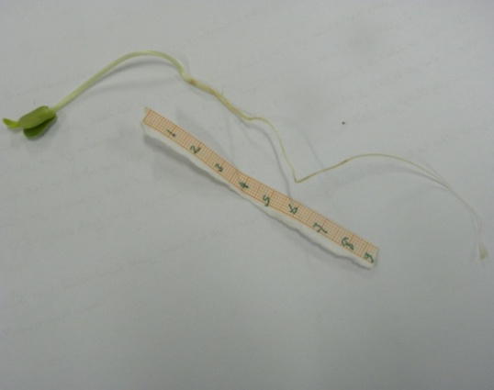

Effect of the different dormancy breaking treatments on the hypocotyle length of Acacia sayal seeds
It is clear from Figure (3) that treatment with H₂SO_{4,} 50%, 60 min. followed by mechanical scratch, gave the highest effect on the hyopcotyle length of the Acacia seyal seedlings. H₂SO_{4,} 98%, 10 min. with mechanical scratching also increase the hypocotyle length. Significant increase in hypocotyle length was observed in the seedlings treated with the hydrogen peroxide (concentrated) for 5min. with mechanical scratching in the third stage of measurements.

Figure (3): Effect Of The Different Dormancy Breaking Treatments On The htpocotyle Length Of Acacia Sayal Seeds

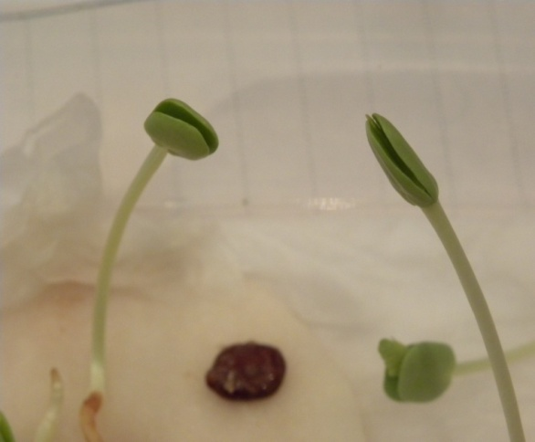 | 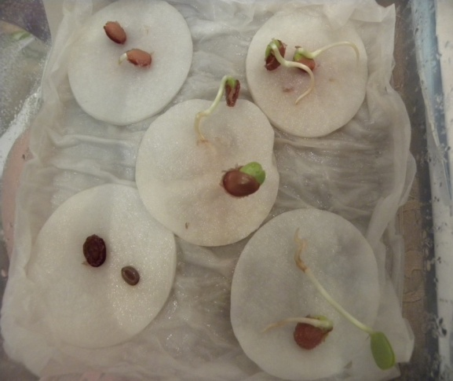
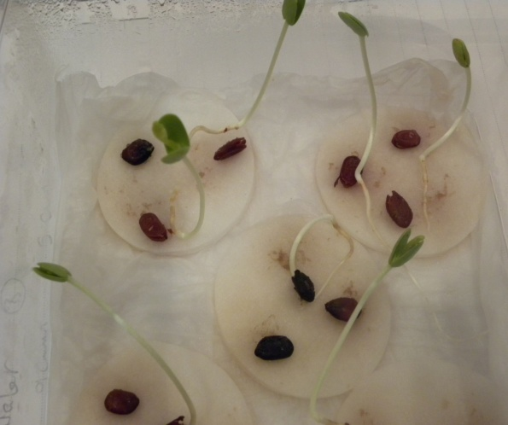 | 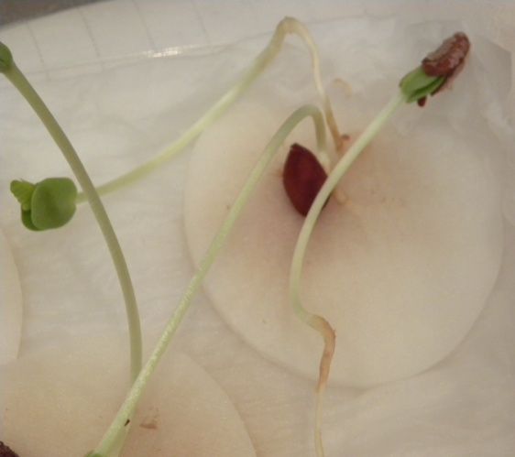
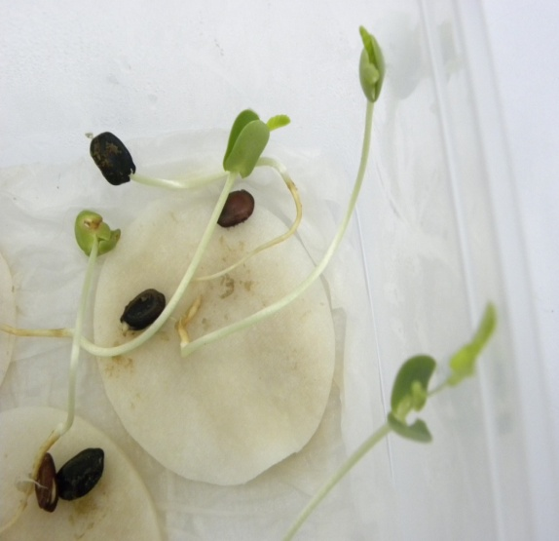 | 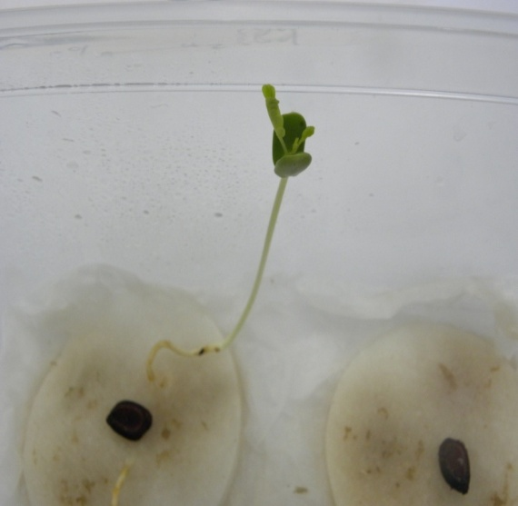

Effect of the different dormancy breaking treatments on adventitious root of acacia sayal seeds.

Figure (4): effect of the different dormancy breaking treatments on adventitious root of acacia sayal seeds.

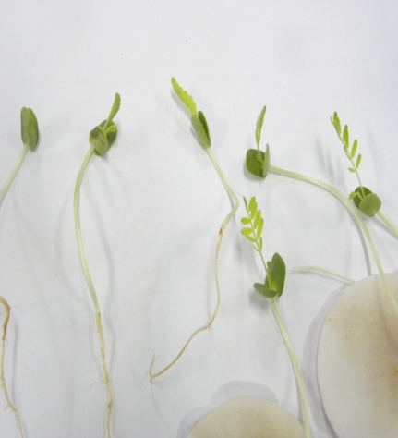 | 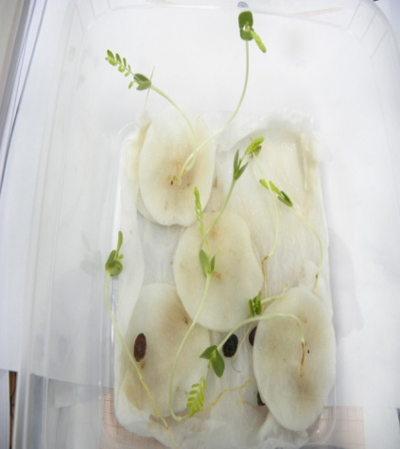 | 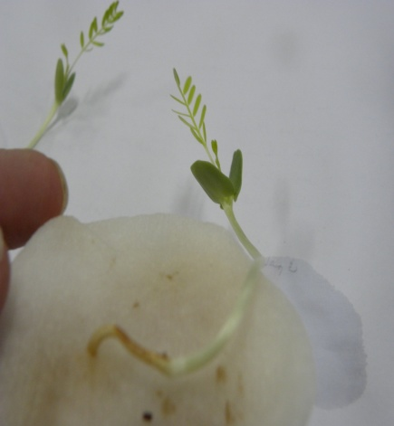

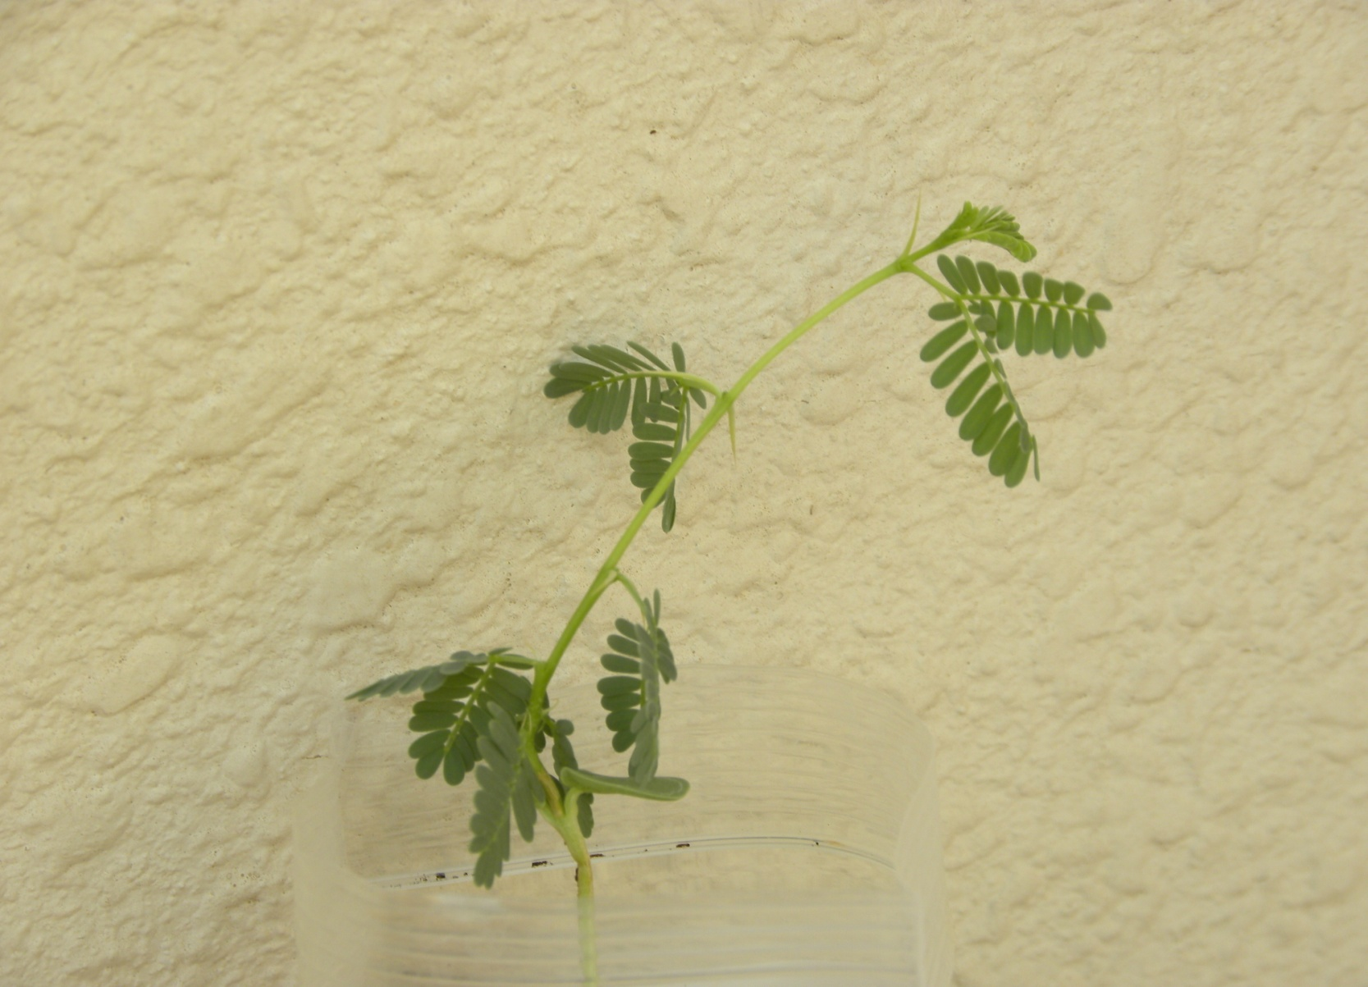
15 days old seedling of Acacia (6 compound leaves), we can observe the compound leaves with two large spines

Conclsion
The most pretreatment succeed in breaking dormancy of Acacia seyal seed soaked in sulfuric acid, 50% for 60 minutes, in addition to mechanical scratching based on the result of this study, one can conclude that the conservation of acacia seeds have been succeed in increasing significantly their vegetation due the combination to both effects of H₂SO₄ and scratching.

References
- Agroforestry Species and Technologies. Winrock International, Arizona, pp 23–24.
- AOSA [Association of Official Seed Analysts], Journal of Seed Technology, 1993;16(3): 1B113.
- BEWLEY, J.D. & BLACK, M. The Physiology and Biochemistry of Seeds, Berlin, Springer-Verlag, V.1, 1978, 306 p.
- Ellis R H, T.D. Hong, & E.H. Roberts, Hand book of seed technology for genebanks, IBPGR, 2(3).
- Fagg C. 2001. Acacia nilotica: pioneer for dry lands.In:ro-shetko JM (ed).
- Finch-Savage W E, and Leubner-Metzger G, New Phytologist, 2006; 171: 501-523.
- Fordham J A, Arnoldia, 1965; 25(1): 1-8.
- Isvand H R, Maddah Arefi H and Tavakkol afshari R, Genetic researches and improvement of rangelands and forest plants in Iran, 2004; 13 (1): 68-83 (In Persian).
- Kirmizi S, Guleryuz G, Arslan H, and Sakar S, TUBĐTAK, 2010; 34: 225-232.
- Potter, R.L., Petersen, J.L., Ueckert, D.N., (1984). Germination responses of Opuntia spp. to temperature, scari.cation and other seed treatments. Weed Science 32, 106–110.

- Rees, M. (1997). Seed dormancy. In Plant ecology. (ed. M. Crawley) pp. 214–238, Blackwell Science, London.
- Springuel, I and Mekki, AM (1994). “Economic Value of Desert Plants: Acacia Trees in the Wadi Allaqi Biosphere Reserve.” Environmental Conservation 21(1): 41-48
- Teketay, D. (1996). Germination ecology of twelve indigenous and eight exotic multipurpose leguminous species from Ethiopia. Forest Ecology and Management, 80, 209-223.

